Assignment #2 Instructions
Due: Tuesday Apri 21, 2020
Please read all the instructions before you begin.

Learning Intentions:

- Components of food preparation, including use and adaptations of ingredients, techniques and equipment.
Assignment Instructions
For this assignment you will need to read a short theory section, prepare a quick bread of your choosing and answer 5 questions about your experience.
COMPLETE IN OFFICE 365 – SEE INSTRUCTIONS AT THE BOTTOM OF PAGE
Baking Theory (Week 2)
Quick Breads
Quick Breads mix and rise faster than yeast breads and require less preparation. Examples of quick breads include bannock, muffins, biscuits, and loaf breads.
After reading that definition, you may be asking yourself what makes a batter or dough rise while it cooks in the oven? The process is called leavening.
The leavening agent is largely responsible for this chemical process; however, eggs, sugar and salt (yeast recipes) all play a part as well. All leavening agents work by trapping air and steam in a batter or dough mixture. Oven heat transforms moisture in the mixture into steam. As moisture transforms into steam, it expands and forces the batter or dough to rise.
There are two types of leavening agents: chemical and natural.
Chemical leavening agents: Baking soda and baking powder. Baking soda requires an acidic ingredient in order to act as a leavening agent. When both are activated they release carbon dioxide gas bubbles that will continue to expand when heated in the oven.
Natural leavening agents: Yeast.
This week we are going to focus on drop batter and soft dough recipes. Drop batters have a ratio of 2:1 dry to wet ingredients and soft doughs have a ratio of 3:1 dry to wet ingredients.
*Method Warning*
One the most common mistakes made in baking is the over mixing of batter or over kneading of dough.
Over mixing can lead to tough, gummy and unpleasantly chewy baked goods. Make sure you follow the method accurately to help prevent this outcome.
Suggested Recipes
*These are only suggestions. The use of family recipes are highly encouraged*
Bannock: https://anitalianinmykitchen.com/bannock/
Gluten-free – Substitute all-purpose flour with gluten-free (cup for cup brand) flour.
Vegan – Substitute the egg with either: flax eggs or 45 ml powdered egg + 40 ml water
- Scroll down and view the step by step pictures outlining the method.
- Prepare all equipment and ingredients before starting.
- Do not overmix the batter!
- Make sure you clean up after you’re done.
- Be safe and have fun!
Ultimate Muffins: https://www.handletheheat.com/ultimate-muffins/
Gluten-free – Substitute all-purpose flour with gluten-free (cup for cup brand) flour.
Vegan – Substitute the egg with either: flax eggs or 45 ml powdered egg + 40 ml water
- Scroll down and watch the video before deciding what variety you would like to make.
- Prepare all equipment and ingredients before starting.
- Do not overmix the batter!
- Make sure you clean up after you’re done.
- Be safe and have fun!
Scones: https://sallysbakingaddiction.com/scones-recipe/
- Scroll down and watch the video before deciding what variety you would like to make.
- Prepare all equipment and ingredients before starting.
- Do not overmix the batter!
- Make sure you clean up after you’re done.
- Be safe and have fun!
Loaves: https://www.foodnetwork.ca/baking/photos/best-sweet-loaves-and-breads/
- Scroll through all the loaf options before deciding what variety you would like to make. The link to each recipe should be bolded in red at the bottom of each description.
- Prepare all equipment and ingredients before starting.
- Do not overmix the batter!
- Make sure you clean up after you’re done.
- Be safe and have fun!

Assignment #2 Questions:
Recipe title:
- What process makes a batter or dough rise and how does it work?
Answer here:

- What is the difference between quick breads and yeast breads?
Answer here:

- What part of this recipe went well for you?
Answer here:

- What could have gone better?
Answer here:

- If you were going to make this recipe again, would you change any ingredients or modify the method in any way? Explain why for either answer.
Answer here:

Extension Assignment
Take a picture of you during the preparation, cooking and serving phases of the lab and insert them into the table below my example:
Preparation | Cooking | Serving
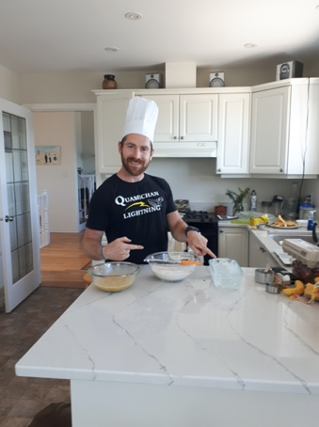 | 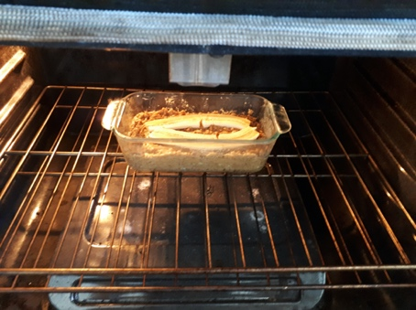 | 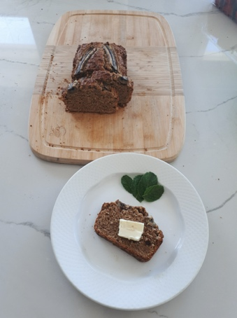

Preparation | Cooking | Serving
How to Insert a Picture into the Textbox:
- Download the pictures onto the device you are working with (send as an email from your phone to your device if you took the pictures with your phone).
- Click on the textbox in which you wish to insert a picture.
- Then click on insert in the top toolbar.
- Then click on picture in the bottom toolbar.
- Then click on from this device.
- Then click on browse.
- Select the picture from “downloads” and click “open” and you’re done!
- Repeat this process for each textbox.
Assessment
Please self-assess with your parent or guardian below:
- Highlight the box that you think best matches your work.
- Click on the highlight icon (pen image) and select the colour yellow.
- Repeat this step for each row.
- Indicate how long this assignment took you to complete below the rubric.
- Add your own comments below this. For example, what did you find interesting, easy, difficult, surprising about the assignment? What did you learn?
Competencies | Emerging | Developing | Proficient | Extending
Preparation & Cooking | Student completed few of the prep and cooking steps. May have got distracted (ie. left the food on the stove unattended) | Student completed most of the prep and cooking steps correctly. | Student completed all of the prep and cooking methods successfully. | Student creatively adjusted the prep or cooking method to enhance the recipe.
Safety &  Sanitation | Student demonstrated few proper safety and sanitation practices such as: using equipment in the appropriate manner, hand washing, sanitizing, cleaning up, dishwashing and final clean up | Student only demonstrated some safety and sanitation practices | Student demonstrated all proper safety and sanitation practices | Student left the kitchen cleaner than when they found it
Final Product | Burnt / undercooked, inedible | Served cold or too hot, flavours don’t match major ingredients | Served at appropriate temperature, flavours match major ingredients | Served with an appropriate garnish, texture reflects cooking technique

Time to complete assignment?
Student Comments:

Teacher Comments:

How to Submit Your Work to your Classroom Teacher:
Here is the preferred method for handing in your finished work:
- Work in office.com, you may need to copy and paste the questions from the pdf.
- Complete the assignment in Word and save it as “Name_Foods 9 #1” (ex: Clark Kent_Foods 9 #1.docx).
- In the top-right corner, click on “share”.
- Enter Candelaria and select my name when I pop up. Make sure it’s set so that I am allowed to edit (so that I can comment on your work).
- Then click “send”. You’re done! I will send it back to you when it’s marked.
- If you are having trouble with office.com, send me an email from your email or your parents’ email with the Word document as an attachment. If that isn’t working, take a picture of it and send it to me in an email.

