Assignment #3 Instructions
Due: Tuesday Apri 28, 2020
Please read all the instructions before you begin.

Learning Intentions:

- Components of food preparation, including use and adaptations of ingredients, techniques and equipment.
Assignment Instructions
For this assignment you will need to read a short theory section, prepare a pastry or cookie of your choosing and answer questions about your experience.
COMPLETE IN OFFICE 365 – SEE INSTRUCTIONS AT THE BOTTOM OF PAGE
Baking Theory (Week 3)
Pastries and Cookies
Pastries are traditionally one of the most difficult things to bake. This is because many pastries recipes require a culinary preparation called lamination in which many thin layers of dough must be separated by butter, requiring the repeated folding and rolling of dough. Some doughs contain over 80 layers!
Cookies on the other hand can be described as a usually thin or slightly raised small crisp cakes made from sweetened dough.
Watch this video on the chemistry of cookies to answer Q.1, 2 and 3 of your assignment:
https://www.ted.com/talks/stephanie_warren_the_chemistry_of_cookies/transcript?language=en
This week we’re going to focus on cookie recipes, however if your family has a pastry recipe that you would like use instead, please feel free to substitute it for one of the suggested cookie recipes.
Choose one of the following types of cookies:
Bar Cookies: brownies (soft dough)
Drop Cookies: oatmeal raisin, chocolate chip (soft dough)
Molded Cookies: shortbread, criss-cross peanut butter, biscotti (stiff dough)
Rolled Cookies: ginger-bread men (stiff dough)

*Method Warning*
Another common mistake in baking occurs when the incorrect consistency of fat is used during the preparation phase. It is very important to accurately follow the recipe directions for this step.
Why? Simply, your final product will lack the appropriate structure and texture. For example, using melted butter as opposed to room temperature butter will most likely result in flat, chewy cookies.
If you need to soften butter to room temperature quickly, click on this link:
https://sallysbakingaddiction.com/soften-butter-quickly-trick/
Try one of the following suggested recipes or a family recipe!
Suggested Recipes
Bar Cookies - Brownies: https://thestayathomechef.com/brownie-recipe/
Gluten-free – Substitute all-purpose flour with gluten-free (cup for cup brand) flour.
Vegan – Substitute Egg with either: flax eggs or 45 ml powdered egg + 40 ml water / Substitute Milk with Non-dairy milk (almond or soy) / Substitute butter with oil or non-dairy margarine
- Scroll down and view the video.
- Make sure you have what you need to complete the recipe before starting.
- Prepare all equipment and ingredients before starting.
- What consistency of fat does the recipe call for?
- Make sure you clean up after you’re done.
- Be safe and have fun!
Drop Cookie Recipes: https://www.foodnetwork.ca/baking/photos/easy-drop-cookies/
Gluten-free – Substitute all-purpose flour with gluten-free (cup for cup brand) flour.
Vegan – Substitute Egg with either: flax eggs or 45 ml powdered egg + 40 ml water / Substitute Milk with Non-dairy milk (almond or soy) / Substitute butter with oil or non-dairy margarine
- Scroll through all the cookie options. The link to each recipe should be bolded in red at the bottom of each description.
- Make sure you have what you need to complete the recipe before starting.
- Prepare all equipment and ingredients before starting.
- What consistency of fat does the recipe call for?
- Make sure you clean up after you’re done.
- Be safe and have fun!

Molded Cookie - Shortbread Cookie Recipe:
https://www.jocooks.com/recipes/classic-shortbread-cookies/
Gluten-free – Substitute all-purpose flour with gluten-free (cup for cup brand) flour.
Vegan – Substitute Egg with either: flax eggs or 45 ml powdered egg + 40 ml water / Substitute Milk with Non-dairy milk (almond or soy) / Substitute butter with oil or non-dairy margarine
- Scroll all the way to the bottom of the page and watch the video.
- Make sure you have what you need to complete the recipe before starting.
- Prepare all equipment and ingredients before starting.
- What consistency of fat does the recipe call for?
- Make sure you clean up after you’re done.
- Be safe and have fun!
Rolled Cookie - Ginger-bread Men:
https://sallysbakingaddiction.com/best-gingerbread-cookies/
Gluten-free – Substitute all-purpose flour with gluten-free (cup for cup brand) flour.
Vegan – Substitute Egg with either: flax eggs or 45 ml powdered egg + 40 ml water / Substitute Milk with Non-dairy milk (almond or soy) / Substitute butter with oil or non-dairy margarine
- Scroll down and watch the video. *You don’t need a stand mixer* An egg beater will work just fine.
- Make sure you have what you need to complete the recipe before starting.
- Prepare all equipment and ingredients before starting.
- What consistency of fat does the recipe call for?
- Make sure you clean up after you’re done.
- Be safe and have fun!

Assignment #2 Questions: (Based on “The Chemistry of Cookies video”)
Recipe title:
- What is an emulsion? What happens at 92°F?
Answer here:

- What happens at 136°F? Explain in detail.
Answer here:

- When do Maillard reactions occur? What is happening as a result?
Answer here:

- What part of this recipe went well for you?
Answer here:

- What could have gone better?
Answer here:

- If you were going to make this recipe again, would you change any ingredients or modify the method in any way? Explain why for either answer.
Answer here:

Take a picture of you during the preparation, cooking and serving phases of the lab and insert them into the table below my example:
Preparation | Cooking | Serving
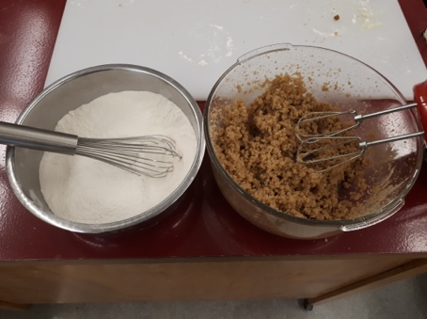 | 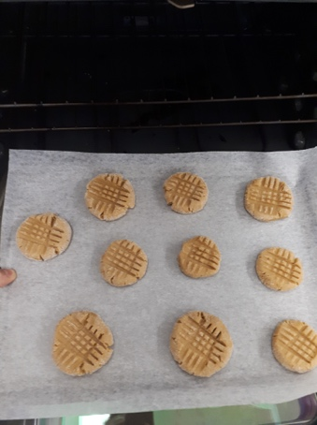 | 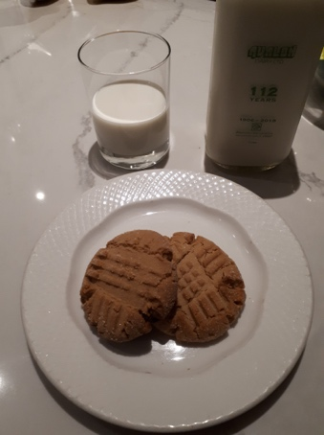
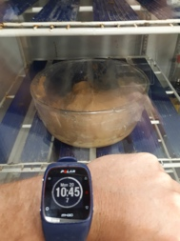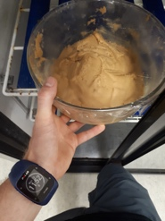 | 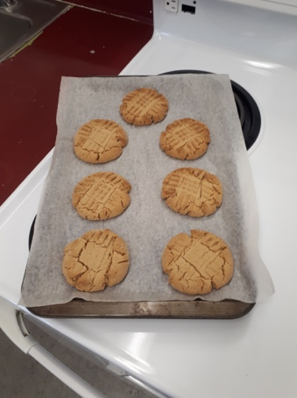 | 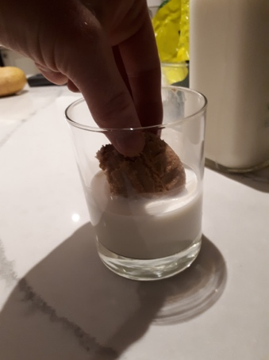

Preparation | Cooking | Serving
How to Insert a Picture into the Textbox:
- Download the pictures onto the device you are working with (send as an email from your phone to your device if you took the pictures with your phone).
- Click on the textbox in which you wish to insert a picture.
- Then click on insert in the top toolbar.
- Then click on picture in the bottom toolbar.
- Then click on from this device.
- Then click on browse.
- Select the picture from “downloads” and click “open” and you’re done!
- Repeat this process for each textbox.
Assessment
Please self-assess with your parent or guardian below:
- Highlight the box that you think best matches your work.
- Click on the highlight icon (pen image) and select the colour yellow.
- Repeat this step for each row.
- Indicate how long this assignment took you to complete below the rubric.
- Add your own comments below this. For example, what did you find interesting, easy, difficult, surprising about the assignment? What did you learn?
Competencies | Emerging | Developing | Proficient | Extending
Preparation & Cooking | Student completed few of the prep and cooking steps. May have got distracted (ie. left the food on the stove unattended) | Student completed most of the prep and cooking steps correctly. | Student completed all of the prep and cooking methods successfully. | Student creatively adjusted the prep or cooking method to enhance the recipe.
Safety &  Sanitation | Student demonstrated few proper safety and sanitation practices such as: using equipment in the appropriate manner, hand washing, sanitizing, cleaning up, dishwashing and final clean up | Student only demonstrated some safety and sanitation practices | Student demonstrated all proper safety and sanitation practices | Student left the kitchen cleaner than when they found it
Final Product | Burnt / undercooked, inedible | Served cold or too hot, flavours don’t match major ingredients | Served at appropriate temperature, flavours match major ingredients | Served with an appropriate garnish, texture reflects cooking technique

Time to complete assignment?
Student Comments:

Teacher Comments:

How to Submit Your Work to your Classroom Teacher:
Here is the preferred method for handing in your finished work:
- Work in office.com, you may need to copy and paste the questions from the pdf.
- Complete the assignment in Word and save it as “Name_Foods 9 #1” (ex: Clark Kent_Foods 9 #1.docx).
- In the top-right corner, click on “share”.
- Enter Candelaria and select my name when I pop up. Make sure it’s set so that I am allowed to edit (so that I can comment on your work).
- Then click “send”. You’re done! I will send it back to you when it’s marked.
- If you are having trouble with office.com, send me an email from your email or your parents’ email with the Word document as an attachment. If that isn’t working, take a picture of it and send it to me in an email.

Extension Assignment
Watch this video on gluten: https://www.youtube.com/watch?v=uEM2iDT-VAk
To save time I highly recommend that you:
- Pre-Read the questions before watching the video.
- Pause and Answer each question as you watch the video.
- Please answer in complete sentences.

What is gluten?
Answer here:

List three steps you would take to determine if you had an insensitivity to gluten?
1)
2)
3)

