Final Baking Assignment
Due: Monday May 4, 2020

Your assignment for this week is straight forward. All you need to do is submit a picture of yourself and a baked good you made for this unit. Also, you must include a descriptive caption. We will be starting a new unit this coming Monday, May 4.
See examples:
Ms. Cross | Mr. Candelaria
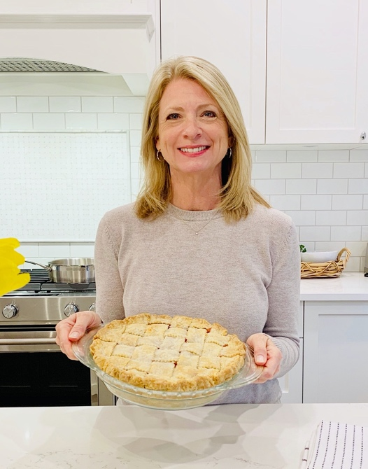 | 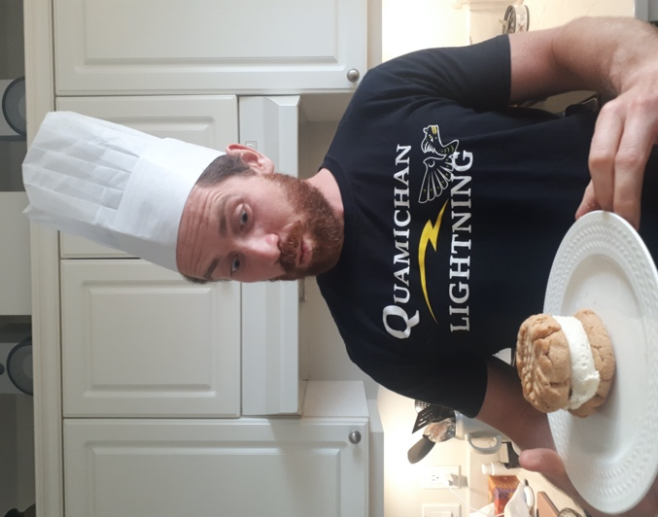
“Sensational Strawberry Rhubarb Pie” | “Peanut Butter Cookie Ice Cream Sandwich”

Type your name in this box
Insert your picture in this box
Type your caption in this box

How to Insert a Picture into the Textbox:
- Download the pictures onto the device you are working with (send as an email from your phone to your device if you took the pictures with your phone).
- Click on the textbox in which you wish to insert a picture.
- Then click on insert in the top toolbar.
- Then click on picture in the bottom toolbar.
- Then click on from this device.
- Then click on browse.
- Select the picture from “downloads” and click “open” and you’re done!
Please “turn in” your assignment on TEAMS.
Moving forward, all new assignments will be assigned through TEAMS. If you are unfamiliar with this platform, please email me at: scandelaria@sd79.bc.ca and I will help you get set up.
Good luck!

