Quamichan Grade 8: Mathematics
Week #2: April 15 - 21
Learning Intentions:
- Curricular learning intentions will vary depending on the course material delivered online by your Math Teacher.
Assignment Instructions:
*If your teacher is: Ms. Barton, Mr. Carlin, or Ms. Taylor:
- Continue with the assigned work on Khan Academy.
  - Go to “Assignments” to see the lessons and activities that your teacher has assigned.
**Please note: your teacher may need to add assignments for you after you have registered. If you don’t see any assignments when you first log in feel free to explore the site.
- Follow through the activities, being sure to watch the videos. Please try the activities in the order that they are presented to you (from top to bottom)
- When you have completed the lessons and sample questions, you can try the quiz! You may try the quiz more than once
*If your teacher is: Mrs. Hopwo, Ms. Lawler, or Mr. Robinson:
- Read the notes located below on Part-to-Part and Part-to-Whole Ratios.
- Complete the assignment located below, titled “Ratios in My Life”.
- Send this assignment back to your Math Teacher, using any of the following methods:
  - Type or upload your assignment (or a picture of it) in your Class Notebook on your Office 365 school account online. Ask your teacher for support if you are not able to access your Class Notebook.
  - Do your assignment electronically (in Word, Pages, Powerpoint, etc.) and attach the file to an email to your Math teacher.
  - Nicely write the assignment on a piece of paper, take a quality picture, and email it to your Math teacher.
Criteria:
- Student will be assessed based on:
  - Achievement in the course material
  - Interaction with the course material
Extending Your Learning (Optional):
- When you have completed the material successfully, your teacher can assign more challenging questions
- You may also explore Khan Academy and find material to attempt that you are interested in

For Students in Mrs. Hopwo, Ms. Lawler and Mr. Robinson’s classes ONLY:
Ratio Notes:
Part to Part and Part to Whole

Part to Part: is a ratio that represents the relationship of one part of a whole to another part of the same whole.
- For example: 🍎🍎🍎🍎🍒🍒🍒🍇🍇🍇🍇🍇
In the example above you see apples, cherries and grapes.
What is the ratio of…..
- apples to cherries: 4 to 3
- Cherries to grapes: 3 to 5
- Apples to cherries and grapes: 4 to 8
These are all examples of a “Part to Part” ratio. We are comparing a part of this whole group to another part of the whole group.

Part to Whole: is a ratio or a fraction that represents a relationship between a part and the whole group
- Using the same fruit example: 🍎🍎🍎🍎🍒🍒🍒🍇🍇🍇🍇🍇
What is the ratio of…..
- Apples to all the fruit: 4 to 12
- Cherries to all the fruit: 3 to 12
- Apples, cherries and grapes to grapes: 12 to 5
These are examples of part of the whole compared to the whole group.

NOTE: You cannot link items that are not similar. So, I would not be able to state 3 dogs and 2 apples as a part to whole. Dogs and apples are not the same.

Another example: 🐵🐵🐵🐶🐶
- There are 3 monkeys and 2 dogs. I could find the ratio of monkeys to dogs, which would be 3:2. This would be an example of part to part.
- Or I could find the ratio of monkeys to animals. This would be 3 to 5. Monkeys to animals would be a part to whole ratio.

RATIOS IN MY LIFE:

- Pick a minimum of 10 Part-to-Part ratios that you have around in your life. For example: people in your house, pets, plants, cars, toys, electronics video games, pens, pencils, forks, spoons, etc.
  - Explain each ratio in words (ex. Number of adults to kids in my family)
  - Represent each ratio in 3 different ways (ex. 2:3, 2/3, and 2 to 3)
  - List 2 equivalent ratios to your original ratio (ex. 2:3 = 4:6 and 20: 30)

- Pick a minimum of 5 Part-to-Whole ratios that you have around in your life. For example, the number of blue LEGO bricks to all the LEGO bricks.
  - Write each ratio as a Part-to-Whole ratio, explain each in words (ex. Blue LEGO bricks to all LEGO bricks)

- Present this information in a style of your choosing. It could be a small poster, a booklet, a powerpoint or word document, a video, or...? Remember you will need to share your project with your teacher, in a way that we can view it!

- Note: there is an optional video on part to whole ratios available through Khan Academy: https://www.khanacademy.org/math/cc-sixth-grade-math/cc-6th-ratios-prop-topic/cc-6th-ratio-word-problems/v/ratios-as-fractions

Here are some examples to inspire you! Your work does not need to be in this format, but it is welcomed! 😊
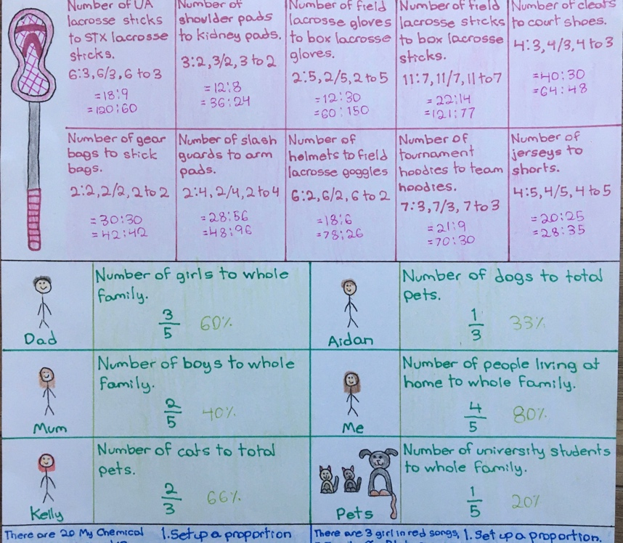
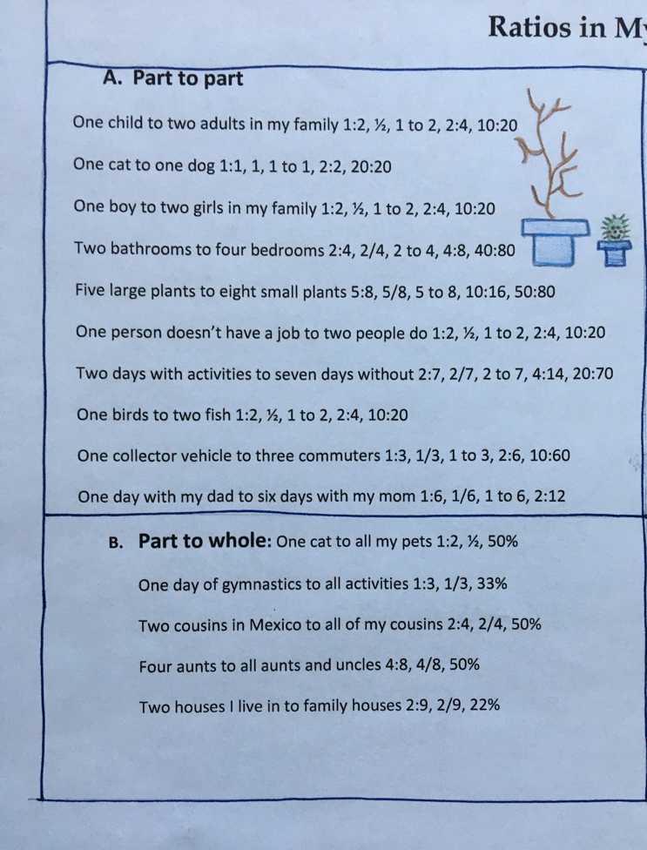

Extending Your Learning (Optional):
- Include pictures or drawings of the items in your ratios.
- For your Part-to-Whole ratios, try turning your ratios into a Percent (Ex: blue LEGO bricks to all LEGO bricks is 124/345, so 36% are blue LEGO bricks)
- Create a minimum of 3 ratio / proportion word problems (ex. Map scale, paint mixtures, ice tea mixed with water) Write these problems out and provide a step by step solution with an answer. (You could google some ratio/proportion word problems to try and get some ideas)

