Grade 9 Math April 29 - May 5

It is incredible that we are on Week 4 of online learning already, isn’t it? We are hoping that you have now found a routine that works for you. Many of you are doing really well on the assignments which is great to see. For those of you that are struggling for any reason at all, please reach out to your teacher and share your situation, as it only gives a better understanding of how we can support you through this difficult time for learning.

Please ensure you read all of the information below before starting.

This week Mr. Crerar, Mr. Conne and Mrs. Switzer’s math classes will continue working on Exponents. We will continue following a similar format to the previous weeks with a basic assignment, mandatory for all Math 9 students, and the ‘extending your learning’ opportunities which are provided to those who want to go beyond the minimal requirements, to practice and refine their skills to further prepare themselves for Math 10 and/or raise their grade in Math 9.

Learning Intentions:
- Students will be able to successfully simplify and solve equations with exponents that require multiple operations

Assignment Instructions:
General Instructions:
- Students will complete the warm-up questions
- Students will follow the instructions and examples from Exponents - Combined Operations Notes
- Students may supplement their learning from the instruction and examples below
- Students will complete all of exercises from Exponents - Combined Operations Practice Questions
- Students will communicate their progress back to their teacher
Specific Instructions:
Start by completing the warm-up questions (pg. 5). Then review the Exponents - Combined Operations Notes (pg. 6-7) and complete all of the practice questions from Exponents - Combined Operations Practice Questions (pg. 8-9). Use the supplement instruction if you need it.

Remember to always show your work so that the reader understands how you reached the answer you did. For this exponents unit here are some tips for solving questions:
- Identify which exponent laws apply to the question.
- Apply the laws to simplify the expression.

Try the “extending your learning” questions if you can. It shows not just your math abilities but your work ethic. Completing some or all of these questions may give you the opportunity to improve your skills and ultimately increase your grade in the class.

Supplementary Instruction and Examples:
Below are some great resources that show examples of the concepts covered this week. If you need some extra help start with the Khan Academy video. Show your teacher evidence (eg. written summary or practice questions) that you completed any of the suggested questions to get credit for extra work.

- Watch this Khan Academy video on multiplying and dividing powers (https://www.khanacademy.org/math/algebra/x2f8bb11595b61c86:rational-exponents-radicals/x2f8bb11595b61c86:exponent-properties-review/v/multiplying-and-dividing-powers-with-integer-exponents)

- Read through this page on mathplanet, paying special attention to the video example at the bottom (https://www.mathplanet.com/education/algebra-1/exponents-and-exponential-functions/properties-of-exponents).
- Check out these real world applications of exponential functions (http://www.algebralab.org/lessons/lesson.aspx?file=Algebra_ExponentsApps.xml)

- Read through the Lumen Learning page on beginning algebra out of algebraic equations and do the example questions provided on that page (with pen and paper) and check answers. Click "try another question" until you are confident in your abilities.
(https://courses.lumenlearning.com/suny-beginalgebra/chapter/read-terms-and-expressions-with-exponents/)
If you need or want assistance on the assignment provided below, we are offering ‘office hours’ using the platform ‘Zoom’ twice per week with one of the four Math teachers: Mr. Kyle Conne, Mr. Bill Crerar, Mrs. Soleil Switzer, and Mrs. Susan Barton. If you wish to speak directly with your Math 9 teacher, please do not hesitate to email them at any time and they will respond in a timely manner. It is highly encouraged that you work on math during office hours if possible that way you can ask questions in real time if needed.

Office Hours: April 29 - May 5 (via ZOOM):
Office hours are an optional, drop-in session that give students a chance to ask questions to a teacher, to interact and work with their peers, or just to stop in and say hi to a friend or teacher. There will be no set lessons for these times, but rather, we will be trying to help students with whatever they need help with.

Zoom is a free, easily accessible platform for conference calling. Access Zoom at https://zoom.us/join.
Time - 2:00pm to 3:00pm
- Thursday, April 30 - Mrs. Switzer
Meeting ID: 822 3374 7784
Password: 8npdsR

Time - 11:00am to 12:00pm
- Tuesday, May 5 - Mrs. Susan Barton
Meeting ID:965-5141-6172
Password:8ydUnU

Please note Zoom etiquette:
- You are not required to turn on your video (although it will be nice to see your face again!) but make sure your audio is on. If you are having connection issues turn your own video off.
- Please mute yourself if you are not speaking. If there are a lot of users there can be quite a bit of background noise.
- If you click "participants" under the videos you will get a popup on the right. There is a button there where you can raise your hand if you have a question. Remember to "lower" your hand once you've asked your question.

Submitting your work:
Please submit completed work by Tuesday, May 5, 2020 via Office 365 or by email to your specific teacher. This may include attaching a word or pdf document, or taking a picture of your completed work. Please save your file in the following format: “Name_Math 9 #4” (ex: John Doe_Math 9 #4.docx), if you have more than one file use a letter following the number to distinguish between them (ex: John Doe_Math 9 #4a.docx).

Mr. Crerar’s class can continue to submit assignments as has been done previously but send them to bcrerar@sd79.bc.ca.

Criteria / Rubric:
This assignment will be assessed by your teacher using the rubric below. In addition, you should use the rubric to self-evaluate by including a statement such as this “In this assignment, I feel that I am proficient, because______”. Also include how long it took you to complete the assignment.

Proficiency Scale | Extending | Proficient | Developing | Emerging
Description | The students work meets the objective; it is clear, with few or no errors and demonstrates a sophisticated understanding of the concepts and competencies relevant to the learning intentions. | The students work almost meets the objective; it has some errors but demonstrates a good understanding of the concepts and competencies relevant to the learning intentions.. | The students work is in progress; it has some errors and demonstrates a partial understanding of the concepts and competencies relevant to the learning intentions. | The students work does not meet the objectives; it has frequent errors and demonstrates minimal or no understanding of the concepts and competencies relevant to the learning intentions..
Phrase | "I could teach this." | "I have a good understanding." | " I get some of it." | "I don't get it."

Teacher comments:
Your teacher will review your work and provide feedback as quickly as possible. Your teachers prefer that you submit your work through Teams and they will provide feedback in that manner so check into Teams often.

Extending Your Learning (Optional):
- Find the value of 1^{8,} 1^{9,} and 1^{10.} What can you say about the value of any power of 1? Explain the reasoning.
- A solar-powered water pump system in Desert Range, Utah, has two solar panels, each containing 6 rows of modules. Each row has 6 modules. How many modules are in each panel? Write the answer as a power. Then find the total number of modules in the system.
- Your cousin, who washes high-rise windows, is assigned a section of 10 rows of windows. Each row contains 10 windows.
  - How many windows are in the section? Write the answer as a power.
  - Your cousin estimates that it takes 5 minutes to wash one window. How long will the entire job take?
  - Can your cousin complete the job in 8 hours? Explain the reasoning.
- You are enlarging a photo on your computer screen. The photo starts at 3 centimeters wide. Each time you enlarge the photo, its width is doubled. You enlarge the photo four times. What is the final width of the photo on your screen?
- 5) On Tuesday, you invited 2 friends to your party. On Wednesday, each of these friends invited 2 other friends. This pattern continued Thursday and Friday. How many people were invited on Friday? Write the answer as a power. How many people were invited in all? Explain the reasoning.

Grade 9 Math April 29 - May 5
Review and Warm-up

Remember these exponential rules!
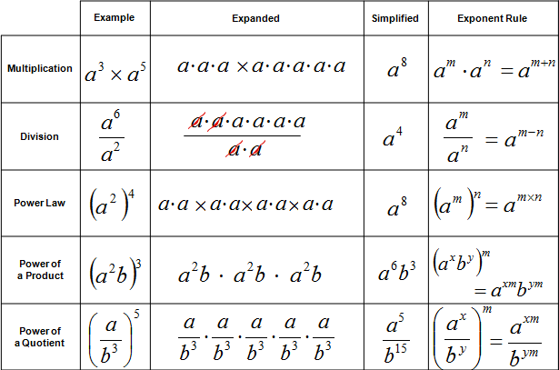
*******************Don’t forget that a = a¹********************

Now try two of these warm-up games and questions.
- Exponent Multiplication Game - Pyramid style of questions, where questions get increasingly harder and are worth more.
- Dig and Explore Exponents - Choose an image, select a square, answer questions that come up to reveal your find. It may not work on a tablet if you don’t have adobe flash player, don’t worry if you can’t access it just try one of the other options.
- Negative Exponents Review and Questions - Quickly read through the information and then try the 10 questions at the bottom of the page.

Grade 9 Math April 29 - May 5
Exponents Part 1 - Combined Operations Notes

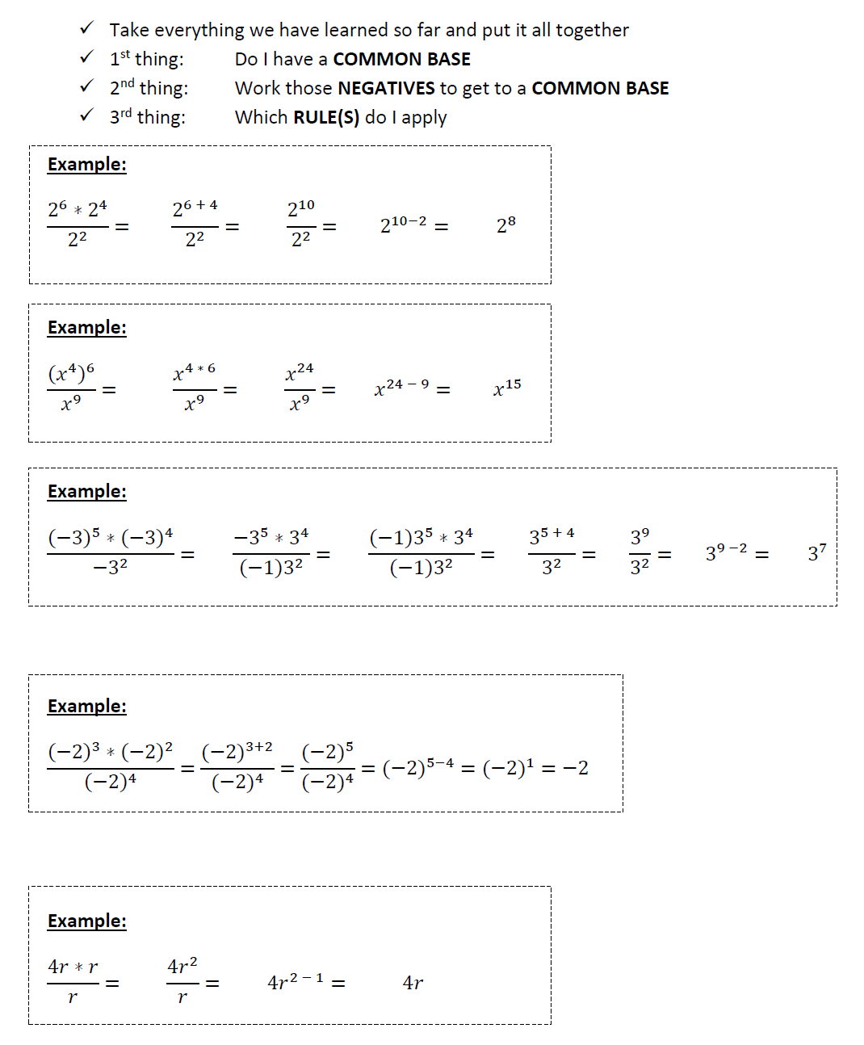

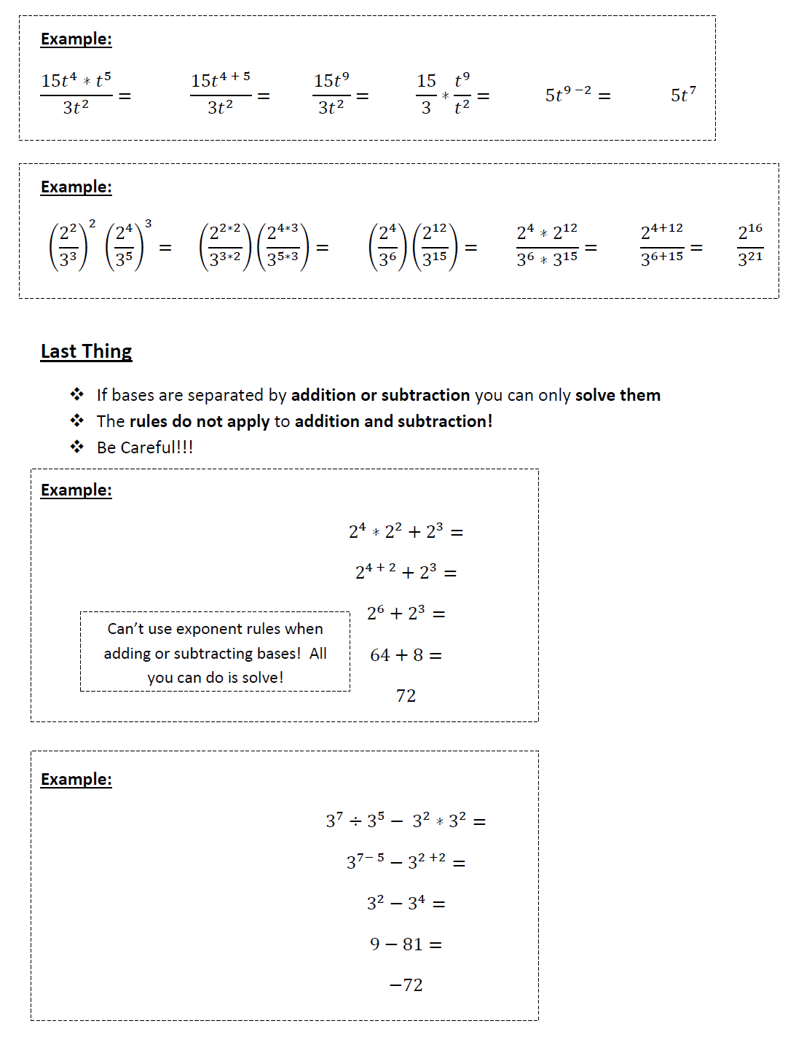

Math April 29 - May 5
Exponents Part 1 - Combined Operations Practice Questions

