Grade 9 Math April 15-21

Please ensure you read all of the information below before starting.

Hey Livingstone’s students. You’ll be brushing up on your knowledge of rational numbers (fractions) this week. After this week, it is expected that you know how to perform operations with fractions and clear them from equations. This is a no calculator week. We don’t want to turn fractions into long decimal numbers, we want to leave them as fractions.

Learning Intentions:
- be able to add, subtract, multiply, and divide fractions
- understand fractions as; a ratio between two numbers, a division operation, and a number unto itself, and be comfortable switching conceptually among these roles
- place fractions on a number line, and depict operations with fractions using a numbers line
- reduce fractions to lowest terms and find the lowest common multiple to use when clearing fractions
- converting common decimals into fractions, and vice versa
- use the order of operations to solve equations including fractions

Assignment Instructions:
General Instructions:
- Do the work
- If you are having trouble doing the work, read the notes. If the notes are confusing, see some of the resources in the Fractions section of the “Assignment page” of livingstonemath.weebly.com
- If you are still having trouble, email me with a specific question and I’ll give you a specific answer
- When you are done, or when you are too frustrated to continue, email me a link, pic, or doc of your assignment and I’ll give you feedback along with an answer key
Specific Instructions:
- Every day start out with a warm-up question, which you’ll find below. I’ll post the answer on my site around noon. Don’t spend more than ten minutes on the warm-up, it’s just to get your mind limber.

- Work for about 50 minutes on the questions. Do odd questions only. If something is very easy, move on to the next section. Math is about learning, not filling pages.

- Take a ten-minute rest after you are done. Don’t stare at your phone, stare at a wall instead, or better yet, go for a walk around the block. This will help to solidify what you’ve learned.

- Having trouble? Read the notes, then ask a classmate, me, google, or Sal Khan. Don’t bug your parents.

Office Hours

Thursday, April 23, 2-3

Tuesday, April 28th, 2-3

Meeting ID: 911 756 1566
Password: 757436

I have separated the notes from the questions. The document is organized like this: warmup questions for each day, then assignment questions, then notes. Again, do odd questions only

Warmup Questions
Wednesday’s warmup:
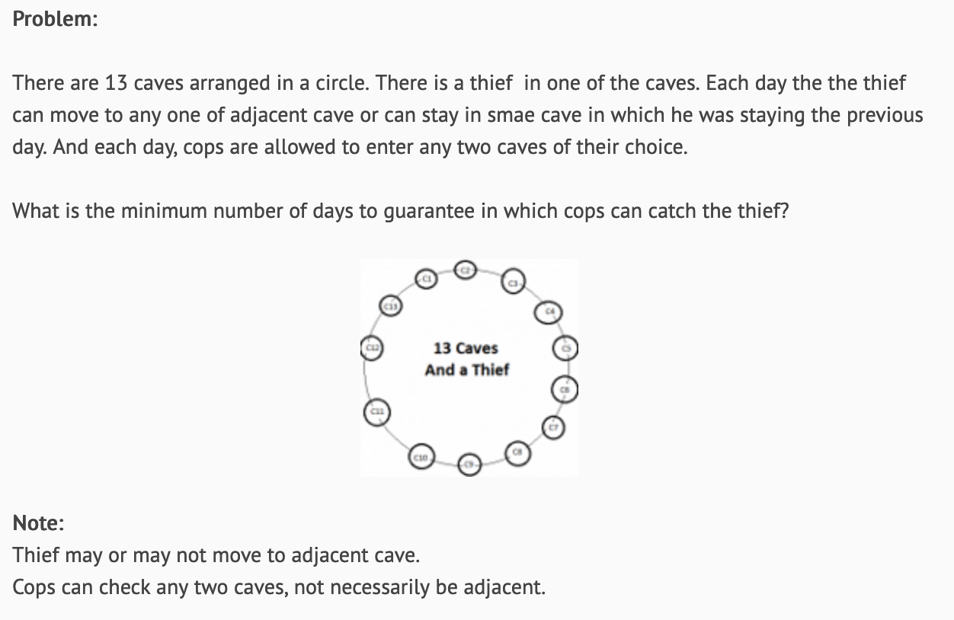
Hint: the key word here is “guarantee

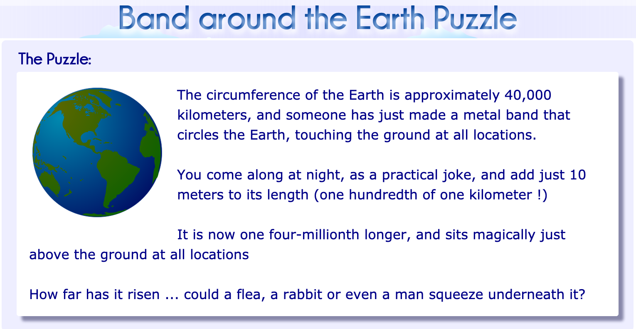
Thursday’s warmup:

Friday’s warmup:
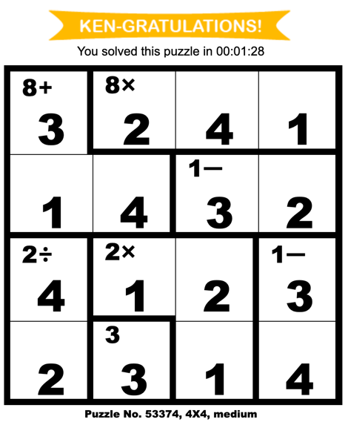
Go onto https://www.kenkenpuzzle.com/howto/solve and learn how to play this simple math game that is a bit like sudoku. Generate a puzzle for yourself under the “play” tab and see if you can solve it. Send me a screen shot if you do. I’ll post the top 3 achievers on my site for the week.
Figure 1. My first game

Monday’s Warmup:
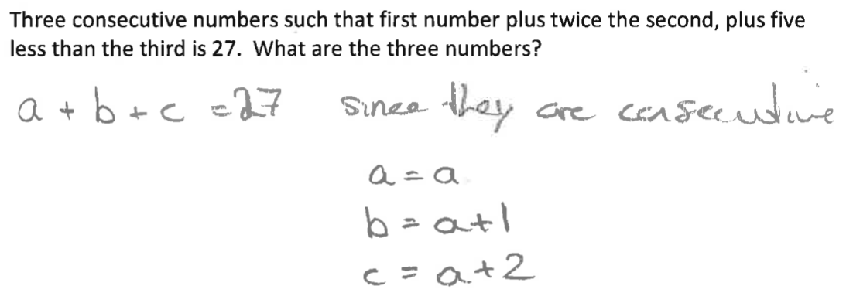
(with a hint to get you started)

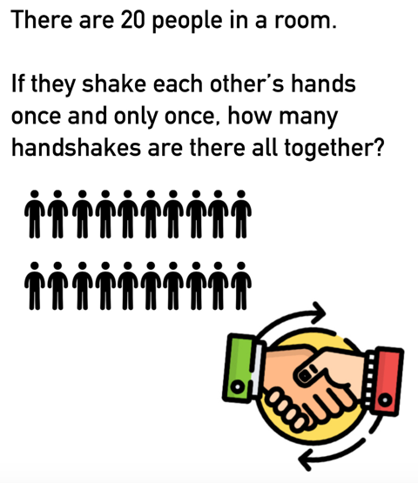
Tuesday’s warmup:

Assignment Questions

Thanks to Adrian Herlaar of SD61 for putting together the package from which questions and notes are drawn.
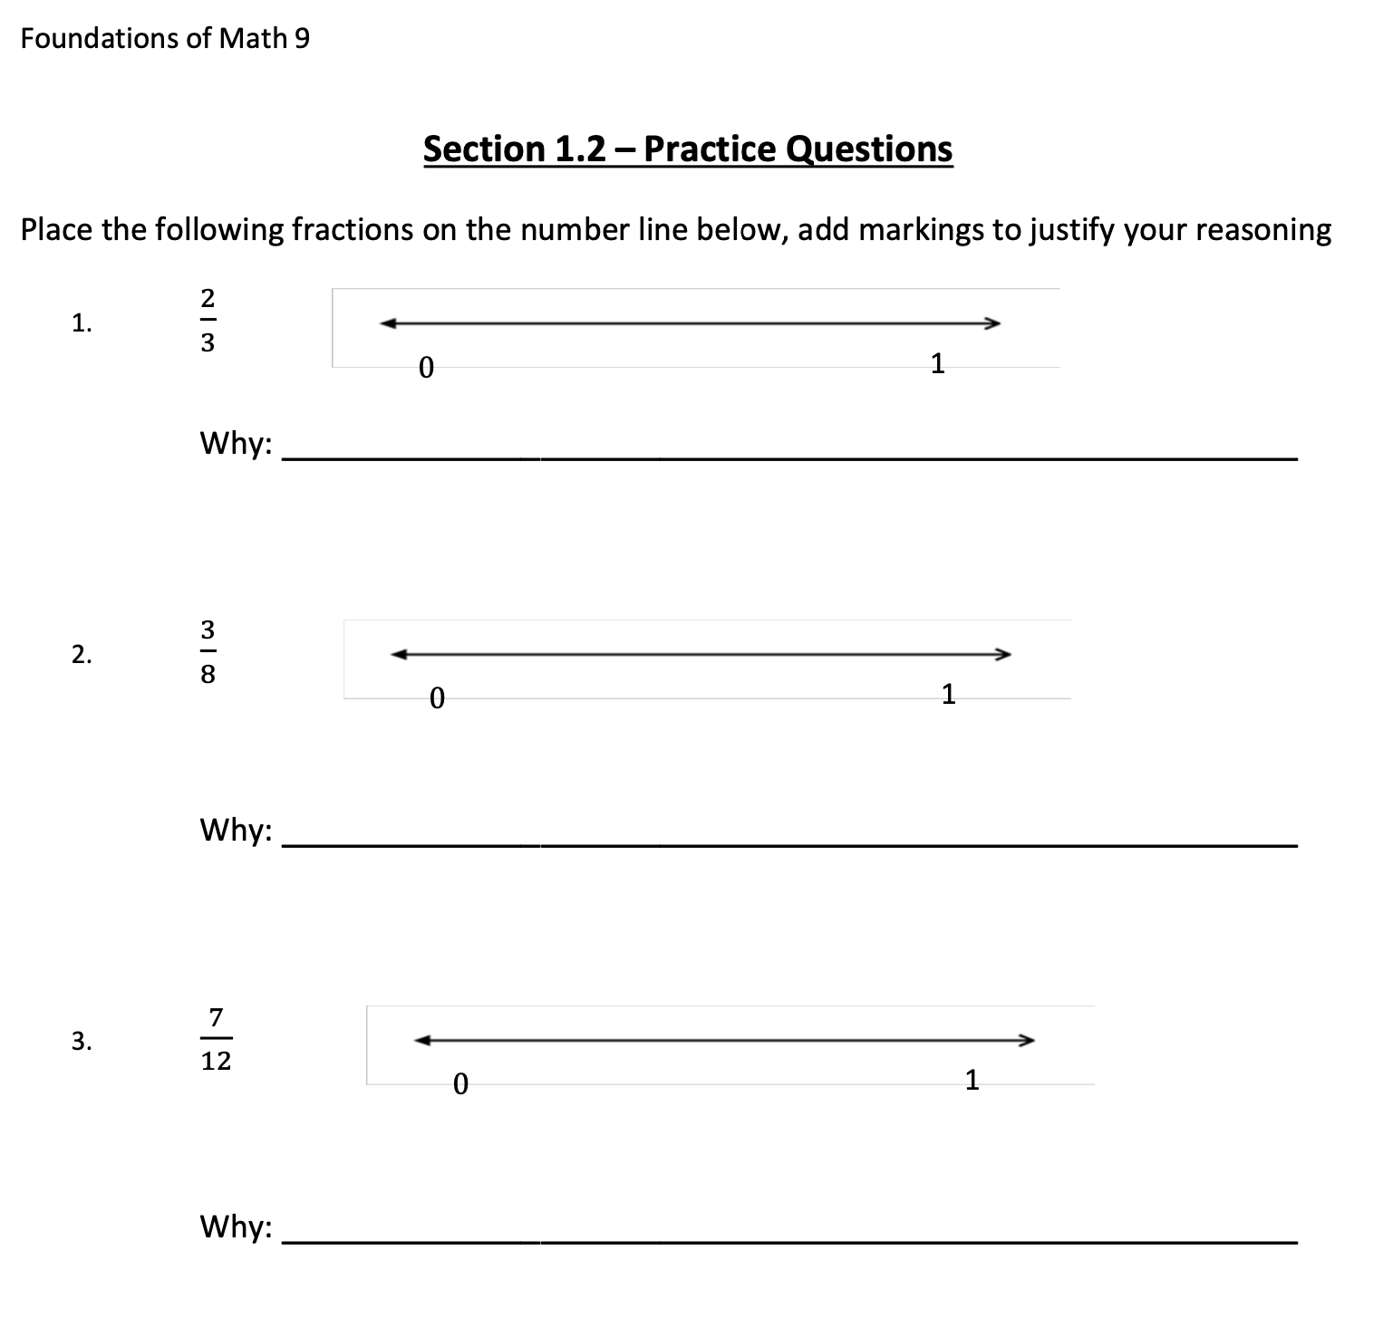
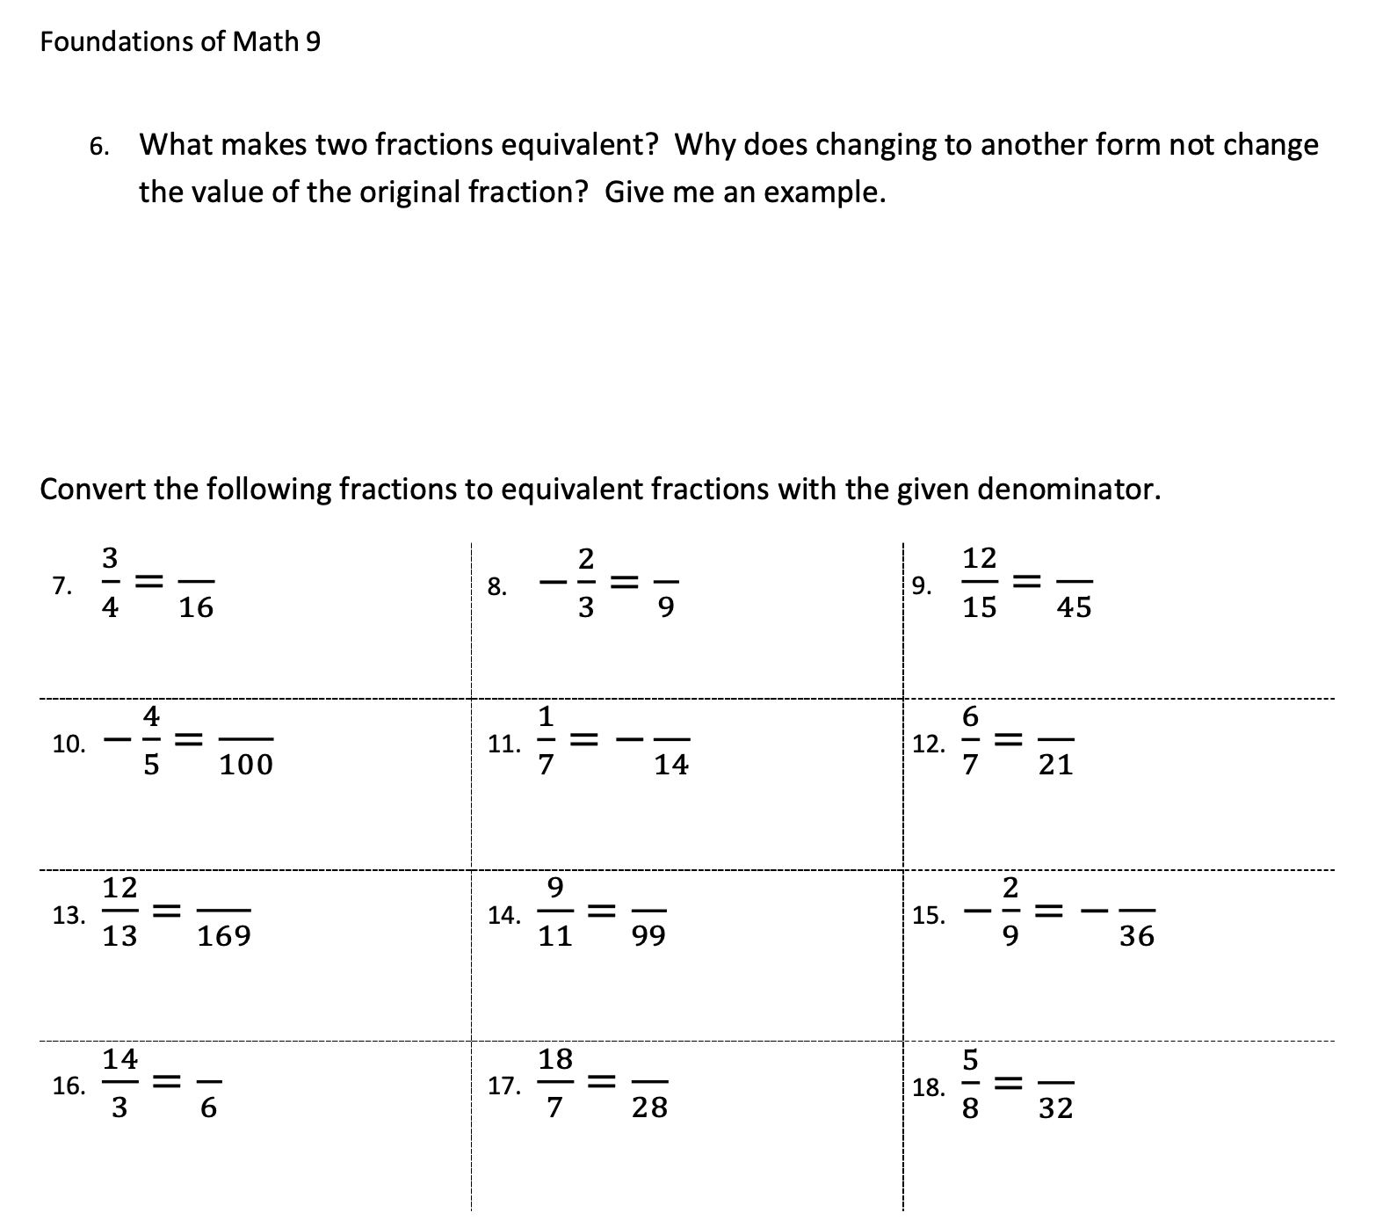

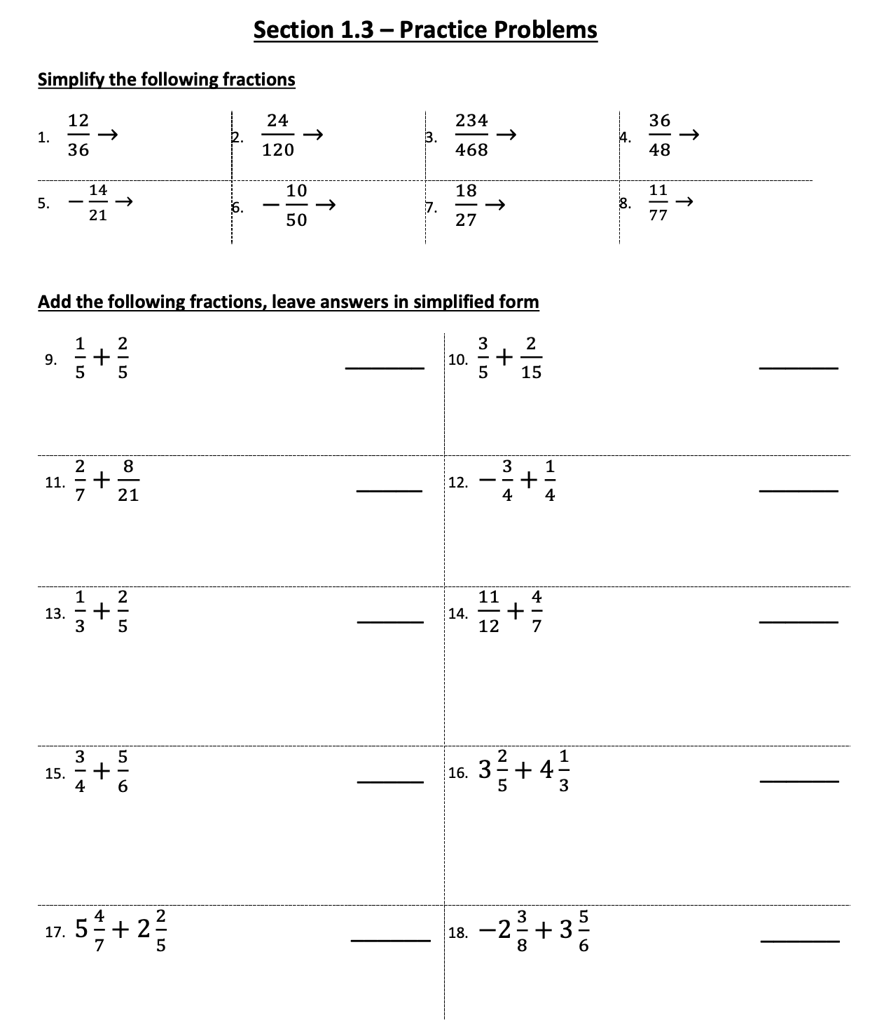

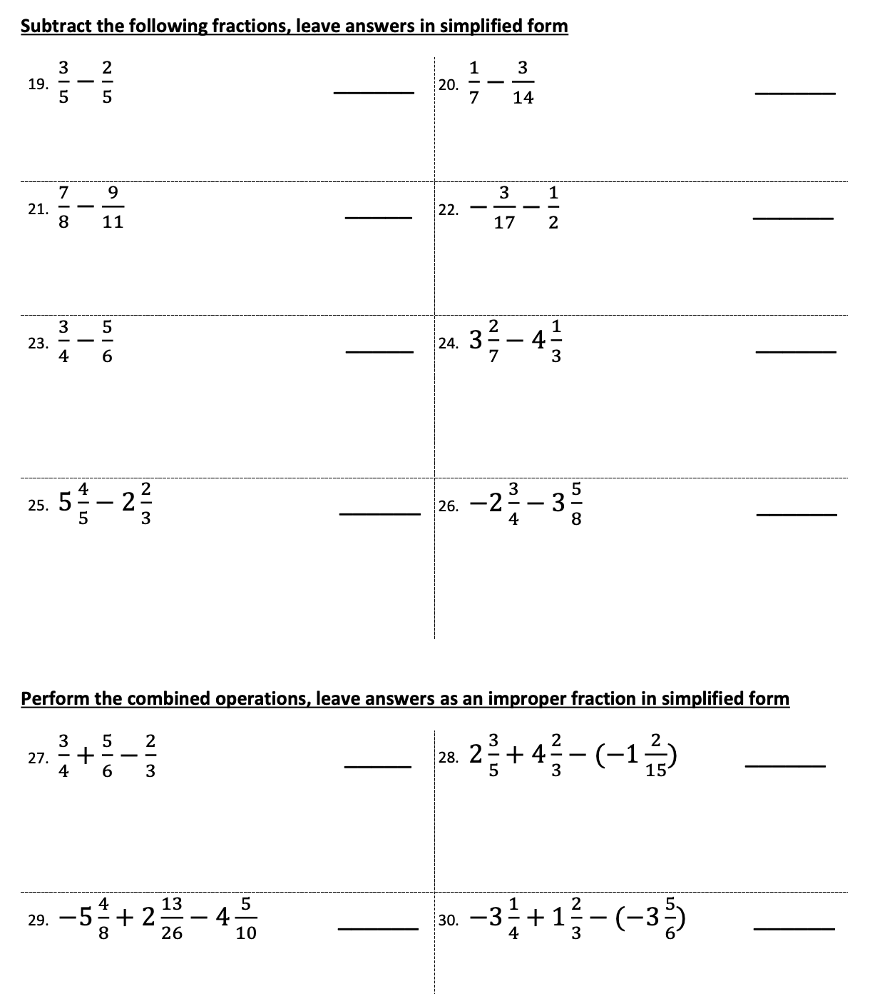

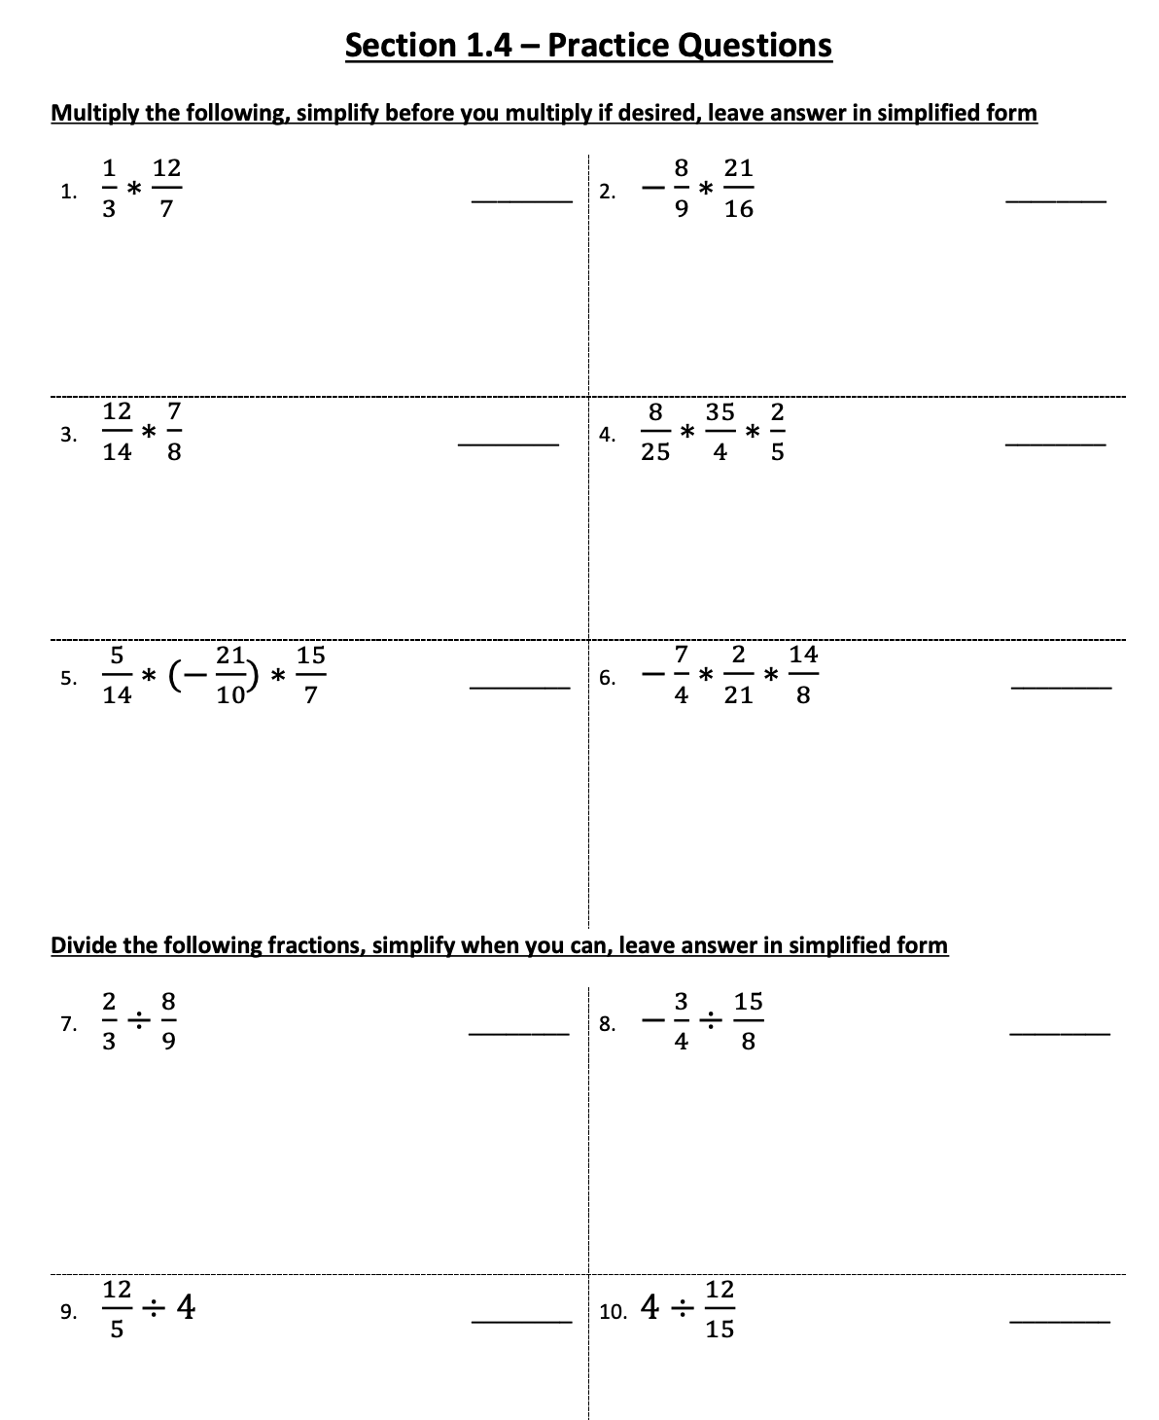

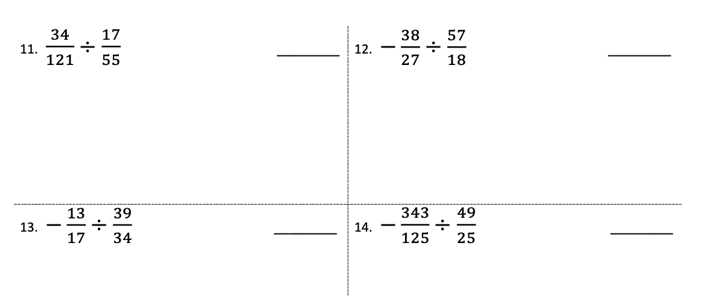
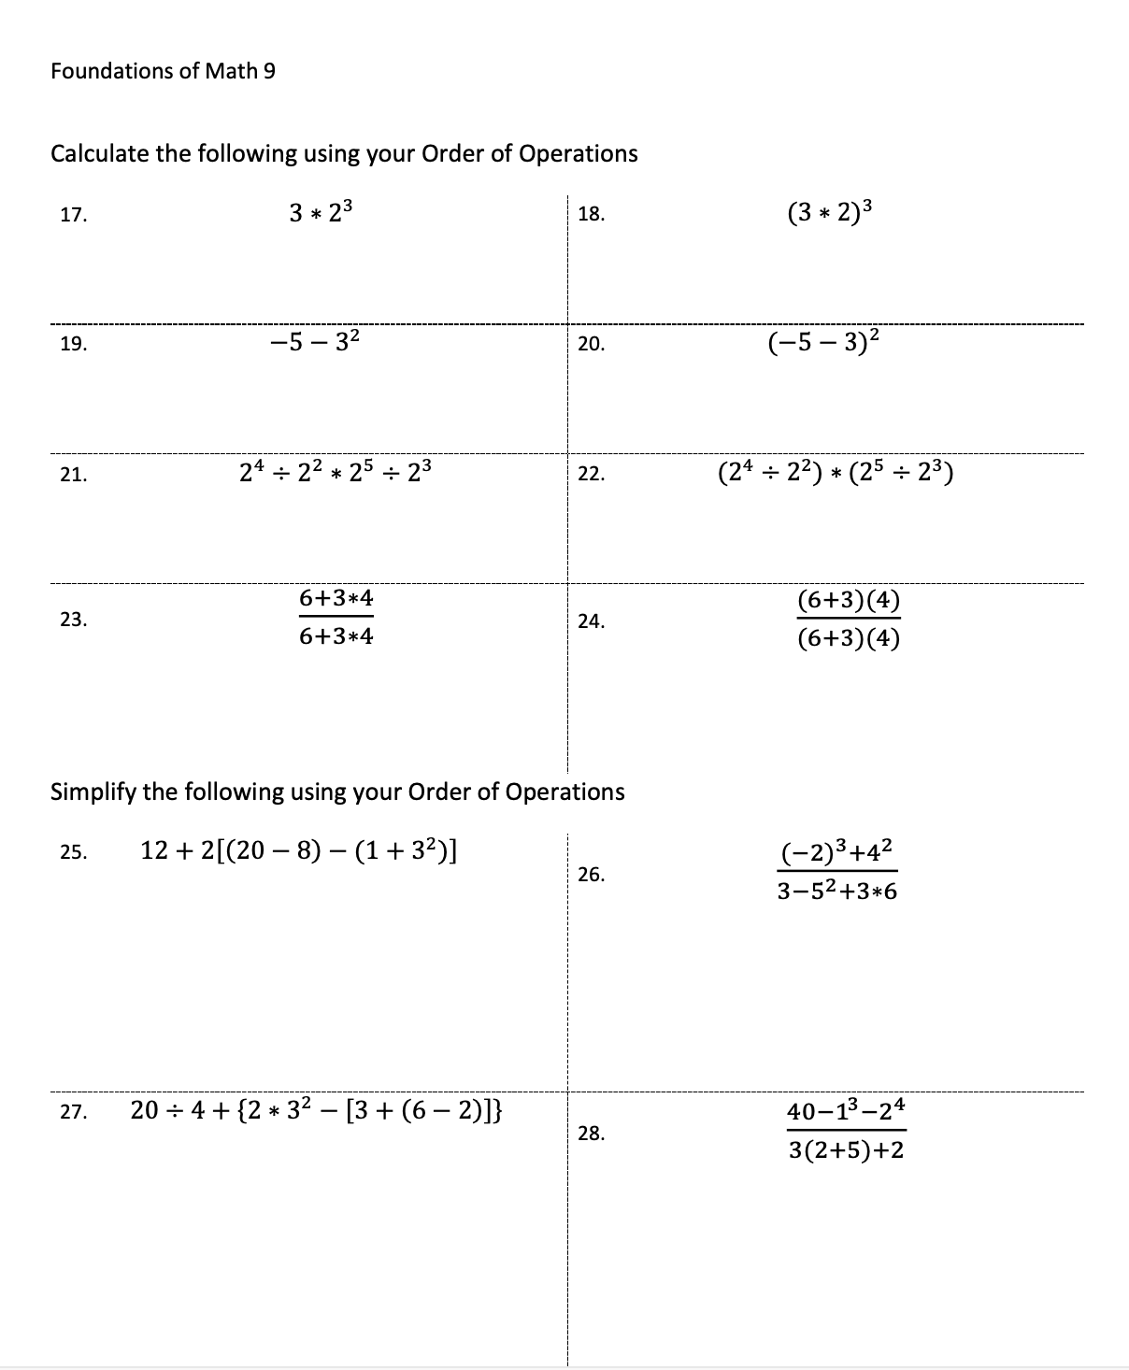

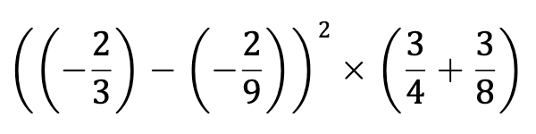
29.

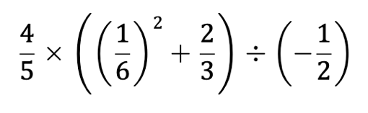
30.

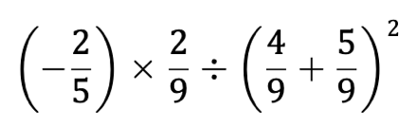
31.

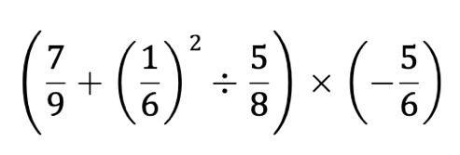
32.

