Grade 9 Math April 22-28

We sure hope that everyone has started to settle into some routine with their learning over the last two weeks. Let’s remember that this is a new way of learning for all of us. Please communicate with your teachers if you are having any issues with technology or the lessons.

Please ensure you read all of the information below before starting.

For the next couple of weeks, different math classes will be covering different topics. Mr. Conne and Mrs. Switzer’s math classes will be working on Exponents. Similar to the previous weeks there is a basic assignment, mandatory for all Math 9 students, and the ‘extending your learning’ opportunities are offered to those who want to go beyond the minimal requirements, to practice and refine their skills to further prepare themselves for Math 10 and/or raise their grad in Math 9.

Learning Intentions:
- Students will be able to successfully recognize exponents associated with positive and negative bases
- Students will be able to use the multiplication and division exponent rules to solve equations with coefficients (numbers only) and variables (letters too)
Assignment Instructions:
General Instructions:
- Students will complete the warm-up questions
- Students will follow the instruction and examples from Exponents - Understanding Exponents Notes and Exponents - Multiplication and Division Rules Notes
- Students may supplement their learning from the instruction and examples below
- Students will complete a minimum of the odd exercises from each of Exponents - Understanding Exponents Practice Questions and Exponents - Multiplication and Division Rules Notes Practice Questions
- Students will communicate their progress back to their teacher
Specific Instructions:
Start by completing the warm-up questions (pg. 5). Then review the Exponents - Understanding Exponents Notes (pg. 6-8) and complete a minimum of the odd practice questions from Exponents - Understanding Exponents Practice Questions (pg. 9-10). Next review the Exponents - Multiplication and Division Rules Notes (pg. 11-16), use the supplement instruction if you need it, and then complete a minimum of the odd practice questions from Exponents - Multiplication and Division Rules Practice Questions (pg. 17-19). Do the even questions as well if you are willing and able. By completing all the questions students may have the opportunity to improve their grade in the course. Ensure you finish by completing the self-assessment.

Remember to always show your work so that the reader understands how you reached the answer you did. For this exponents unit here are some tips for solving questions:
- Identify which exponent laws apply to the question.
- Apply the laws to simplify the expression.

Try the extending your learning questions if you can, it shows not just your math abilities but your work ethic. Completing some or all of these questions may give you the opportunity to raise your assessment to extending and ultimately increase your grade in the class.

Supplementary Instruction and Examples:
Below are some great resources to show other examples of the concepts covered this week. Show your teacher evidence (eg. written summary or practice questions)that you completed any of the suggested questions to get credit for completion.

- Watch this Khan Academy video on multiplying and dividing powers (https://www.khanacademy.org/math/algebra/x2f8bb11595b61c86:rational-exponents-radicals/x2f8bb11595b61c86:exponent-properties-review/v/multiplying-and-dividing-powers-with-integer-exponents)

- Read through the Laws of Exponents from Math is Fun (https://www.mathsisfun.com/algebra/exponent-laws.html)

- Read through this page on mathplanet, paying special attention to the video example at the bottom (https://www.mathplanet.com/education/algebra-1/exponents-and-exponential-functions/properties-of-exponents).
- Practice with the 4 problems at the end of this page by Saddleback College (https://www.saddleback.edu/faculty/lperez/algebra2go/begalgebra/reals/b001.pdf).
- Try these questions from Khan Academy
(https://www.khanacademy.org/math/algebra/x2f8bb11595b61c86:rational-exponents-radicals/x2f8bb11595b61c86:exponent-properties-review/e/exponent_rules)

- Read through the Lumen Learning page on beginning algebra out of algebraic equations and do the example questions provided on that page (with pen and paper) and check answers. Click "try another question" until you are confident in your abilities.
(https://courses.lumenlearning.com/suny-beginalgebra/chapter/read-terms-and-expressions-with-exponents/)
If you need or want assistance on the assignment provided below, we are offering ‘office hours’ using the platform ‘Zoom’ twice per week with one of the four Math teachers: Mr. Kyle Conne, Mr. Aaron Livingstone, Mrs. Soleil Switzer, and Mrs. Susan Barton. If you wish to speak directly with your Math 9 teacher, please do not hesitate to email them at any time and they will respond in a timely manner. It is highly encouraged that you work on math during these times if possible that way you can ask questions in real time if needed.

Office Hours: April 22 - 28 (via ZOOM):
Office hours are an optional, drop-in session that give students a chance to ask questions to a teacher, to interact and work with their peers, or just to stop in and say hi to a friend or teacher. There will be no set lessons for these times, but rather, we will be trying to help students with whatever they need help with.

Zoom is a free, easily accessible platform for conference calling. Access Zoom at https://zoom.us/join.
Time - 2:00pm to 3:00pm
- Thursday, April 23 – Mr. Livingstone
Meeting ID: 911 756 1566
Password: 757436
Time – 2:00pm to 3:00pm
- Tuesday, April 28 – Mr. Conne
Meeting ID: 911 756 1566
- Password: 757436

Please note Zoom etiquette:
- You are not required to turn on your video (although it will be nice to see your face again!) but make sure your audio is on. If you are having connection issues turn your own video off.
- Please mute yourself if you are not speaking. If there are a lot of users there can be quite a bit of background noise.
- If you click "participants" under the videos you will get a popup on the right. There is a button there where you can raise your hand if you have a question. Remember to "lower" your hand once you've asked your question.

Submitting your work:
Please submit completed work by Tuesday, April 28, 2020 via Office 365 or by email to your specific teacher. This may include attaching a word or pdf document, or taking a picture of your completed work. Please save your file in the following format: “Name_Math 9 #3” (ex: John Doe_Math 9 #2.docx), if you have more than one file use a letter following the number to distinguish between them (ex: John Doe_Math 9 #2a.docx).

Criteria / Rubric:
This assignment will be assessed by your teacher using the rubric below. In addition, you should use the rubric to self-evaluate by including a statement such as this “In this assignment, I feel that I am proficient, because______”. Also include how long it took you to complete the assignment.

Proficiency Scale | Extending | Proficient | Developing | Emerging
Description | The students work meets the objective; it is clear, with few or no errors and demonstrates a sophisticated understanding of the concepts and competencies relevant to the learning intentions. | The students work almost meets the objective; it has some errors but demonstrates a good understanding of the concepts and competencies relevant to the learning intentions.. | The students work is in progress; it has some errors and demonstrates a partial understanding of the concepts and competencies relevant to the learning intentions. | The students work does not meet the objectives; it has frequent errors and demonstrates minimal or no understanding of the concepts and competencies relevant to the learning intentions..
Phrase | "I could teach this." | "I have a good understanding." | " I get some of it." | "I don't get it."

Teacher comments:
Your teacher will review your work and provide feedback in the form you sent your assignment to them. If submitting through Office 365, check your document again within a few days to see your teacher’s feedback on your work if you haven’t received notification.

Extending Your Learning (Optional):

1. E-coli bacteria can reproduce at a rate quick enough that a colony will double in size (therefore number of individual bacteria) every 20 minutes. If a colony of e-coli starts with 150 individual bacteria, how many bacteria will be in the colony after 2 hours? How many bacteria will there be in the colony after half an hour?

If a^{b} = c, then $\sqrt[b]{c}=a$

We call this idea a “root” or a “radical”. Eg.

2⁴ = 2 x 2 x 2 x 2 = 16 and $\sqrt[4]{16}=2$

3³ = 3 x 3 x 3 = 27 and $\sqrt[3]{27}=3$

So, if we ask a question such as “Find $\sqrt[4]{2401}$ “, what this question is asking us is “what is some number n, where n x n x n x n = 2401?” Here, there are 4 ns, because we are looking for the 4th root of n.

On your calculator, you will have a button that looks like or maybe $\sqrt[x]{ y }$ that will find this number for you.

If we don’t, we can always guess and check. Eg.
$$\sqrt[4]{2401}= ?$$
___ x ___ x ___ x ___ = 2401
2 x 2 x 2 x 2 = 16, much too small
10 x 10 x 10 x 10 = 10 000, much too big
6 x 6 x 6 x 6 = 1296, so either 7, 8 or 9
7 x 7 x 7 x 7 = 2401!
This means that$\sqrt[4]{2401}= 7$

Try finding the roots of the questions below:

1) $\sqrt[2]{196}$ = 2) $\sqrt[2]{289}$ =

3) $\sqrt[3]{216}$ = 4) $\sqrt[3]{1331}$ =

5) $\sqrt[4]{81}$ = 6) $\sqrt[4]{625}$ =

7) $\sqrt[5]{32}$ = 8) $\sqrt[6]{729}$ =

Grade 9 Math April 22-28
Warm-up

Read the following information and then complete the practice questions.

Term = the values on which the mathematical operations take place in an expression; can be a constant or variable or both in an expression
Constant = a number on its own; has a fixed value
Coefficient = a number before a variable
Variable = an unknown, generally represented by a letter

Base Number = the number that gets multiplied with an exponent
Exponent/Power = how many times to multiply the base value by itself; represented as a symbol above and to the right of the base number

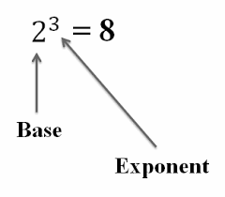
Expression = number, variable, or combination of numbers and variables with an operation (+, -, etc)
Equation = two expressions connected by an equal sign

Questions:

Determine if each is an expression or an equation and then indicate what each number or letter would be called given the definitions above.

- 16 - 6 = 10

- 3³

- y ➗ 25

- 2y + 8 = 40

- 4² + 2² =

Grade 9 Math April 22-28
Exponents Part 1 - Understanding Exponents
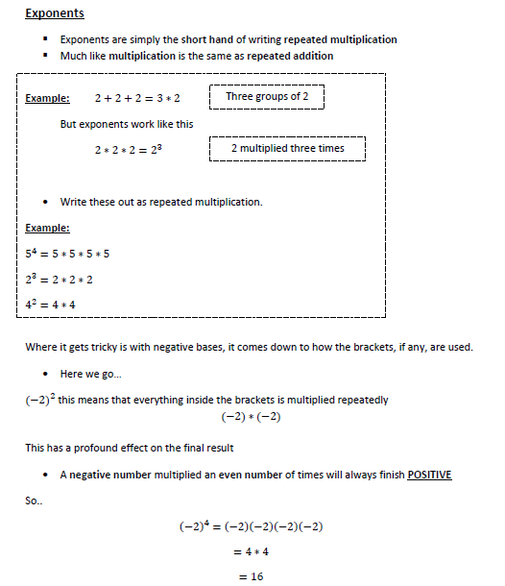

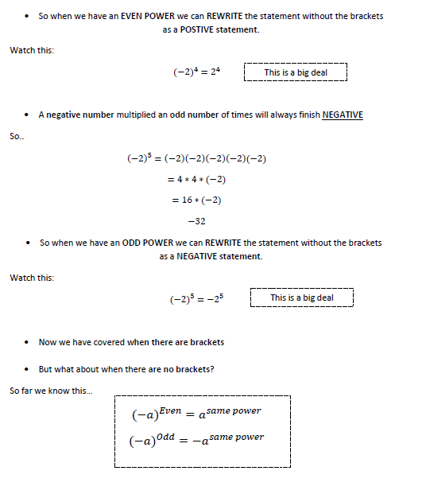

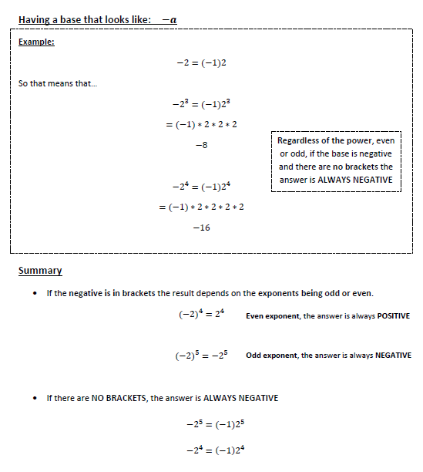

Grade 9 Math April 22-28
Exponents Part 1 - Understanding Exponents Practice Questions

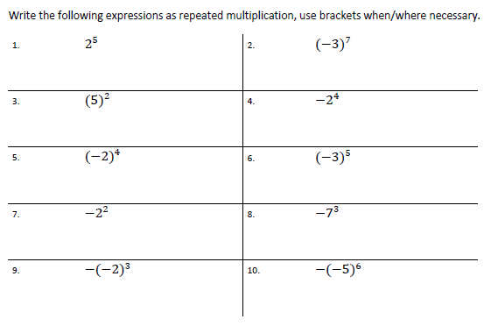
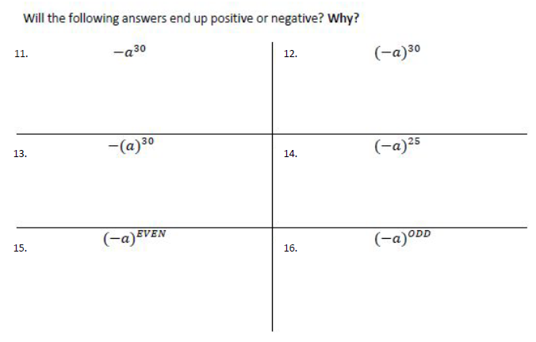

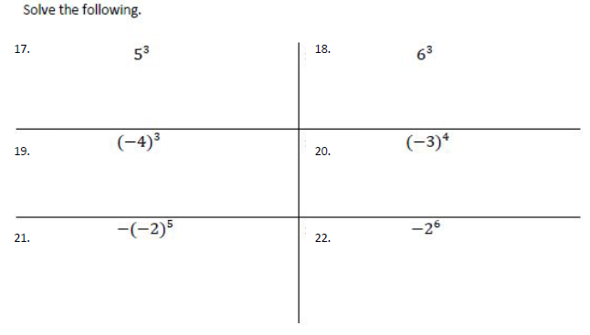

Grade 9 Math April 22-28
Exponents Part 1 - Multiplication and Division Rule Notes

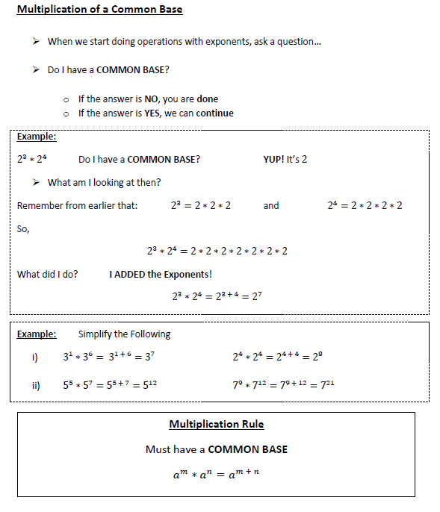

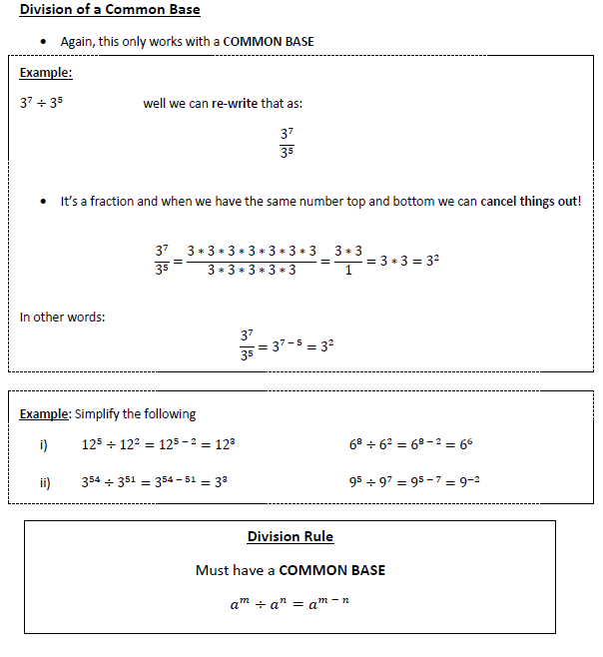

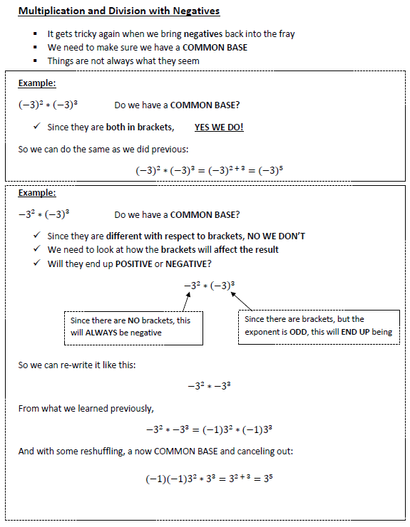
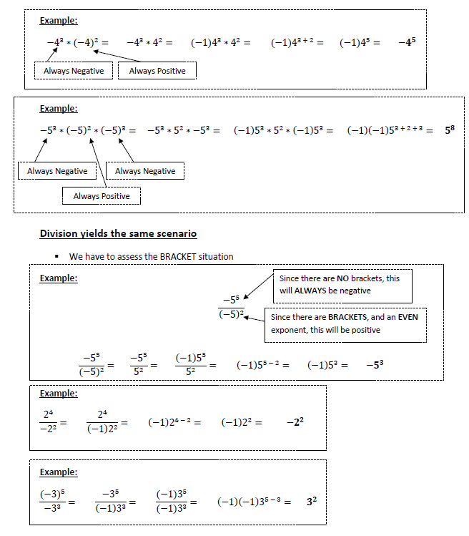
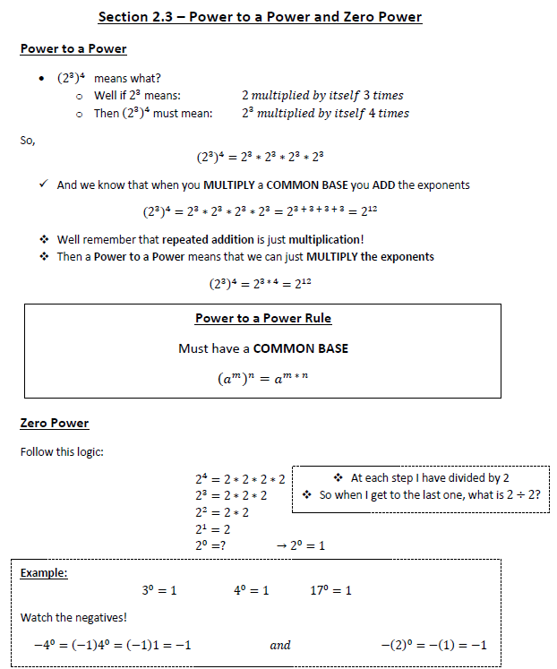
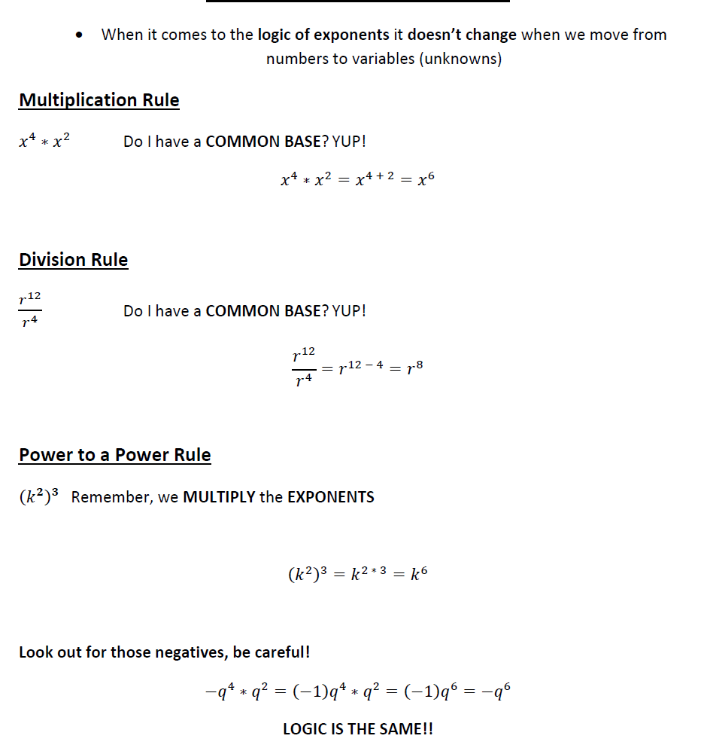

Grade 9 Math April 22-28
Exponents Part 1 - Multiplication and Division Rule Practice Questions

Simplify the following, leave answer in Exponential Form.
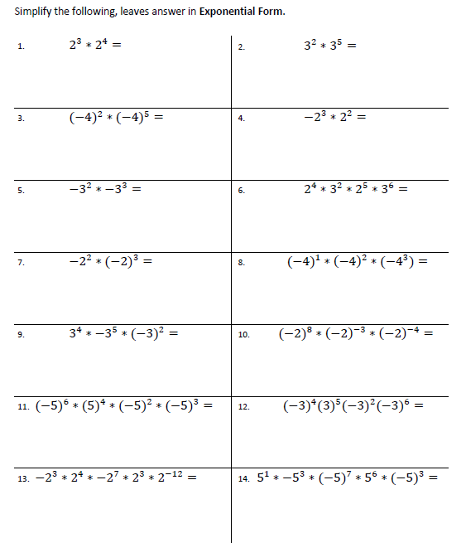

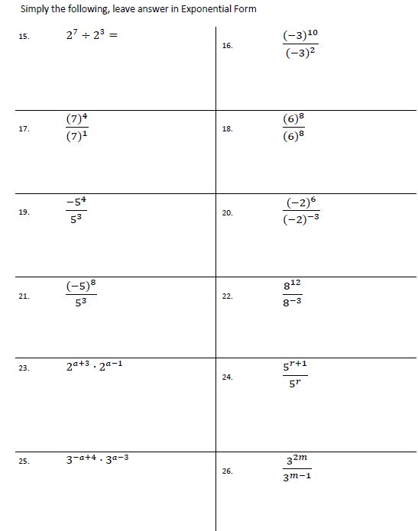

Simplify the following, leave answer in Exponential Form.
