Quamichan Grade 8: Science
Week #2 - April 15-21

Learning Intentions:
- To investigate the features of a wave.
- To investigate frequency and wavelength.
- To continue the process of online learning in this new setting (completing the assignment and sending back to your Science Teacher in a receivable format).

Assignment Instructions:
- Read the attached section (4.1) of the BC Science 8 Textbook.
  - Note: Section 4.1 can also be accessed via this link: https://drive.google.com/drive/folders/0B3EbWHKwTyj2VUJVTDRHNHBPeEE
- Complete the work sheet “Grade 8 Science: Features of a Wave”
  - This worksheet is included as a word document and will also be available in your Class Notebook.
  - Send the completed worksheet to your Science teacher using one of the following options:
    - Fill in the worksheet in your Class Notebook on your Office 365 school account online. Ask your teacher for support if you are not able to access your Class Notebook.
    - Type the answers in a document on a phone or computer and attach it to an email to your Science Teacher.
    - Type the answers directly in an email to your Science Teacher
    - Write the answers on a piece of paper, take a quality picture, and email it to your science teacher
- Demonstrate how different waves make different sounds by creating a “music video” with a hard surface and a ruler. Hold the ruler firmly at one end and flick the other end to make a sound (you’ve all done this before). Experiment with different items at different lengths to create a 15 second “song” which you record and send to your teacher. See example here. Note: this video is for example purposes only. Yours will be much better ;)
  - Send the completed ~15 second video to your Science teacher using one of the following options:
    - Insert it in the Science Section of your Class Notebook on your Office 365 school account online. Ask your teacher for support if you are not able to access your Class Notebook.
    - Email it to your Science teacher (making sure that it is only 15 seconds long)
    - Post the video to your you tube account and send your teacher a link to the video
Criteria:
- All questions are completed with complete sentences.
- Questions on worksheet are answered correctly.
- Video demonstrates you can make different pitches of sound by varying wavelengths.

Extending Your Learning (Optional):
- Play an actual song with multiple rulers or one ruler changing length. Think simple like Hot Cross Buns.
- Include an explanation of why the different length of ruler makes a different pitch. Your explanation would talk about wavelengths. This could be written or included in your video.
- Activity 4-1. Watching Water Waves. This optional activity is from the pdf version of your textbook on page 134. You could video this (it may look cool in slow motion) and send a video to your teacher.

Name: ________________ Div. _______ Date: _________
Grade 8 Science:
Week 2: Apr. 15 – 21
Features of a Wave:

Use the vocabulary words below to label the parts of a wave.
- Amplitude
- Crest
- Trough
- Wavelength
- Rest Position
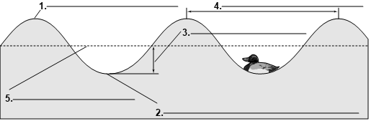

Define each of the terms below:
- Amplitude:
- Crest:
- Trough:
- Wavelength:
- Rest position:

Characteristics of Waves
Use the information in the graphs to answer the questions.

1) How long is the wavelength of the wave below?

2) How large is the amplitude of the wave below?

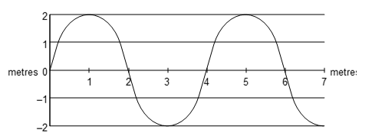

3) Which of the following waves below has the smaller amplitude, A or B?

4) Which wave carries more energy, A or B?

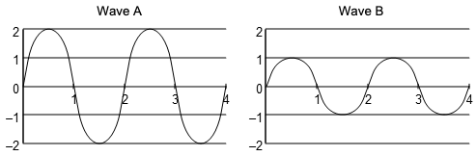

5) What is the same for waves X and Y below: amplitude, wavelength, or frequency?

6) Which wave has a greater frequency, X or Y?

7) Which wave has a longer wavelength, X or Y?

