Introduction to Cell Biology Webquest Student Worksheet

HINT: You may want to watch the videos more than once or pause the video to answer questions.
Part A - What Are Cells?
At the following link, watch the “What Are Cells” video clip by Bill Nye the Science Guy.
As you watch fill in the blanks and answer the following questions.
https://www.youtube.com/watch?v=98hGuTScrjw

- There are approximately ______________________cells are in the human body.
- List 5 types of cells found in the human body:
  - ___________________,
  - ___________________,
  - ___________________,
  - ___________________,
  - ___________________.
- Cells are similar to bricks in a brick wall because ______________________________ _____________but different because________________________________________.

Part B - How Are Prokaryotic and Eukaryotic Cells Different?

At the following link, watch the “Introduction to Cells - The Grand Tour” video by The Amoeba Sisters. As you watch fill in the blanks and answer the following questions.
https://www.youtube.com/watch?v=8IlzKri08kk
- List the 3 parts of the Modern Cell Theory:
  - __________________________________________________________,
  - __________________________________________________________,
  - __________________________________________________________.
- What 2 major groups are cells divided into:
  - ______________________ b) ______________________________.
- What 4 things do both eukaryotes and prokaryotes contain?
  - _________________________,
  - _________________________,
  - _________________________,
  - _________________________.

- Prokaryotes have NO __________________ or _____________________________ which eukaryotes DO have (PRO=NO and EU=DO).
- Ribosomes make ___________________ and can be found in the _________________ of eukaryotes.
- Endoplasmic reticulum attaches to the nuclear membrane, is involved in the ____________ of molecules, and comes in smooth and rough form.
- This organelle is the ultimate packing center? ___________________________________.
- The power plants of the cell are ___________________ which make ATP energy through cellular respiration.
- Eukaryotes can be ______________ or animal cells.
- Plant cells have ______________ which make glucose using light energy through photosynthesis.
- Plant cells have one large central vacuole, while animal cells have several smaller vacuoles but both often have this function _______________________________.
- What type of cell has a cell wall? ____________________

Part C - The Nucleus Controls the Function of Life
At the following link, watch the “Learn Biology Cells: The Nucleus” video by Mahalo and complete the following questions.
https://www.youtube.com/watch?v=55gFY7YfUHM

- The is where most of the is stored.
The is inside the nucleus, and is where are made.
Long strands of combine with special proteins to create a long fiber called
, this chromatin is then used to create .

- Label the following items on the diagram below:

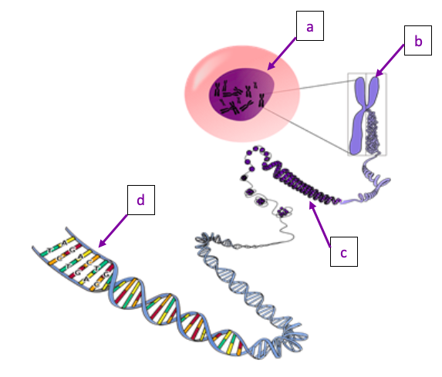
- Humans have chromosomes in our body cells.

Part D - Chromosomes
At the following link, watch the video “Chromosomes” by Brightstorm and complete the following questions.
www.brightstorm.com/science/biology/cell-division-and-reproduction/chromosome

- A is a molecule of .
- Chromatin is loosely organized .
- Visible are tightly packaged .
  - Chromosomes only develop during division.
  - Chromatids are made of strands of DNA molecules, these are attached to one another.
- How many feet of DNA are packaged into the nucleus of all of our cells? Feet
- When are chromosomes visible? During .

Using your textbook pages 127-129, answer the following questions (#24-26).
- Chromosomes are generally found in pairs. What are the chromosome numbers found in the following organisms:
  - Human .
  - Cow .
  - Chicken .
  - Corn .
  - Butterfly .
  - Bat .
- How many chromosomes are found in a single human sperm cell? .
- How many chromosomes are found in a single human ovum cell? .

Part E - DNA and Genes

At the following link, watch the video called “DNA Structure and Function” by the Amoeba Sisters and complete the following questions.
https://www.youtube.com/watch?v=_POdWsii7AI
- A clone is an copy, because the material is the same.
- List 4 traits that are controlled by our DNA:

- What does every cell in our body have? .
- Gene Regulation is: . Gene regulation depends on the function of the cell type (skin cells do not produce digestive enzymes).
- DNA stands for .
- The four base pairs are:

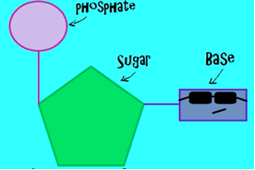
  - The Rhyme to help you remember is:
    - In the .
    - In the .

- Using the above base pair knowledge, complete the sequence of base pairs that would exist on the other side of this DNA strand:
ACCTGCTAT

- A mismatched base pair can result in a .
Part F: Cell Life Cycle
The life cycle of a cell is divided into three stages known as the cell cycle. See below for a diagram of the cell cycle.
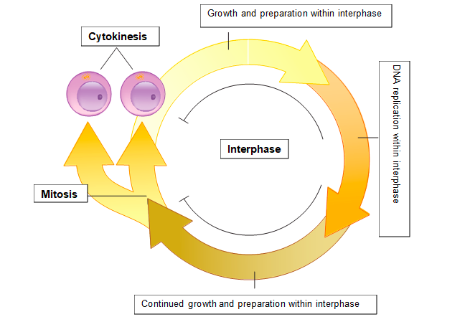
The stages of the cell cycle are interphase, mitosis, and cytokinesis.
Explain below what occurs in each of the three stages of a cell’s life cycle. See pages 153 to 158 of the textbook.
Interphase: | Mitosis: | Cytokinesis

