Assignment #5 (Sandwich Build)
Due: Tuesday May 13, 2020
Please read all the instructions before you begin.

Learning Intentions:

- Components of food preparation, including use and adaptations of ingredients, techniques and equipment.

Assignment Instructions
For this assignment you will need to read a short theory section, make a tasty sandwich and answer some questions about your experience.
Lunch Time (Week 1)
A little history:
Lunch or the midday meal interestingly has only been around since the dawn of the industrial revolution starting back in the 19th century, in which male workers began to work long shifts at the factory, severely disrupting the age-old eating habits of rural life. Before this, the main meal of the day, then called dinner, for almost everyone took place late in the morning after several hours of work.
Many countries in the world still consider lunch to be the main meal of the day. For example, most small shops in Spain close for between two and four hours – usually between 1:30 pm to 4:30 pm – to allow workers to go home for a full lunch.
We North Americans generally eat a quick lunch in the middle of the workday that often includes some type of sandwich, soup, salad or leftovers from the previous night's dinner.

Lunch Unit: Lesson #1 Sandwiches
- Read over my summary of “How to Build a Better Sandwich”
- Construct a sandwich of your own following the principles outlined in the article
- Fill out the sandwich table and answer the assignment questions below.

“How to Build a Better Sandwich” https://www.seriouseats.com/2016/03/how-to-make-the-best-sandwich-pro-tips.html summarized:

- The Bread: Try to get good bread then make it even better. Getting good bread is half the battle. If you’re stuck with stale and / or processed bread, so be it. You can make it better by toasting it or griddling it with some butter. Finally, try to match the texture of the bread with the ingredients inside. Often, contrasting the texture of the bread (crunchy) with the ingredients inside (peanut butter and jelly) or crunchy chicken with a super soft white bread works well.

- The Condiments: Again, better condiments and more of them. Condiments like mayo and mustard help protect your bread from wet vegetables like tomatoes and pickles. Don’t be afraid to play around with your condiments, for example, I like to add siracha to the mayo in my house. It gives it a nice little kick to each bite.

- Vegetables: Treat your vegetables right! Vegetables need to be washed even if they’re clean. It brings them back to life. And don’t hesitate to season them with salt and pepper and or a little olive oil.

- Protein: There are very few if any proteins that don’t belong in a sandwich from fried chicken to tofu. If possible, try to heat up the protein just before adding it to the sandwich. “The juices come out, the sweet, the savory, it all surfaces when you bring the protein up to temperature.”

- Layering: "You need to have some restraint in terms of how much you're putting onto a sandwich—if it's bigger than your mouth, you're probably in a bad place for eating it. More is not better." Having too many ingredients doesn't just make a sandwich hard to eat; it can also mess with flavor and balance. “If you're going to put something on a sandwich, you should be able to know that it's there and that it's complementing the other ingredients." Generally, you want to alternate hot and cold ingredients and put the garnishes above the protein. “You want those garnishes in your mouth first, so they’re not overpowered by your protein.”

See my example:
Sandwich Title: Candelaria’s BLT Special
Sandwich Components | Preparation Details | Taste / Texture Description
Bread | Two slices of whole grain bread, toasted. | Taste – The sweetness of the tomato and saltiness of the bacon matched perfectly. The tangy zip from the pickle and mustard combined well with the other ingredients. I put a little too much avocado on the bottom layer, luckily it’s rich, mellow flavour didn’t clash with the overall taste.  Texture – I did over toast the bread a tad. However, the crunchy exterior nicely complimented the ingredients inside. I ate the sandwich almost immediately after making it. The lettuce was still crisp and fresh. If I were to make it the night before, I might substitute the lettuce with Kale or remove it altogether. Soggy lettuce is the worst.
Condiments | Mayonnaise and Dijon mustard lathered over both slices
Vegetables | Avocado and red onion thinly sliced Pickles and tomato thickly sliced.  One piece of crisp romaine lettuce.
Protein | Fried bacon
Layering | Avocado first, bacon second, tomato third, followed by pickles and red onion, topped with lettuce and a dollop of hot sauce.

Sandwich Title:
Sandwich Components | Preparation Details | Taste / Texture Description
Bread |  | Taste -  Texture -
Condiments

Vegetables

Protein

Layering

Assignment #2 Questions:
- What is the difference between lunch in Canada and Spain?
Answer here:
- When layering your sandwich, why do you want to place the garnishes above the protein?
Answer here:
- What part of your sandwich build went well?
Answer here:
- What could have gone better?
Answer here:
- Next time you make a sandwich, what are you going to keep the same or do differently?
Answer here:
Insert a picture of your sandwich into the textbox below:
See my example:
Candelaria’s BLT Special
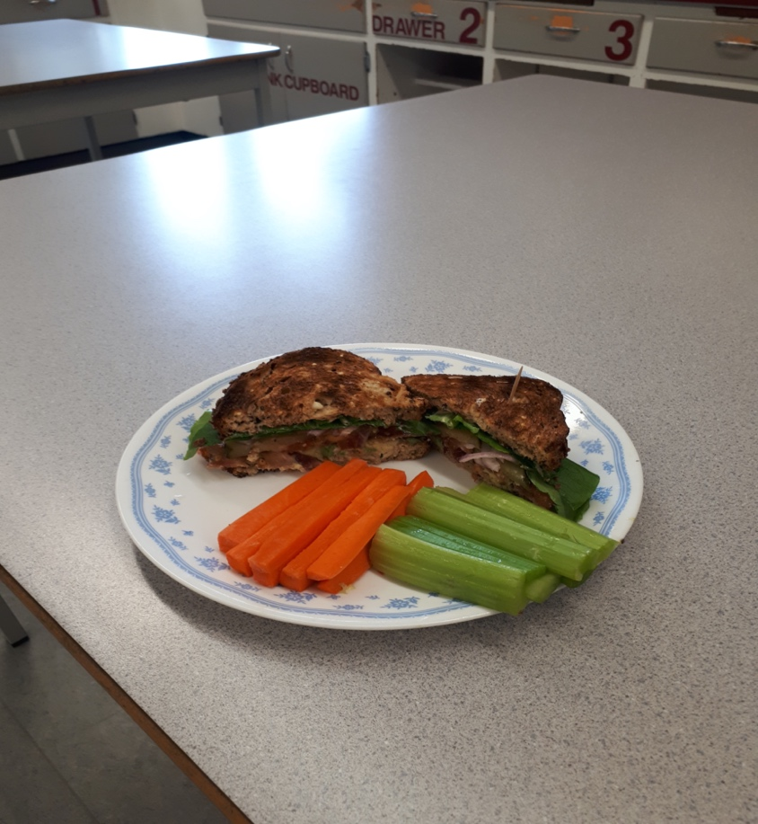

Insert your sandwich in the textbox below:
Title Here
Picture Here

How to Insert a Picture into the Textbox:
- Download the pictures onto the device you are working with (send as an email from your phone to your device if you took the pictures with your phone).
- Click on the textbox in which you wish to insert a picture.
- Then click on insert in the top toolbar.
- Then click on picture in the bottom toolbar.
- Then click on from this device.
- Then click on browse.
- Select the picture from “downloads” and click “open” and you’re done!
- Repeat this process for each textbox.

Time to complete assignment?
Student Comments:

Teacher Comments:

Extension Assignment
Watch Jamie Oliver’s "ultimate turkey sandwich video”: https://www.youtube.com/watch?v=2ReWD9x5ecE
To save time I highly recommend that you:
- Pre-Read the questions before watching the video.
- Pause and Answer each question as you watch the video.
- Please answer in complete sentences.
Extension Questions
- Which sandwich making principles does Jamie Oliver use in his sandwich?
Answer in complete sentences and give lots of detail.

- What two ingredients does Jamie save to reuse later while making his sandwich?

