Lunch Unit: Lesson #2 (Grilled Cheese Crown Competition)
Due: Tuesday May 19, 2020
Please read all the instructions before you begin.

Learning Intentions:

- Components of food preparation, including use and adaptations of ingredients, techniques and equipment.

Assignment Instructions
For this assignment you will need to watch Jamie Oliver’s “Cheese Toastie with a Crown,” make your own grilled cheese with a crown and answer some questions about your experience.

Lunch Unit: Lesson #2 (Grilled-Cheese Crown Competition)
Task #1: Watch Jamie Oliver’s “Cheese Toastie with a crown”: https://www.google.com/search?client=firefox-b-e&q=jamie+oliver+grilled+chees#kpvalbx=_8fiyXpKhEZK50PEPx_GtyAw46

Task #2: Creation Time
Ingredients
- Two Slices of bread  - Pinch of paprika |  | - ½ cup shredded cheddar  - 1-2 tbsp soft butter
Method
- Pull out a skillet or frying pan  - Butter every side of each slice  - Put a generous amount of shredded cheddar in between the slices  - Put your toastie on the pan (medium/low heat)  - Toast for 3 minutes each side  - Flip when other side is crispy and golden brown  - After 1st flip, weigh down toastie with a plate and something heavy, for example, jar of pickles or bag of flour.  - Grate a layer of cheese into the pan (low/medium) heat. | - Sprinkle a pinch of paprika on top.  - Place your toastie in the middle, leave for 10-20seconds, then take a flipper and carefully scoop out your sandwich with all the cheese attached.  - DON’T flip it until all the cheese has hardened into a crown.  - Serve with a condiment of your choice.  - TAKE a picture of your Crowned Creation!
Insert a picture of your Crowned Creation here:
How to Insert a Picture into the Textbox:
- Download the pictures onto the device you are working with (send as an email from your phone to your device if you took the pictures with your phone).
- Click on the textbox in which you wish to insert a picture.
- Then click on insert in the top toolbar.
- Then click on picture in the bottom toolbar.
- Then click on from this device.
- Then click on browse.
- Select the picture from “downloads” and click “open” and you’re done!
- Repeat this process for each textbox.

Competition Details:
Next week, I will attach a document with everyone’s Crowned Creations to assignment #7. Each creation will be given a number. The creations that score the highest will take the top three spots. Scores will be based on this rubric:

Categories | 1 point | 2 points | 3 points | Score
The Crown | Crown shows little to no height, partially formed, a little burnt. | Crown shows some height (2cm) and circles most of the toastie. | Crown shows impressive height (5cm) and circles the whole toastie
Condiments | Sloppily plopped onto the plate | Neatly plopped onto the plate | Creatively plopped onto the plate
Overall Appearance | Looks edible, but you’re hesitant to take a bite | The “toastie” and condiments are placed neatly. You’re starting to salivate. | You want to take a big bite out of it right now! Very creative display.
Total

For Example:
Bird’s Eye View | Side View
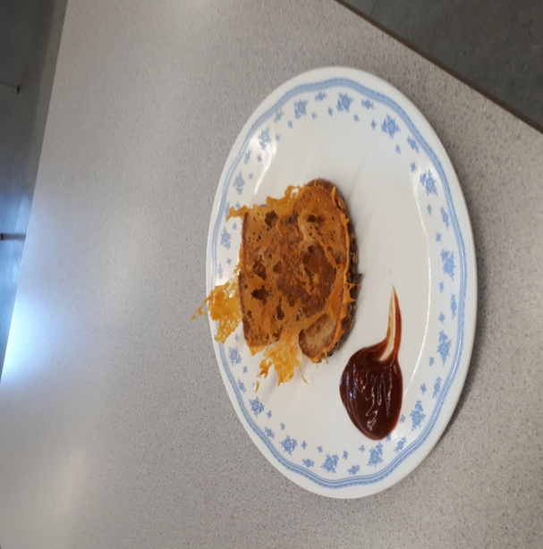 | 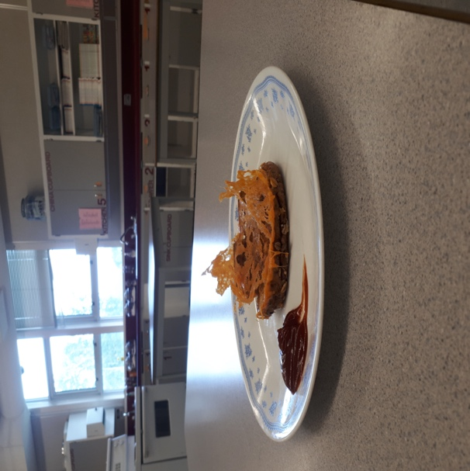

I would give this creation: Crown (3), Condiments (2), and Overall Appearance (2), Total = 7

Extension Assignment: Why Shop Local?
I think we are very lucky to live in such agriculturally rich part of Canada. We have access to fresh local foods year-round. When it comes to cooking, fresh is always best! There are a number of reasons why shopping local can be beneficial for you and your community. The BC Association of Farmers’ Markets has created an excellent website that clearly outlines several reasons in the link below:
https://bcfarmersmarket.org/why-bc-farmers-markets/
Task 1: Do you think it is important to shop local? Why or why not?
List at least 5 reasons why you think it is or isn’t important to shop local.
Answer in complete sentences here:

Task 2: What is in season (fresh) during the month of May on Vancouver Island and Southwest BC? Use this link:
https://bcfarmersmarket.org/why-bc-farmers-markets/whats-in-season/
Answer here:

