Lunch Unit: Lesson #3 (Soups & Stews)
Due: Tuesday May 26, 2020
Please read all the instructions before you begin.

Learning Intentions:
- Components of food preparation, including use and adaptations of ingredients, techniques and equipment.

Assignment Instructions
For this assignment you will need to read a short theory section, make a soup or stew and answer some questions about your experience.
Lunch Time (Week 3)
Soups & Stews
Soups and stews share many traits and differ mostly in consistency and cooking method. Most soups and stews have a base liquid stock, made from a combination of vegetables and or meats cooked in pots. Soups tend have more liquid (broth) than stews. Stews are generally cooked at a low temperature for long periods of time, whereas soups often require the boiling and then simmering of solid ingredients for a shorter period of time.
Many cultures and countries proudly lay claim to their own particular soup or stew. You might ask, why is this type of dish so commonly found all over the world? There is evidence that humans first started experimenting with this form of cooking as far back as 20,000 years ago. Soups and stews are one of the most nutritious dishes you can make. Most of the nutrients, oils and fats from the vegetables and meats are retained when cooked in a pot. It is very likely that ancient soups/stew concoctions could have enormously benefitted our early ancestors all over the globe. To boot, soups and stews are a great way to use up vegetables and meat that are about to spoil.
Lunch Unit: Lesson #3 (Puréed Vegetable Soup or a Family Recipe?)
The general vegetable puréed soup recipe below is not mandatory. You may use a family soup/stew recipe or another soup/stew recipe that suits your needs.
Task 1: Puréed Vegetable Soup
Equipment Needed | Ingredients
- Large saucepan or pot  - Blender or stick blender | - 1000 ml chopped *vegetables  - 15 ml vegetable or olive oil  - 1 small onion, finely chopped |  | - 2 cloves garlic, minced  - 500 ml vegetable stock  - 2-3 seasonings of your choice
Possible Seasonings  - 5 ml lemon juice  - 3 ml thyme  - 1 bay leaf (remove before puréeing)  *Vegetable options: broccoli, carrots, sweet potatoes, potatoes, or other) |  | - 10 ml parsley  - 5 ml basil  - 5 ml oregano  - 5 ml ground ginger  - 5 ml curry powder
Method
- Prepare vegetables and set aside.
- In a large saucepan or pot, heat oil over medium heat. Add onion, garlic, and seasonings. Cook, stirring occasionally, for 3-5 min or until onion is softened.
- Add vegetables; stir for 1 min.
- Add stock and bring to a boil. Then reduce heat, cover with a lid, and simmer for 10-15 minutes or until vegetables are tender. Taste and adjust seasonings as needed.
- With an immersion blender or in a blender, purée soup until all the ingredients are the same consistency. If you do not have a blender; mash vegetables with a potato masher.
- If soup seems to thick, add additional stock. If you don’t have any more stock, water will suffice.
- Ladle into bowls and garnish with a swirl of sour cream if desired.

Try to use at least one local vegetable that was recently or is currently in season in your soup or stew. These include:
Fresh: - Celery - Peas - Potatoes - Turnup
Stored: - Beans - Beets - Carrots - Garlic - Onion - Ginger

List all the vegetables used in your soup/stew
Answer here:

If you choose to use another recipe, please take a picture of it or include a link to that recipe in your assignment.
Copy link or picture of alternate recipe in text box below:

Task 1: (Questions)
Recipe title:
- How are soups and stews similar?
Answer here:

- How might soups and stews benefitted our early ancestors?
Answer here:

- What did you need to do to prepare for this recipe?
Answer here:

- Did you make any mistakes? If yes, how would fix them? If no, what helped you complete the recipe error- free? (knowledge, patience, experience?)
Answer here:

- If you were going to make this recipe again, would you change any ingredients or modify the method in any way? Explain why for either answer.
Answer here:
Task 2: Spot the mistake
I have a made some form of a mistake in one of these pictures. You get one mark for identifying the mistake and 1 mark for suggesting the proper correction. Answer in complete sentences.
Preparation | Cooking | Serving
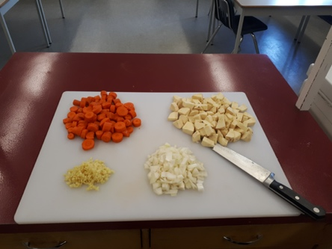 | 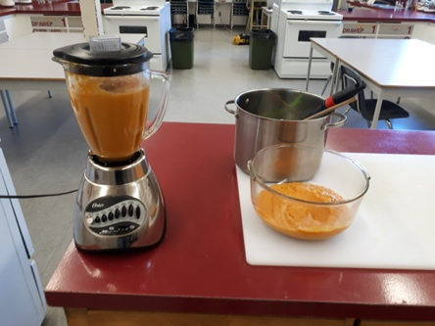 | 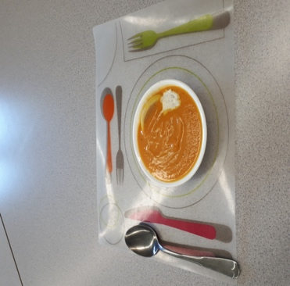
Mistake:
Correction:
Assessment
Please self-assess with your parent or guardian below:
- Highlight the box that you think best matches your work.
- Click on the highlight icon (pen image) and select the colour yellow.
- Repeat this step for each row.
- Indicate how long this assignment took you to complete below the rubric.
- Add your own comments below this. For example, what did you find interesting, easy, difficult, surprising about the assignment? What did you learn?
Competencies | Emerging | Developing | Proficient | Extending
Preparation & Cooking | Student completed few of the prep and cooking steps. May have got distracted (ie. left the food on the stove unattended) | Student completed most of the prep and cooking steps correctly. | Student completed all of the prep and cooking methods successfully. | Student creatively adjusted the prep or cooking method to enhance the recipe.
Safety &  Sanitation | Student demonstrated few proper safety and sanitation practices such as: using equipment in the appropriate manner, hand washing, sanitizing, cleaning up, dishwashing and final clean up | Student only demonstrated some safety and sanitation practices | Student demonstrated all proper safety and sanitation practices | Student left the kitchen cleaner than when they found it
Final Product | Burnt / undercooked, inedible | Served cold or too hot, flavours don’t match major ingredients | Served at appropriate temperature, flavours match major ingredients | Served with an appropriate garnish, texture reflects cooking technique

Time to complete assignment?
Student Comments:

Teacher Comments

