Foods Assignment #8 (Pizza)
Due: Tuesday June 2, 2020
Please read all the instructions before you begin.

Learning Intentions:
- Components of food preparation, including use and adaptations of ingredients, techniques and equipment.

Assignment Instructions
For this assignment you will need to read a short theory section, make a pizza and answer some questions about your experience.
Pizza
The earliest forms of pizza were first made roughly 7000 years ago in the form of baked flatbreads with several toppings. The dish originated in the Mediterranean and didn’t start to become popular until after the second world war when allied troops stationed in Italy brought word of the delicious dish back home.
Today, pizza ranks as one of the most popular dishes worldwide. Duncan alone, a city of only 5000, houses 8 different pizzerias in an area no larger than 4km².
What makes the perfect pizza? As it turns out, it is a very contentious issue. Some prefer the traditional Neapolitan style while others swear by the classic New York-style pizza. Normally, you would get a chance to make your own pizza from scratch; therefore, I am going to provide an easy homemade pizza dough recipe. That being said, if making your own dough proves to be too much of a challenge for whatever reason, just buy it. When making your own pizza keep these basic principles in mind:
- Use great sauce. If your sauce is just bleh, your pizza will be too. Check out this simple 5-minute homemade sauce recipe.

- Add a little cheese before the toppings. Starting with a very thin layer of cheese helps the toppings stick.

- As for other toppings, the best pies keep the toppings minimal and balanced. Try to limit it to two or three, asking yourself at each step whether what you’re adding is complementing the ingredients you added before.

- Blast that heat, you should be baking your pizzas as hot as your oven will go—generally in the 550°F range. BE CAREFUL. REMEMBER YOUR OVEN SAFETY STEPS!
- Watch the pizza carefully. The pizza goes from almost done to too brown fairly quickly. So be careful and use that oven light!

Pizza Lesson: (Instructions)
Task 1: Prepare your dough or buy it.
- Click on this link for instructions: https://joyfoodsunshine.com/easy-homemade-pizza-dough/
Task 2: Prepare an easy homemade pizza sauce.
- Click on this link for instructions: https://joyfoodsunshine.com/easy-homemade-pizza-sauce-recipe/
Task 3: Build and bake your pizza!
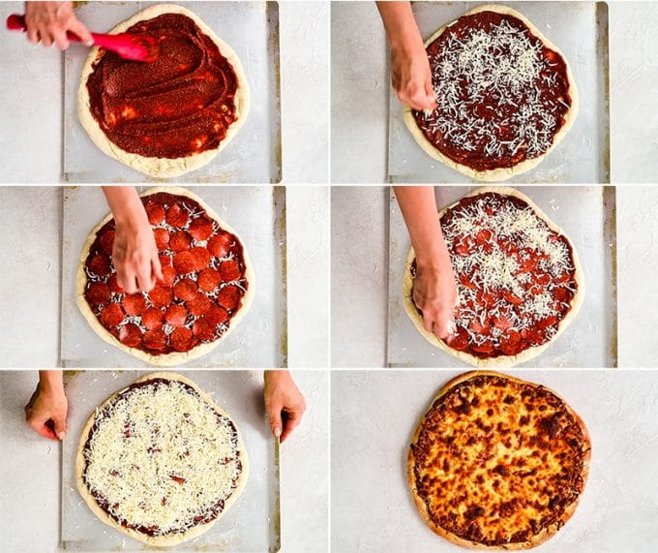

- Once the dough is pre-baked, slather on the sauce and toppings and bake @ 450-550 degrees F for 15-25 minutes (WATCH CAREFULLY!) until the cheese is bubbly and the crust is golden brown.
Describe your Pie

Dough | Sauce | Toppings | Cheese
My Pie:  Homemade  All-purpose flour, yeast, oil, salt and sugar | My Pie:  5-minute homemade sauce recipe:  https://joyfoodsunshine.com/easy-homemade-pizza-sauce-recipe/ | My Pie:  Green Pepper, Ground beef | My Pie:  Mozzarella
Your Pie: | Your Pie: | Your Pie: | Your Pie:

Task 1: (Questions)
Pizza Type:
- Where does pizza originally come from? How did it become popular?
Answer here:

- What is your favorite pizza joint in town? If pizza isn’t your thing, what is your favorite take-out food and restaurant in Duncan?
Answer here:

- What did you need to do to prepare for this recipe?
Answer here:

- Did you make any mistakes? If yes, how would fix them? If no, what helped you complete the recipe error- free? (knowledge, patience, experience?)
Answer here:

- If you were going to make this recipe again, would you change any ingredients or modify the method in any way? Explain why for either answer.
Answer here:
Assessment
Please self-assess with your parent or guardian below:
- Highlight the box that you think best matches your work.
- Click on the highlight icon (pen image) and select the colour yellow.
- Repeat this step for each row.
- Indicate how long this assignment took you to complete below the rubric.
- Add your own comments below this. For example, what did you find interesting, easy, difficult, surprising about the assignment? What did you learn?
Competencies | Emerging | Developing | Proficient | Extending
Preparation & Cooking | Student completed few of the prep and cooking steps. May have got distracted (ie. left the food on the stove unattended) | Student completed most of the prep and cooking steps correctly. | Student completed all of the prep and cooking methods successfully. | Student creatively adjusted the prep or cooking method to enhance the recipe.
Safety &  Sanitation | Student demonstrated few proper safety and sanitation practices such as: using equipment in the appropriate manner, hand washing, sanitizing, cleaning up, dishwashing and final clean up | Student only demonstrated some safety and sanitation practices | Student demonstrated all proper safety and sanitation practices | Student left the kitchen cleaner than when they found it
Final Product | Burnt / undercooked, inedible | Served cold or too hot, flavours don’t match major ingredients | Served at appropriate temperature, flavours match major ingredients | Served with an appropriate garnish, texture reflects cooking technique

Time to complete assignment?
Student Comments:

Teacher Comments

