Grade 9 Math May 6-12

We are really impressed with the work you have been doing thus far. Keep up the good work!
We have said it already and we will say it again, for those of you that are struggling for any reason at all, please reach out to your teacher and share your situation, as it only gives a better understanding of how we can support you through this difficult time for learning.

PLEASE ENSURE YOU READ ALL OF THE INFORMATION BELOW BEFORE STARTING.

This week all Math 9 classes will begin learning about Polynomials. This unit will build on both the algebra and exponents units you have already completed. We will continue following a similar format to the previous weeks with a basic assignment, mandatory for all Math 9 students, and the ‘extending your learning’ opportunities which are provided to those who want to go beyond the minimal requirements, to practice and refine their skills to further prepare themselves for Math 10 and/or raise their grade in Math 9.

Learning Intentions:
- Students will be able to recognize a polynomial and be familiar with common terminology.
- Students will be able to simplify polynomial expressions by combining like terms.

Assignment Instructions:
General Instructions:
- Students will complete the review and warm-up questions
- Students will follow the instructions and examples from Polynomials - Combining Like Terms Notes
- Students may supplement their learning from the instruction and examples below
- Students will complete all of the exercises from Polynomials - Combining Like Terms Practice Questions
- Students will communicate their progress back to their teacher
Specific Instructions:
Start by completing the warm-up questions (pg. 5). Then review the Polynomials - Combining Like Terms Notes (pg. 6-8) and complete all of the practice questions from Polynomials - Combining Like Terms Practice Questions (pg. 9-11). Use the supplementary instruction if you need it. Remember to always show your work so that the reader understands how you reached the answer you did.

Try the “extending your learning” questions if you can. It shows not just your math abilities but your work ethic. Completing some or all of these questions may give you the opportunity to improve your skills and ultimately increase your grade in the class.

Supplementary Instruction and Examples:
Below are some great resources that show examples of the concepts covered this week. If you need some extra help start with the Khan Academy video. Show your teacher evidence (eg. written summary or practice questions) that you completed any of the suggested questions to get credit for extra work.

- Watch this Khan Academy video introducing polynomials (https://www.khanacademy.org/math/algebra/x2f8bb11595b61c86:quadratics-multiplying-factoring/x2f8bb11595b61c86:multiply-monomial-polynomial/v/polynomials-intro)
- Try these 4 practice questions at Khan Academy (https://www.khanacademy.org/math/algebra/x2f8bb11595b61c86:quadratics-multiplying-factoring/x2f8bb11595b61c86:multiply-monomial-polynomial/e/polynomials-intro)

- Math is Fun has a really simplified summary of the basics of polynomials, check it out. (https://www.mathsisfun.com/algebra/polynomials.html)

- Read through this page on mathplanet, paying special attention to the video example at the bottom (https://www.mathplanet.com/education/algebra-1/factoring-and-polynomials/monomials-and-polynomials).
- Look at the examples on Purple Math for Combining Like Terms. (https://www.purplemath.com/modules/polydefs2.htm)
- Read through the first part (just down to the add and subtract polynomials section) of the Lumen Learning page on polynomial basics and do the Try It question provided on that page (with pen and paper) and check answers. Click "try another question" until you are confident in your abilities.
(https://courses.lumenlearning.com/collegealgebra2017/chapter/introduction-polynomials/)
If you need or want assistance on the assignment provided below, we are offering ‘office hours’ using the platform ‘Zoom’ twice per week with one of the four Math teachers: Mr. Kyle Conne, Mr. Bill Crerar, Mrs. Soleil Switzer, or Mrs. Susan Barton. If you wish to speak directly with your Math 9 teacher, please do not hesitate to email them at any time and they will respond in a timely manner. It is highly encouraged that you work on math during office hours if possible that way you can ask questions in real time if needed.

Office Hours: May 6 to 12 (via ZOOM):
Office hours are an optional, drop-in session that give students a chance to ask questions to a teacher, to interact and work with their peers, or just to stop in and say hi to a friend or teacher. There will be no set lessons for these times, but rather, we will be trying to help students with whatever they need help with.

Zoom is a free, easily accessible platform for conference calling. Access Zoom at https://zoom.us/join.
Time - 2:00pm to 3:00pm - Mr. Crerar
- Thursday, May 7
Meeting ID: 869-159-5396
Password: 7x8EK1
Time – 2:00pm – 3:00pm
- Tuesday, May 12 – Mr Kyle Conne
- Meeting ID: 911 756 1566
- Password: 757436

Please note Zoom etiquette:
- You are not required to turn on your video (although it will be nice to see your face again!) but make sure your audio is on. If you are having connection issues turn your own video off.
- Please mute yourself if you are not speaking. If there are a lot of users there can be quite a bit of background noise.
- If you click "participants" under the videos you will get a popup on the right. There is a button there where you can raise your hand if you have a question. Remember to "lower" your hand once you've asked your question.

Submitting your work:
Please submit completed work by Tuesday, May 12, 2020 via Office 365, Teams or by email to your specific teacher. This may include attaching a word or pdf document, or taking a picture of your completed work. Please save your file in the following format: “Name_Math 9 #4” (ex: John Doe_Math 9 #4.docx), if you have more than one file use a letter following the number to distinguish between them (ex: John Doe_Math 9 #4a.docx).

Mrs. Switzer’s class please submit via Teams if possible
Mrs. Barton’s class please submit via email sbarton@sd79.bc.ca
Mr. Crerar’s classes can continue to submit assignments as has been done previously but send them to bcrerar@sd79.bc.ca

Criteria / Rubric:
This assignment will be assessed by your teacher using the rubric below. In addition, you should use the rubric to self-evaluate by including a statement such as this “In this assignment, I feel that I am proficient, because______”. Also include how long it took you to complete the assignment.

Proficiency Scale | Extending | Proficient | Developing | Emerging
Description | The students work meets the objective; it is clear, with few or no errors and demonstrates a sophisticated understanding of the concepts and competencies relevant to the learning intentions. | The students work almost meets the objective; it has some errors but demonstrates a good understanding of the concepts and competencies relevant to the learning intentions.. | The students work is in progress; it has some errors and demonstrates a partial understanding of the concepts and competencies relevant to the learning intentions. | The students work does not meet the objectives; it has frequent errors and demonstrates minimal or no understanding of the concepts and competencies relevant to the learning intentions..
Phrase | "I could teach this." | "I have a good understanding." | " I get some of it." | "I don't get it."

Teacher comments:
Your teacher will review your work and provide feedback as quickly as possible.

Extending Your Learning (Optional):

1.

2.

3.

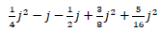
4.

Grade 9 Math May 6 - 12
Review and Warm-up

To answer the following questions think back to Week 3 Exponents or do a little research of your own.

Question 1. What is the difference between an expression and an equation?

When we work with polynomials in grade 9, they are always expressions, and never equations. We are never trying to find what x or y or a or b is. We are only trying to simplify and modify the polynomial.
What is a polynomial?
A polynomial is an algebraic expression with numbers, letters, additions, subtractions, multiplications, divisions, exponents and brackets. In a polynomial, we call the letters variables instead of unknowns. Eg. 3a² + 5a - 3
A polynomial is made up of terms. We can imagine that these terms are like quantities, either known or unknown, but quantities none the less.

Question 2. What are some examples of terms? Provide three.

Polynomials can be simplified by combining like terms. Like terms have the same variables with the same exponents or are simple integers (numbers).

Question 3. From the list below, group the like terms.
3x
7
2b
3x²
x
8b²
b
10

Grade 9 Math May 6 - 12
Polynomials Part 1 - Combining Like Terms Notes

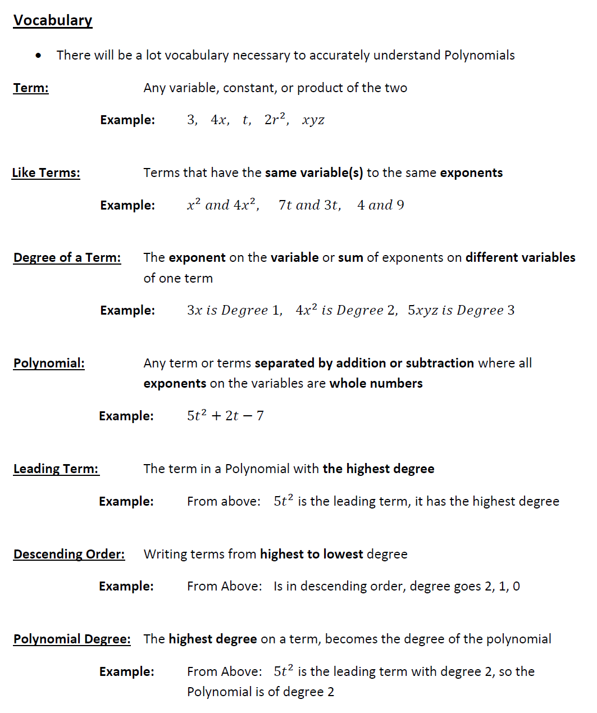

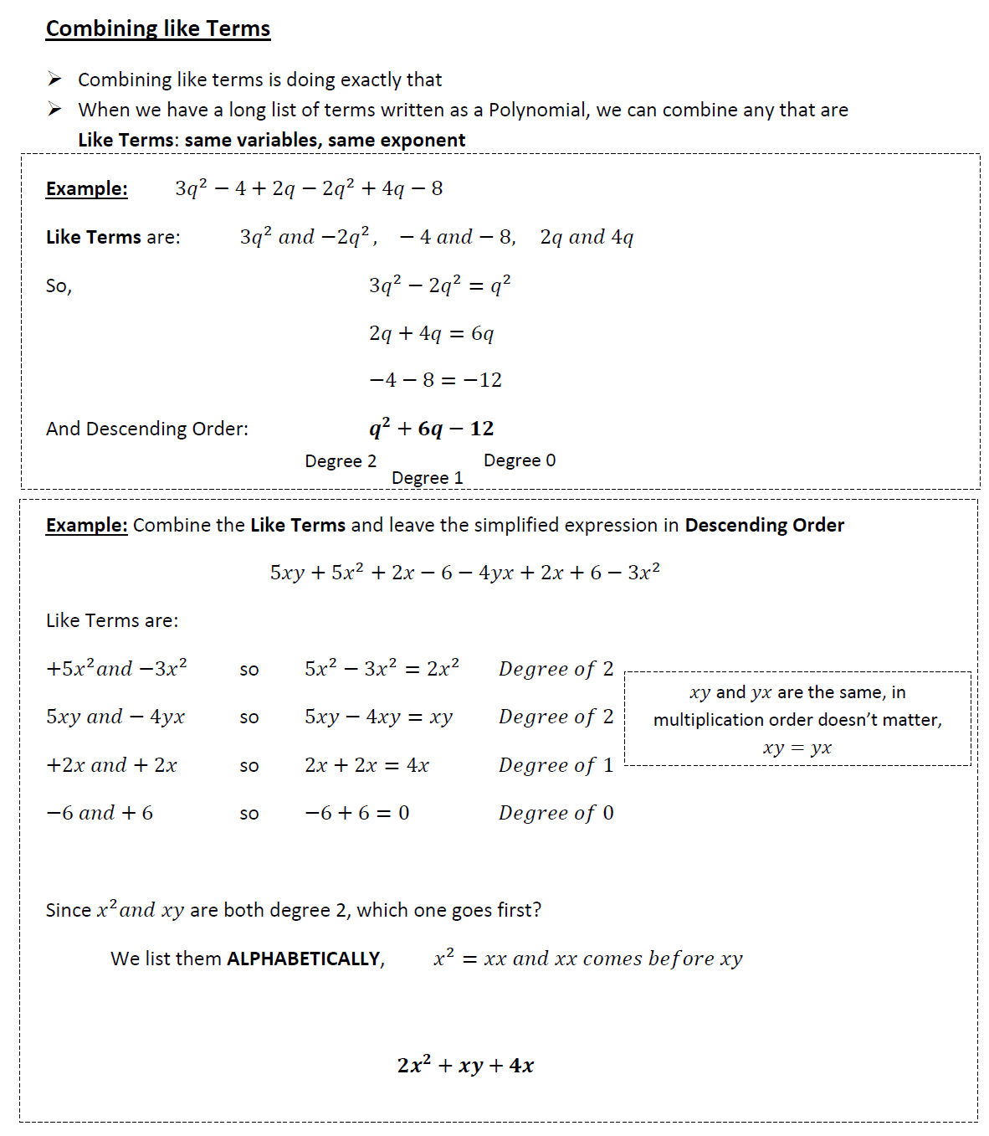

Using Algebra Tiles

- Algebra tiles can be used to visually represent polynomials
- See the example below

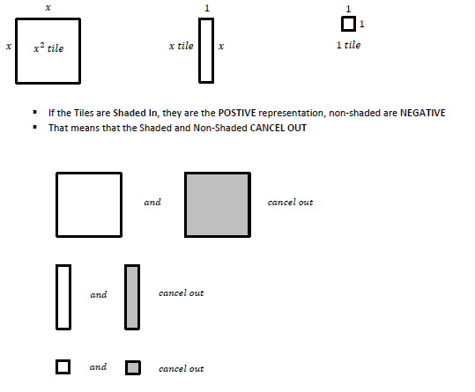

- We can describe a polynomial using tiles in the following way
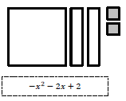

Grade 9 Math May 6 - 12
Polynomials Part 1 - Combining Like Terms Practice Questions

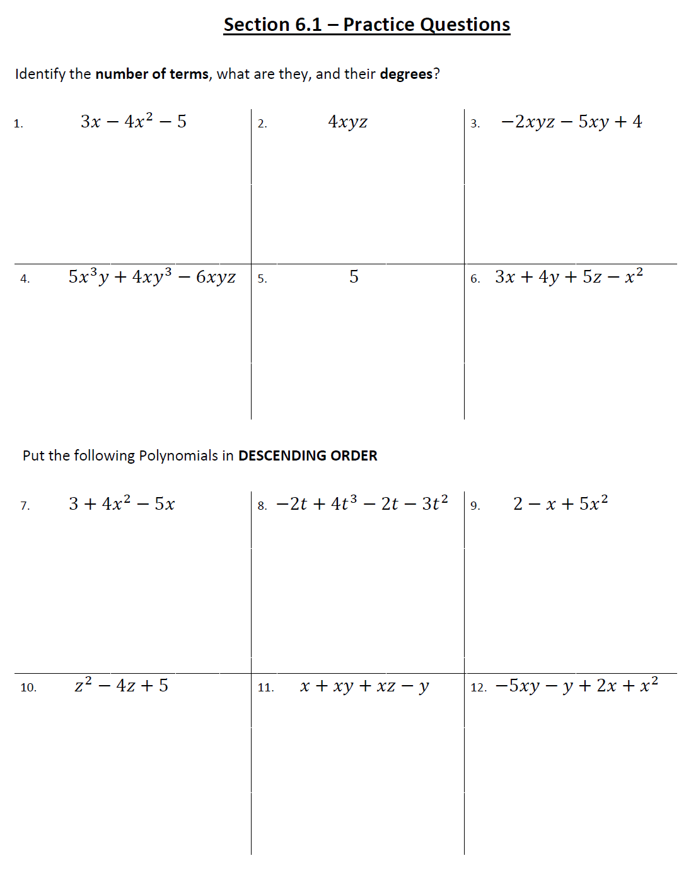
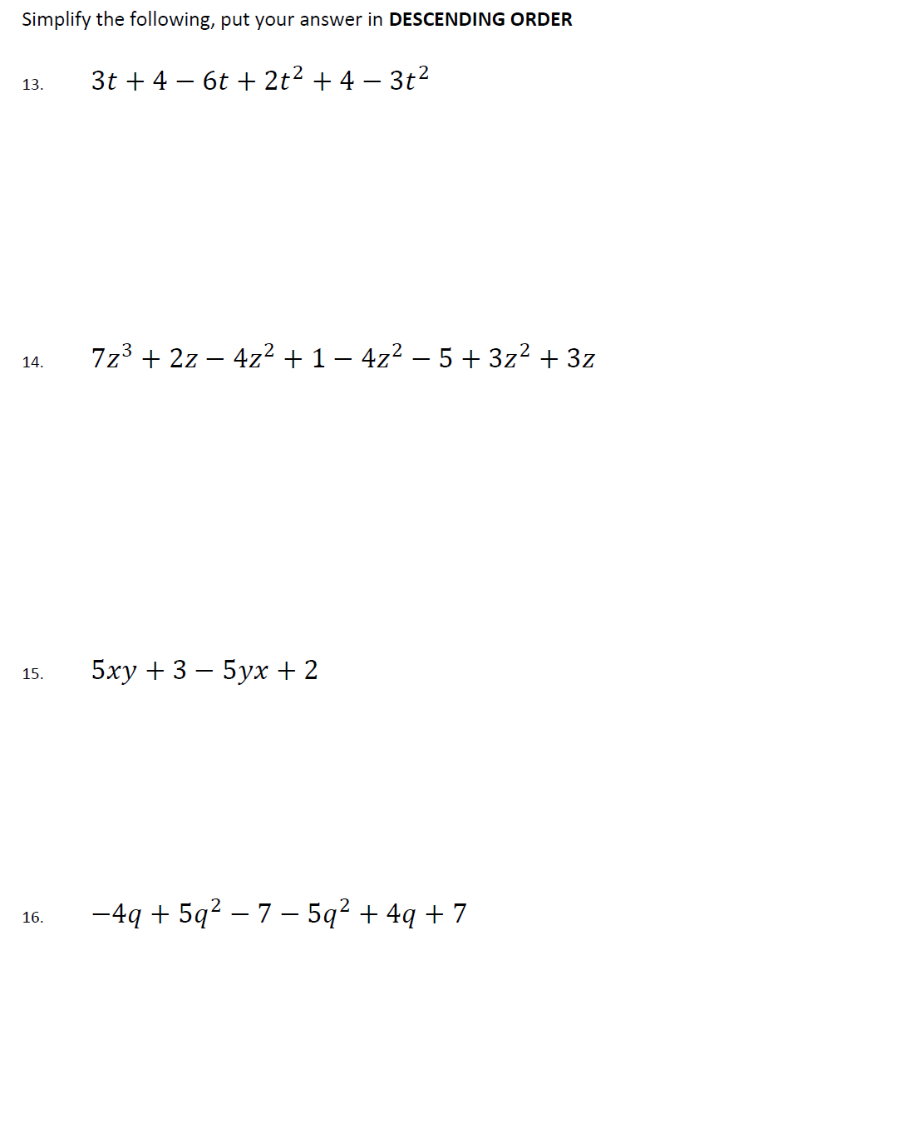

Describe the following sets of tiles as a polynomial
17.

18.

Display the following polynomials as a set of tiles

19. x² + 4x - 7

20. 3x² + x + 3

