Grade 9 Math May 13-19

Welcome to Week 6, this week all Math 9 classes will continue learning about Polynomials. Review the notes pages before completing the practice questions.

READ ALL OF THE INFORMATION BELOW BEFORE STARTING

Learning Intentions:
- Students will be able to add and subtract polynomials
- Students will be able to use algebra tiles to represent polynomials

Assignment Instructions:
- Follow the instructions and examples from Polynomials Part 2 - Adding and Subtracting Polynomials Notes (pg. 4-7).
- Remember to always show your work so that the reader understands how you reached the answer you did.
- Complete a minimum of the odd numbered questions from Polynomials Part 2 - Adding and Subtracting Polynomials Practice Questions (pg. 8-12).
- Complete all the questions for an opportunity to receive an extending assessment and improve your grade
- Supplement your learning from the instruction and examples below
- Try the “extending your learning” questions for an opportunity to improve your grade and improve your skills.Communicate your progress back to your teacher

Office Hours: May 13 to 19 (via ZOOM):
If you need help, join the office hours. .
https://zoom.us/join.
Time - 2:00pm to 3:00pm - Mrs. Switzer
- Thursday, May 14
Meeting ID: 925 1292 2665
Password: math9

Time – 11am-12pm
- Tuesday, May 19 – Mrs. Barton
- Meeting ID: 965 5141 6172
- Password: 8ydUnU

Submitting your work:
Please submit completed work by Tuesday, May 19, 2020 via the preferred or discussed method of your teacher.

Mrs. Switzer’s class please submit via Teams if possible
Mrs. Barton’s class please submit via email to sbarton@sd79.bc.ca
Mr. Crerar’s classes please submit via email to bcrerar@sd79.bc.ca. Only do the odd numbered questions 1 - 25.

Criteria / Rubric:
This assignment will be assessed by your teacher using the rubric below. In addition, you should use the rubric to self-evaluate by including a statement such as this “In this assignment, I feel that I am proficient, because______”. Also include how long it took you to complete the assignment.

Proficiency Scale | Extending | Proficient | Developing | Emerging
Description | The students work meets the objective; it is clear, with few or no errors and demonstrates a sophisticated understanding of the concepts and competencies relevant to the learning intentions. | The students work almost meets the objective; it has some errors but demonstrates a good understanding of the concepts and competencies relevant to the learning intentions.. | The students work is in progress; it has some errors and demonstrates a partial understanding of the concepts and competencies relevant to the learning intentions. | The students work does not meet the objectives; it has frequent errors and demonstrates minimal or no understanding of the concepts and competencies relevant to the learning intentions..
Phrase | "I could teach this." | "I have a good understanding." | " I get some of it." | "I don't get it."

Teacher comments:
Your teacher will review your work and provide feedback as quickly as possible.

Supplementary Instruction and Examples:
Below are some great resources that show examples of the concepts covered this week. If you need some extra help start with the Khan Academy video. Show your teacher evidence (eg. written summary or practice questions) that you completed any of the suggested questions to get credit for extra work.

- Watch this Khan Academy video about adding polynomials (https://www.khanacademy.org/math/algebra2/x2ec2f6f830c9fb89:poly-arithmetic/x2ec2f6f830c9fb89:poly-add-sub/v/adding-and-subtracting-polynomials-1?modal=1), and this one about subtracting polynomials
(https://www.khanacademy.org/math/algebra2/x2ec2f6f830c9fb89:poly-arithmetic/x2ec2f6f830c9fb89:poly-add-sub/v/subtracting-polynomials?modal=1)

- Try these 4 practice questions at Khan Academy (https://www.khanacademy.org/math/algebra2/x2ec2f6f830c9fb89:poly-arithmetic/x2ec2f6f830c9fb89:poly-arithmetic/x2ec2f6f830c9fb89:poly-add-sub/e/add---subtract-polynomials-challenge?modal=1)

- This page on Math is Fun explains how to add and subtract polynomials. (https://www.mathsisfun.com/algebra/polynomials-adding-subtracting.html)

- Read through this page on mathplanet, paying special attention to the video example at the bottom (this is the same as last week, but focus on the section about adding and subtracting) (https://www.mathplanet.com/education/algebra-1/factoring-and-polynomials/monomials-and-polynomials).
- Look at the examples on Purple Math for Combining Like Terms. (https://www.purplemath.com/modules/polydefs2.htm) (this is the same page we asked you to look at last week. This time, focus on the examples lower down the page with the parentheses.
- Check out this page on Lumen Learning again. This time, scroll down and read the section on adding and subtracting polynomials. Do the Try It question provided on that page (with pen and paper) and check answers. Click "try another question" until you are confident in your abilities.
(https://courses.lumenlearning.com/collegealgebra2017/chapter/introduction-polynomials/)

Extending Your Learning (Optional):
Any operations with polynomials we do using integers can be done with both positive and negative integers, along with fractions and decimals. All the same rules still apply, but unfortunately these types of questions are very difficult to attempt with tiles. Try these challenge questions:

- (-3.5a + $\frac{3}{4}$ - 4${a^{2}}^{}$) + (5$a^{2}$- 7 + $\frac{1}{2}$a )

- ($\frac{5}{2}b$ + 1.5${b^{2}}^{}$) - (-6$b^{2}$+ 0.625 - 4b)

- (3c - 5.2d + 8${d^{2}}^{})$ + (0.75d - 5.5${c^{2}}^{}$- 3.8d)
- (4${f^{3}}^{}$+ 5${f^{2}}^{}$+ 6f + 7) - (6$f^{3}$- 5$f^{2}$ + 4f)

NOTES
Grade 9 Math May 13 - 19
Polynomials Part 2 - Addition and Subtraction of Polynomials

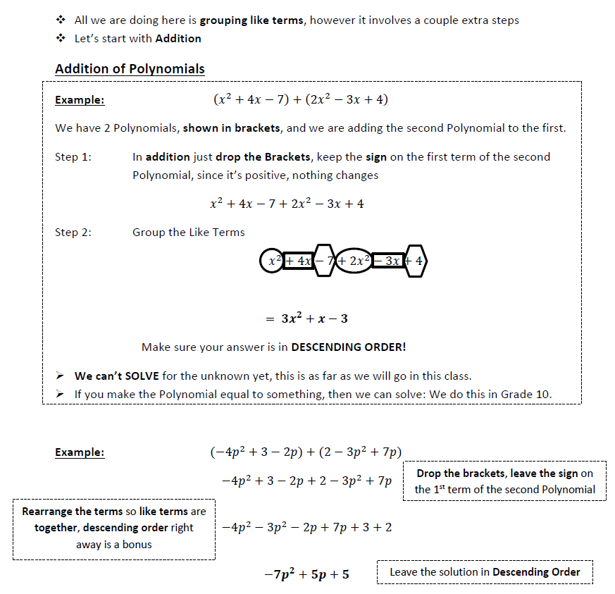

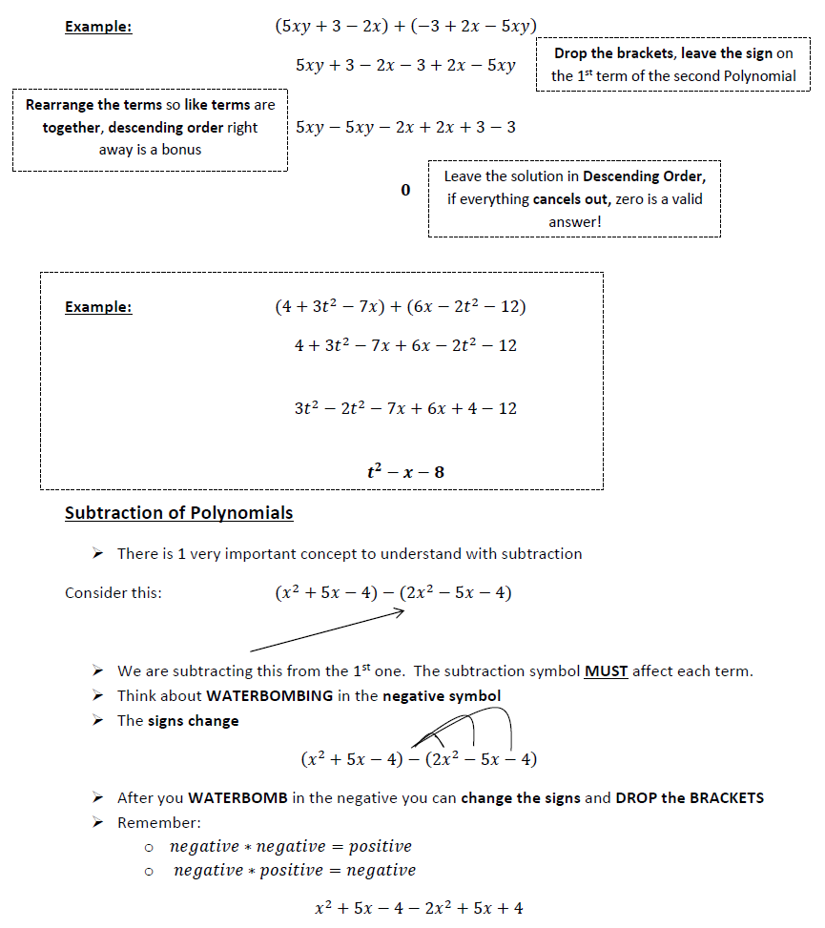

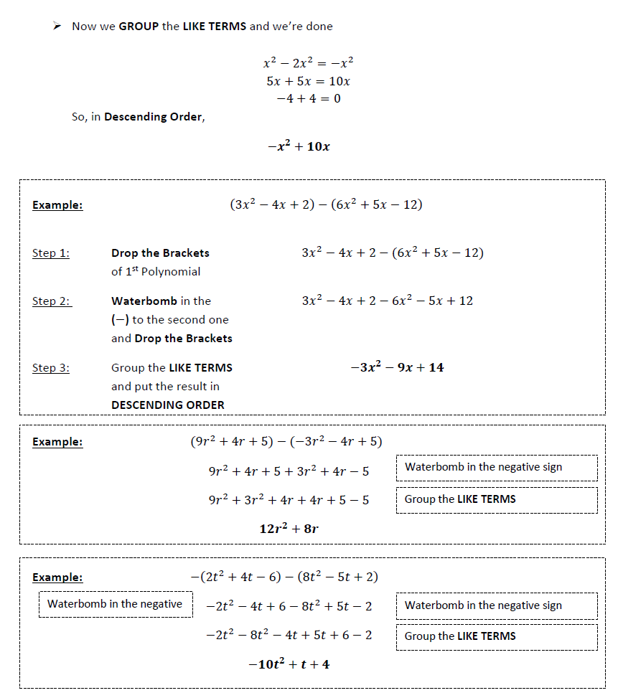
Using Algebra Tiles

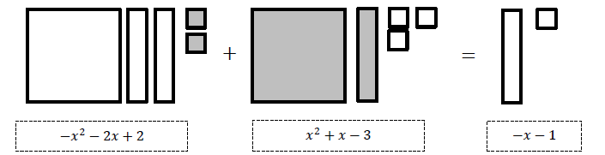
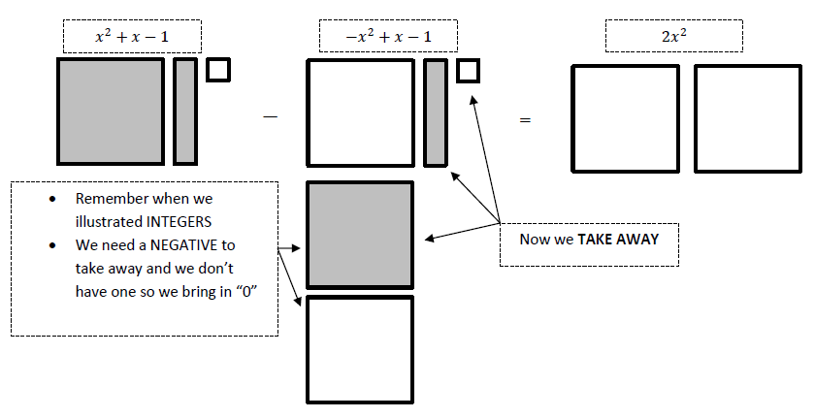

PRACTICE QUESTIONS
Grade 9 Math May 13 - 19
Polynomials Part 2 - Addition and Subtraction of Polynomials

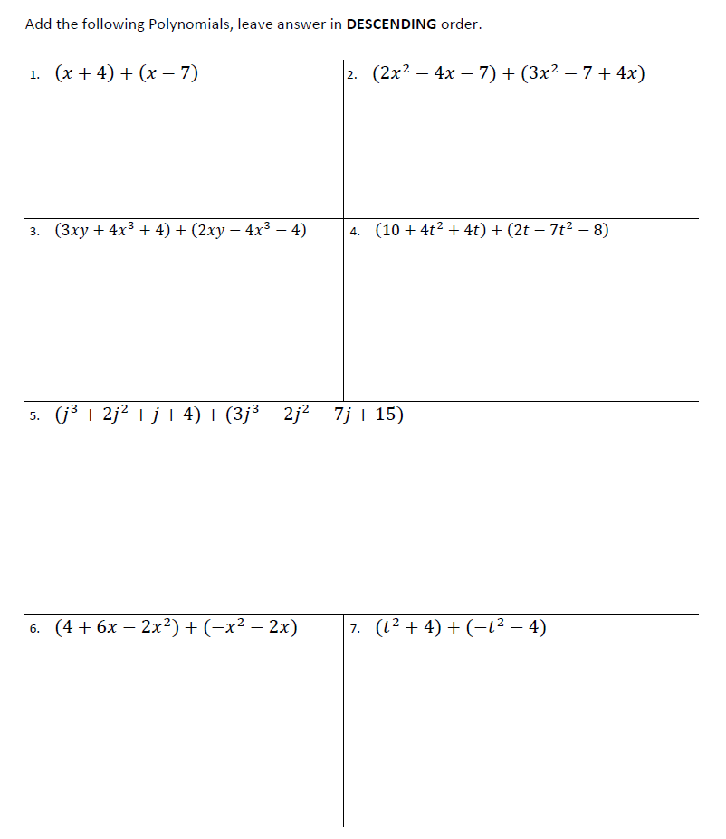
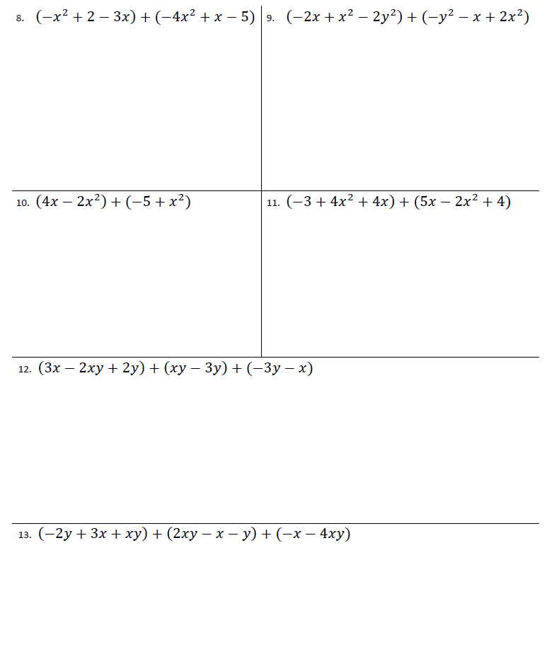
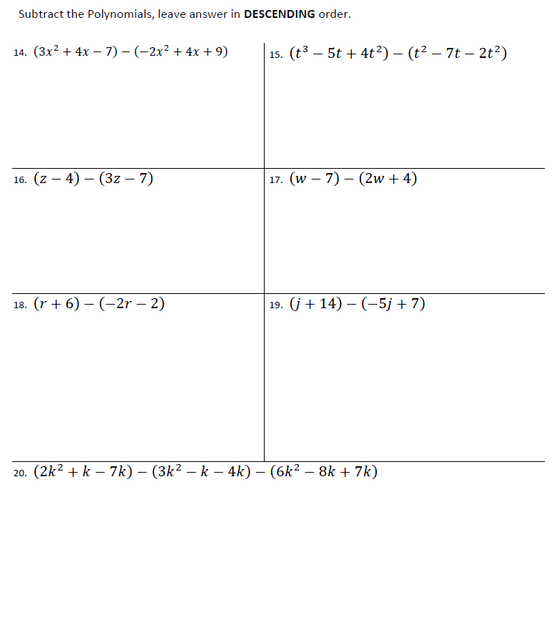

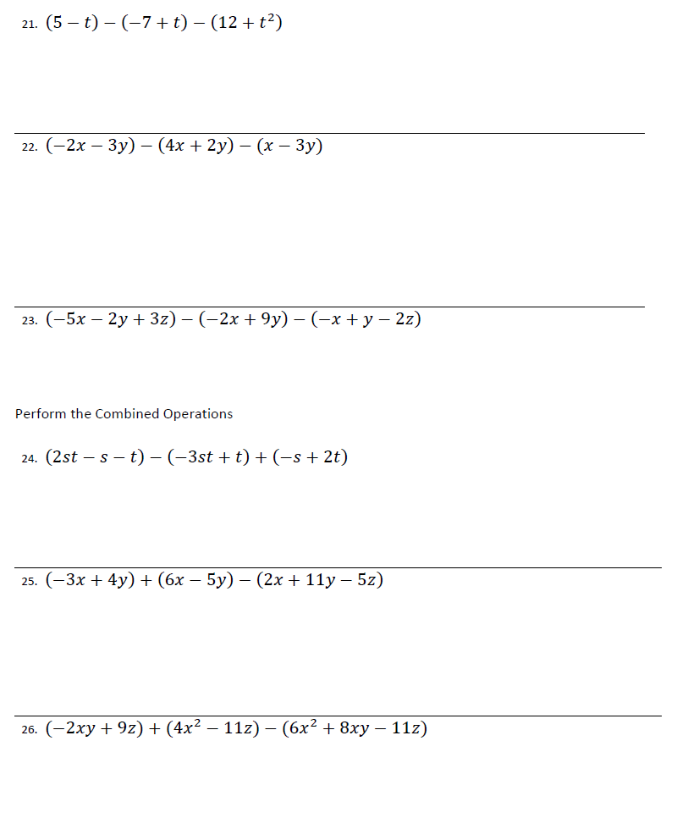

Show the algebra tiles as written terms (eg. 2x²), then solve. Show your answer as algebra tiles and as a written term.

27. Add the Polynomial, leave answer in DESCENDING order.
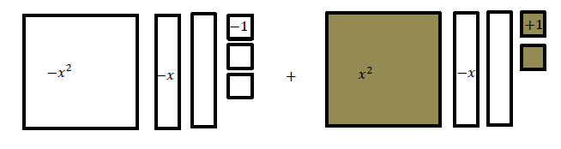

28. Subtract the Polynomial, leave answer in DESCENDING order.

