Grade 9 Math May 20 - 26

Welcome to Week 7, this week all Math 9 classes will finish up our unit on Polynomials. Review the notes pages before completing the practice questions.

READ ALL OF THE INFORMATION BELOW BEFORE STARTING

Learning Intentions:
- Students will be able to multiply and divide polynomials
- Students will be able to use combined operations with polynomials
- Students will be able to use algebra tiles to represent polynomials

Assignment Instructions:
- Follow the instructions and examples from Polynomials Part 3 - Multiplying, Dividing, and Combined Operations with Polynomials Notes (pg. 4-7).
- Remember to always show your work so that the reader understands how you reached the answer you did.
- Complete a minimum of the odd numbered questions from Polynomials Part 3 - Multiplying, Dividing, and Combined Operations with Polynomials Practice Questions (pg. 8-10).
- Complete all the questions for an opportunity to receive an extending assessment and improve your grade
- Supplement your learning from the instruction and examples below
- Try the “extending your learning” questions for an opportunity to improve your grade and improve your skills.Communicate your progress back to your teacher

Office Hours: May 20 to 26 (via ZOOM):
If you need help, join the office hours. .
https://zoom.us/join.
Thursday, May 21 2:00pm to 3:00pm - Mr. Crerar
- Meeting ID: 869 159 5396
- Password: 7x8EK1

Monday, May 25 2:00pm to 3:00 pm - Mrs. Soleil Switzer
- Meeting ID: 925 1292 2665
- Password: math9

Tuesday, May 26 11:00-12:00- Ms. Barton
- Meeting ID: 965 5141 6172
- Password: 8ydUnU

Tuesday, May 26 2:00pm to 3:00 pm - Mr. Kyle Conne
  - Meeting ID: 911 756 1566
  - Password: 757436

Submitting your work:
Please submit completed work by Tuesday, May 26, 2020 via the preferred or discussed method of your teacher.

Mrs. Switzer’s class please submit via Teams if possible
Mrs. Barton’s class please submit via email to sbarton@sd79.bc.ca
Mr. Crerar’s classes please submit via email to bcrerar@sd79.bc.ca. Only do the odd numbered questions 1 - 21.

Criteria / Rubric:
This assignment will be assessed by your teacher using the rubric below. In addition, you should use the rubric to self-evaluate by including a statement such as this “In this assignment, I feel that I am proficient, because______”. Also include how long it took you to complete the assignment.

Proficiency Scale | Extending | Proficient | Developing | Emerging
Description | The students work meets the objective; it is clear, with few or no errors and demonstrates a sophisticated understanding of the concepts and competencies relevant to the learning intentions. | The students work almost meets the objective; it has some errors but demonstrates a good understanding of the concepts and competencies relevant to the learning intentions.. | The students work is in progress; it has some errors and demonstrates a partial understanding of the concepts and competencies relevant to the learning intentions. | The students work does not meet the objectives; it has frequent errors and demonstrates minimal or no understanding of the concepts and competencies relevant to the learning intentions..
Phrase | "I could teach this." | "I have a good understanding." | " I get some of it." | "I don't get it."

Teacher comments:
Your teacher will review your work and provide feedback as quickly as possible.

Supplementary Instruction and Examples:
Below are some great resources that show examples of the concepts covered this week. If you need some extra help start with the Khan Academy video. Show your teacher evidence (eg. written summary or practice questions) that you completed any of the suggested questions to get credit for extra work.

- Watch this Khan Academy video about multiplying polynomials (https://www.khanacademy.org/math/algebra2/x2ec2f6f830c9fb89:poly-arithmetic/x2ec2f6f830c9fb89:mono-by-poly/v/multiplying-monomials-by-polynomials, and this one about dividing polynomials
(https://www.khanacademy.org/math/precalculus/x9e81a4f98389efdf:polynomials/x9e81a4f98389efdf:polynomial-division/e/divide-polynomials-by-monomials)

- Try these 4 practice questions at Khan Academy (https://www.khanacademy.org/math/algebra2/x2ec2f6f830c9fb89:poly-arithmetic/x2ec2f6f830c9fb89:mono-by-poly/e/finding-the-product-of-a-monomial-and-a-polynomial)

- This page on Math is Fun explains how to multiply polynomials. We are only looking at multiplying a polynomial by a monomial. (https://www.mathsisfun.com/algebra/polynomials-multiplying.html)

- Look at the examples on Purple Math (only down to multiplying a monomial by a polynomial) (https://www.purplemath.com/modules/polymult.htm)
- This site has some great examples for dividing polynomials (https://www.ck12.org/book/ck-12-algebra-i-concepts-honors/section/7.12/)

Extending Your Learning (Optional):

FOIL
Everything that we know about multiplying a polynomial by a variable and multiplying a polynomial by a number is used to multiply a binomial (polynomial with two terms) by another binomial. The fancy math word for this is binomial distribution, but we often see this called expanding a polynomial or FOILing a polynomial.

FOIL is an acronym that reminds us to multiply every term of the first binomial by every term of the second binomial being multiplied. Specifically, it tells us to multiply the first terms of the binomials, the outside terms, the inside terms, and the last terms. Eg.

(a + 2)$×$(a + 3) =
First: a$×$a = a¹⁺¹ = a²
Outside: a$×$3 = 3a
Inside: 2$×$a = 2a
Last: 2$×$3 = 6

Once we have done our multiplications (there will always be 4), we combine like terms:
a² + 3a + 2a + 6 = a² + 5a + 6

Usually, instead of writing the multiplication symbol between the two binomials, we simply write the two binomials with their brackets beside each other. This still means to multiply them together. Eg. (a + 2)(a + 3) = (a + 2)$×$(a + 3)

Exercises
1) (a + 4)(a + 6)

2) (b + 3)(b – 4)

3) (c – 2)(c – 5)

4) (3d + 1)(2 + d)

5) (e – 4)(5 + 6e)
NOTES
Grade 9 Math May 20 - 26
Polynomials Part 3 - Multiplication, Division and
Combined Operations with Polynomials

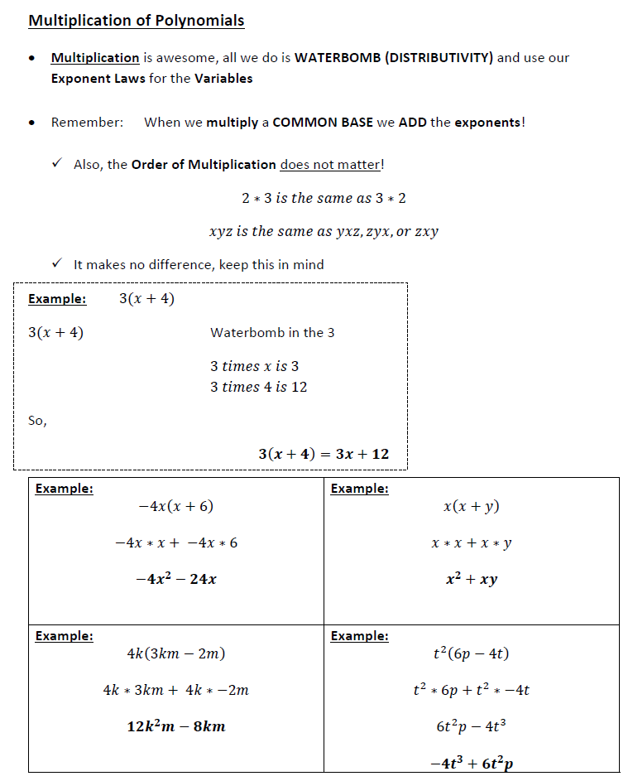

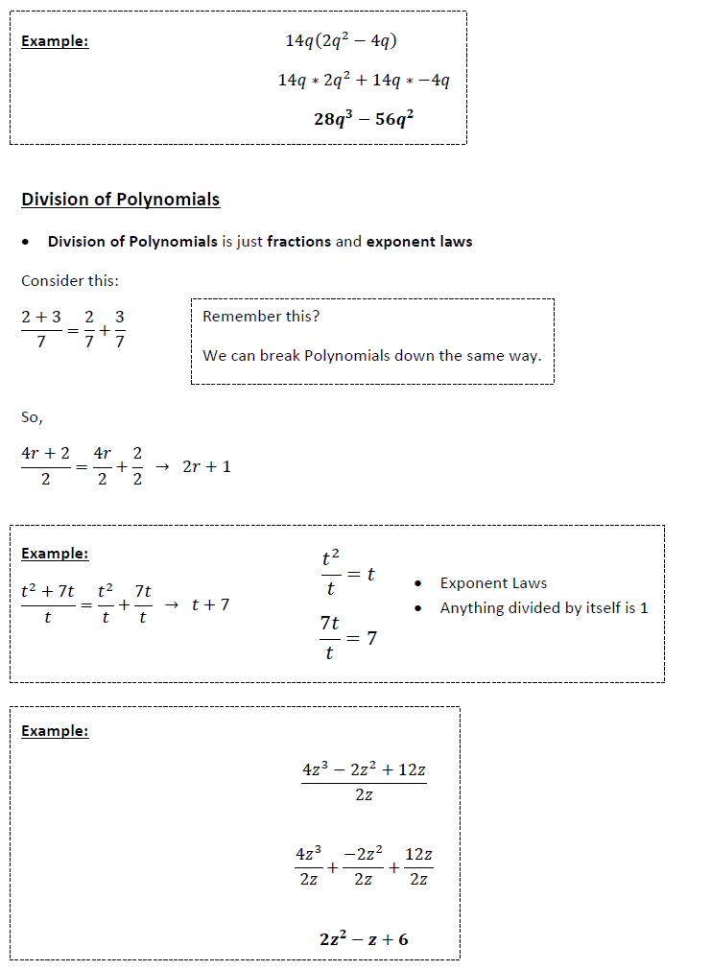

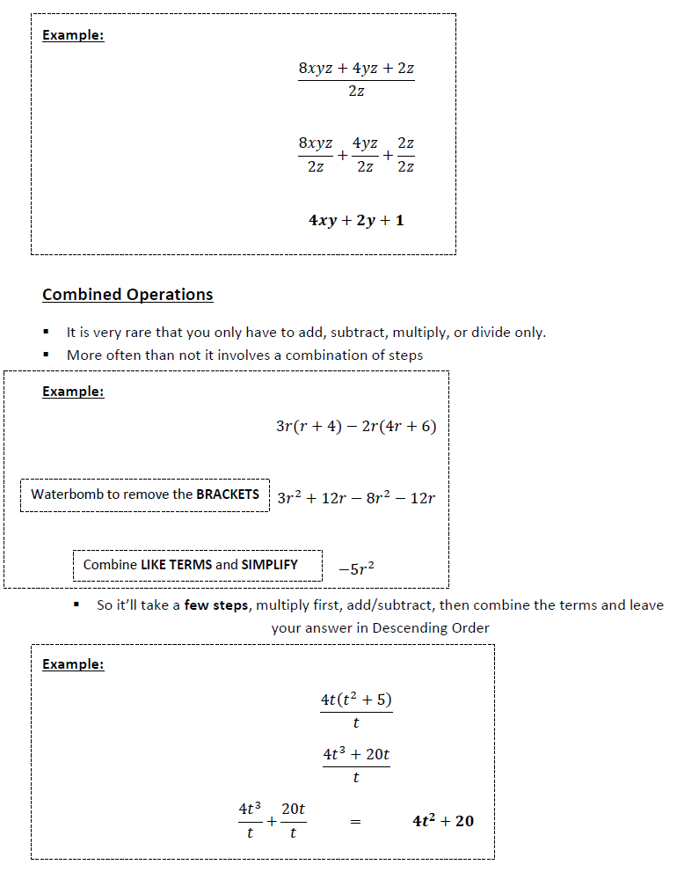
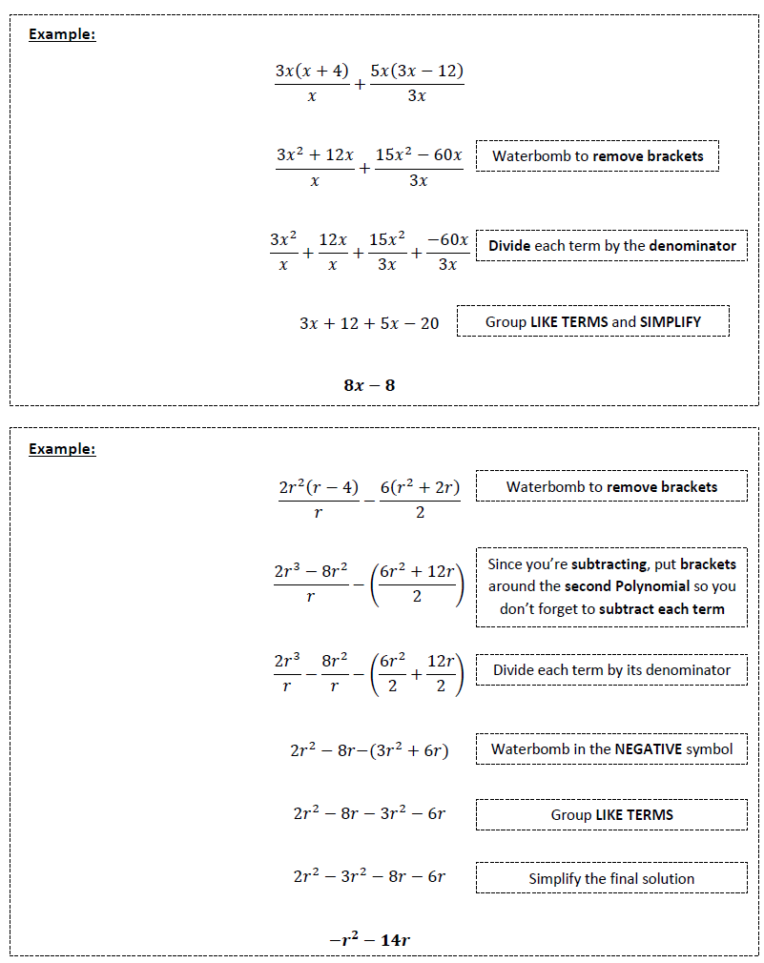

PRACTICE QUESTIONS
Grade 9 Math May 20 - 26
Polynomials Part 3 - Multiplication, Division and
Combined Operations with Polynomials

