Grade 9 Math Assignment #8 May 27 - June 2

Welcome to Week 8, this week all Math 9 classes will start a new unit on graphing linear relations. Review the notes pages before completing the practice questions.

READ ALL OF THE INFORMATION BELOW BEFORE STARTING

Learning Intentions:
- Students will be able to use expressions and equations to describe patterns
- Students will be able to use
- Students will be able to use

Assignment Instructions:
- Follow the instructions and examples from Linear Relations Part 1a - Writing Equations to Describe Patterns Notes (pg. 5-10) and then complete all the questions from Writing Equations to Describe Patterns Practice Questions (pg. 11-12).
- Remember to always show your work so that the reader understands how you reached the answer you did.
- Follow the instructions and examples from Linear Relations Part 1b - Graphing Linear Relations Notes (pg. 13-18) and then complete all the questions from Linear Relations Part 1b - Graphing Linear Relations Practice Questions (pg. 19-21).
- Complete all the questions for an opportunity to receive an extending assessment and improve your grade
- Supplement your learning from the instruction and examples below
- Try the “extending your learning” questions for an opportunity to improve your grade and improve your skills.Communicate your progress back to your teacher

Office Hours: May 27 to June 2 (via ZOOM):
If you need help, join the office hours. .
https://zoom.us/join.
Thursday, May 28 11:00 am to 12:00pm - Mr. Crerar
- Meeting ID: 869 159 5396
- Password: 7x8EK1

Thursday, May 28 2:00 to 3:00pm - Mrs. Switzer
- Meeting ID: 925 1292 2665
- Password: math9

Monday, June 1 2:00 to 3:00 pm - Mrs. Soleil Switzer
- Meeting ID: 925 1292 2665
- Password: math9

Tuesday, June 2 11:00 am to 12:00pm - Ms. Barton
- Meeting ID: 965 5141 6172
- Password: 8ydUnU

Submitting your work:
Please submit completed work by Tuesday, June 2, 2020 via the preferred or discussed method of your teacher.

Mrs. Switzer’s class please submit via Teams if possible
Mrs. Barton’s class please submit via email to sbarton@sd79.bc.ca
Mr. Crerar’s classes please submit via email to bcrerar@sd79.bc.ca. On pg 15, follow Method 1.

Criteria / Rubric:
This assignment will be assessed by your teacher using the rubric below. In addition, you should use the rubric to self-evaluate by including a statement such as this “In this assignment, I feel that I am proficient, because______”. Also include how long it took you to complete the assignment.

Proficiency Scale | Extending | Proficient | Developing | Emerging
Description | The students work meets the objective; it is clear, with few or no errors and demonstrates a sophisticated understanding of the concepts and competencies relevant to the learning intentions. | The students work almost meets the objective; it has some errors but demonstrates a good understanding of the concepts and competencies relevant to the learning intentions.. | The students work is in progress; it has some errors and demonstrates a partial understanding of the concepts and competencies relevant to the learning intentions. | The students work does not meet the objectives; it has frequent errors and demonstrates minimal or no understanding of the concepts and competencies relevant to the learning intentions..
Phrase | "I could teach this." | "I have a good understanding." | " I get some of it." | "I don't get it."

Teacher comments:
Your teacher will review your work and provide feedback as quickly as possible.

Supplementary Instruction and Examples:
Below are some great resources that show examples of the concepts covered this week. If you need some extra help start with the Khan Academy video. Show your teacher evidence (eg. written summary or practice questions) that you completed any of the suggested questions to get credit for extra work.

- Watch this Khan Academy video about linear graphing word problems (https://www.khanacademy.org/math/cc-eighth-grade-math/cc-8th-linear-equations-functions/8th-linear-functions-modeling/v/interpreting-linear-graphs)

- Try these practice questions at Khan Academy - Modeling with tables, equations and graphs (https://www.khanacademy.org/math/cc-eighth-grade-math/cc-8th-linear-equations-functions/8th-linear-functions-modeling/a/modeling-with-tables-equations-and-graphs)

- Check out this page on Quick Math that explains linear relations and their graphing. (https://quickmath.com/math-tutorials/linear-relations-and-their-graphing.html)

- Try this coordinates and scatter plots activity

Extending Your Learning (Optional):
Lines on the cartesian plane are used to show us information. Specifically, they show us relations between different quantities.
If we want to represent information visually, we need to start with two ideas in mind:
1) What quantities are on the axes? What do the numbers represent?

2) What is the appropriate scale for the situation?
For example, let’s say we want to make a graph to show how much money it costs to take a taxi. We know what you need to pay $8 to start, then $2 for each kilometer that you go.
What quantities should we label on the axes? What scale should we choose? How do we draw a line to represent this scenario? What is the equation of that line?

I bought a box of cookies that contains 20 cookies. I eat 2 cookies a day every day. Represent this scenario on the cartesian plane. What is the equation of the linear relation?

NOTES
Grade 9 Math May 27 - June 2
Linear Relations Part 1a - Writing Equations to Describe Patterns
Patterns and relationships are an important part of math. We can represent patterns in a number of different ways, including pictures, words, table of values or an equation. We can model many real-world situations with a linear relation and use the relation to make predictions and solve problems.

Example 1. Describing Patterns
Look at the pattern made from square tiles in each of the Figures below.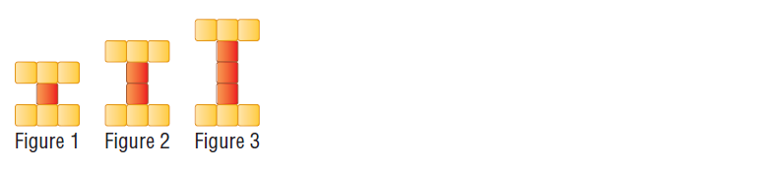
What changes in each figure? How could you describe the relationship between the figure number and the number of tiles?
Answer: One tile is added in the center of each figure. The relationship is the figure number is equal to the number of tiles added.

Relations in math are how one quantity relates to or changes another quantity. We can talk about how the amount of Arizona Ice Teas you buy changes how much you pay for ice tea. We can talk about how the amount of people coming to dinner changes how much food you cook.
The most important mathematical idea of relations is that of the independent variable and dependent variable. Remember that a variable is a letter representing a quantity that can vary or change.
The quantity that changes the other quantity is called the independent variable. In math, we choose what the value of the independent variable will be. We usually call the independent variable “x”.
The quantity that is changed by the independent variable is called the dependent variable. We do not choose the value of the dependent variable. Instead, it is determined for us by the value of the independent variable and what the relation between the two variables is. We usually call the independent variable “y”.

Example 2: Independent and Dependent Variables
Does the amount of food you have cooked determine how many people show up at your house for dinner or does the amount of people showing up at your house for dinner determine how much food you cook?
The amount of people will determine the amount of food needed so...
Independent variable = the number of people
Dependent variable = the amount of food
Choose a letter to represent your variables
N = number of people
F = food
Suppose for every person coming to dinner you are going to cook 3 potatoes. If 5 people come, how many potatoes will you cook? If 7 people come, how many potatoes will you cook? What is the mathematical relation between the independent and dependent variables?
I can describe the relationship in words and say that for every person the number of potatoes goes up by 3. I could write this as an equation where total potatoes = T
T = 3 x N

A reminder that an expression and an equation are different. 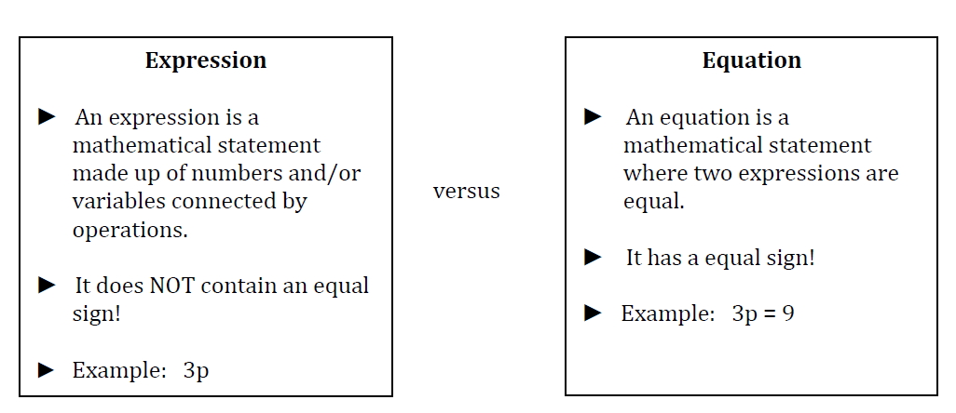
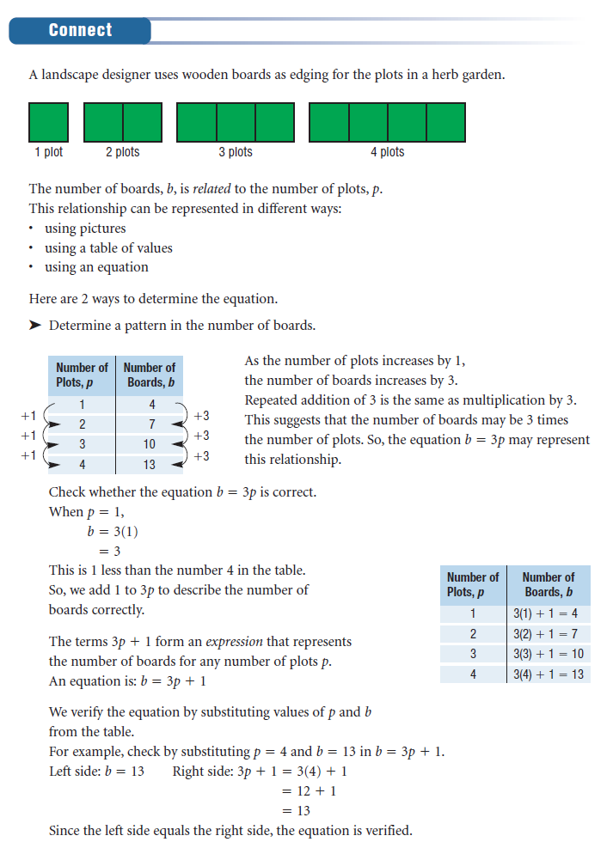

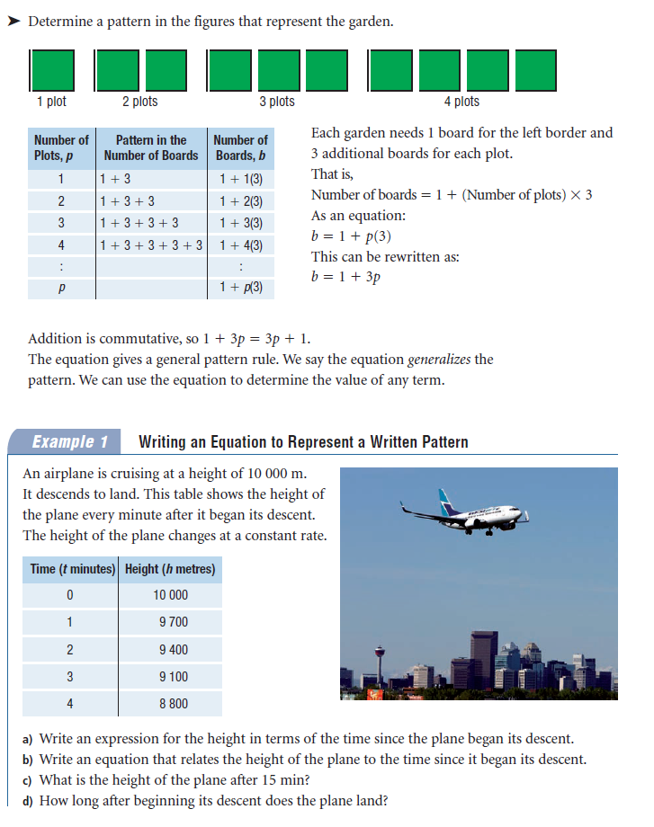
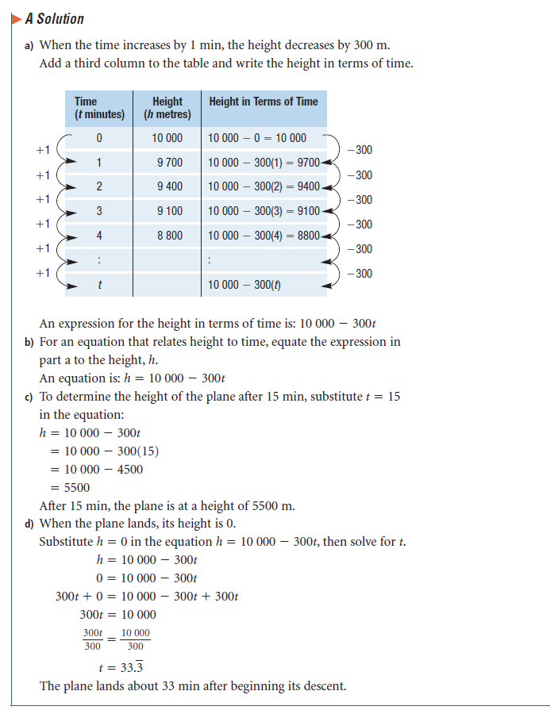

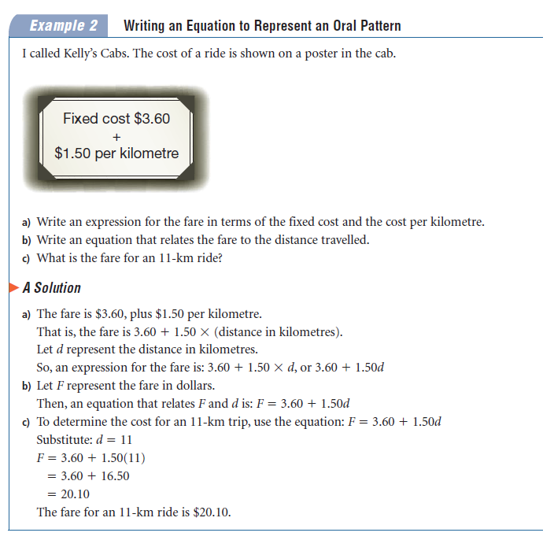

PRACTICE QUESTIONS
Grade 9 Math May 27 - June 2
Linear Relations Part 1a - Writing Equations to Describe Patterns
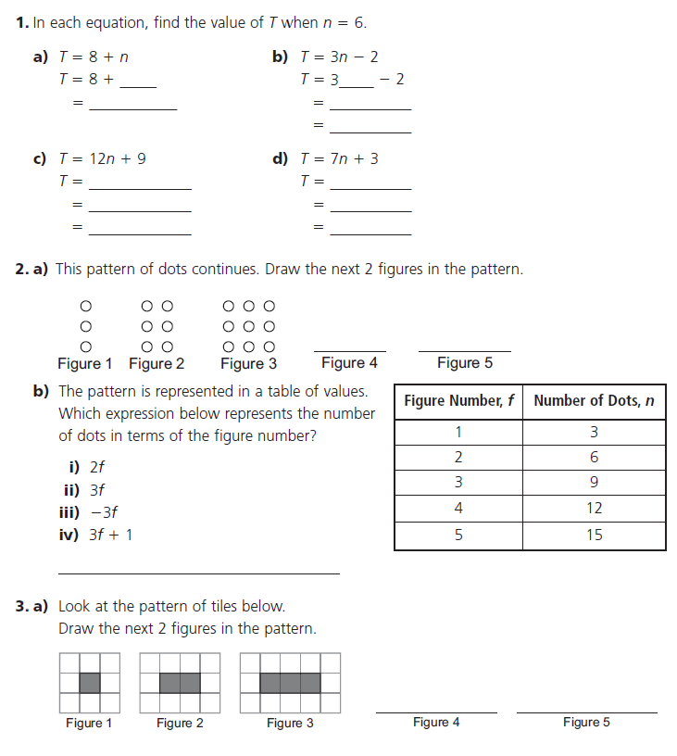
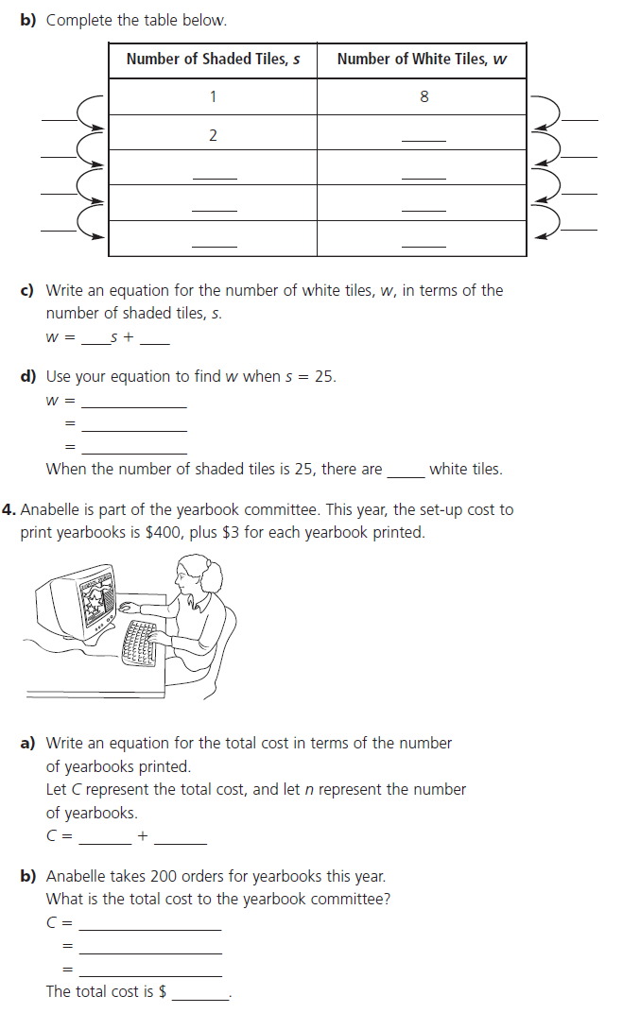
NOTES
Grade 9 Math May 27 - June 2
Linear Relations Part 1b - Graphing Linear Relations

The Cartesian Plane
We place points on the cartesian plane based on ordered pairs. An ordered pair is two values, one for the horizontal position (x) and one for the vertical position (y). They are written in parentheses with a comma between the two: (x, y). The x always comes first, y always comes second.
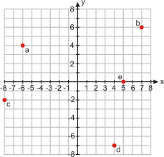
In the above example the ordered pairs are a(-6, 4), b(7, 6), c(-8, -2), and d(4, -7).

Try drawing the following points on the cartesian plane according to their ordered pairs.
A = (1,1)
B = (-3, 4)
C = (-1, -6)
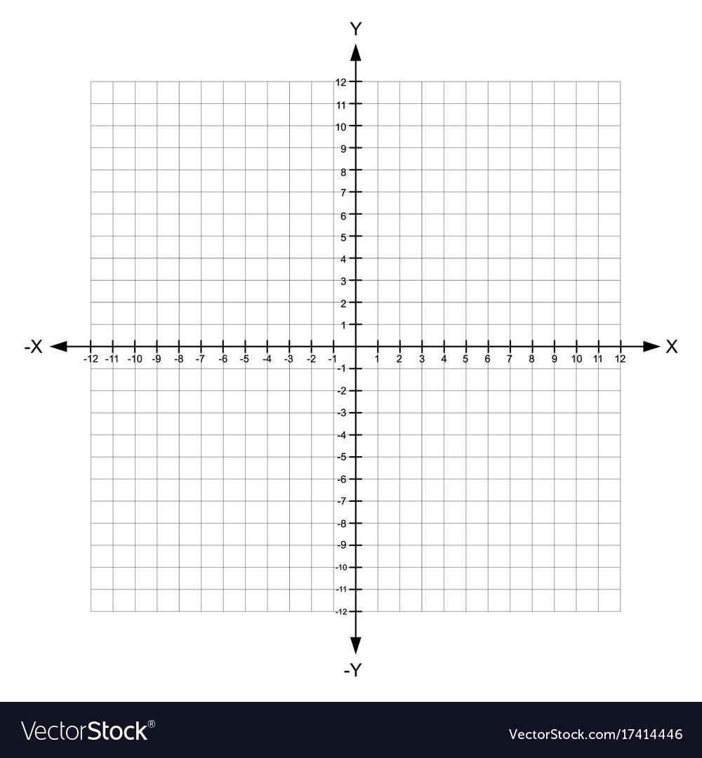
D = (2, -5)

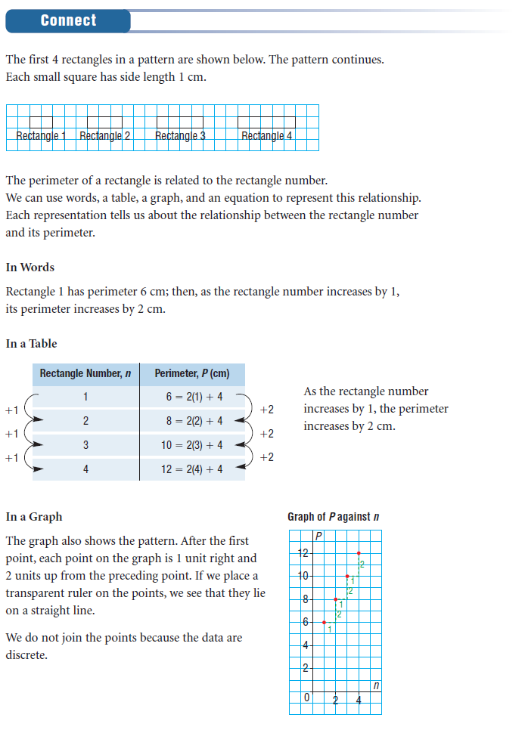
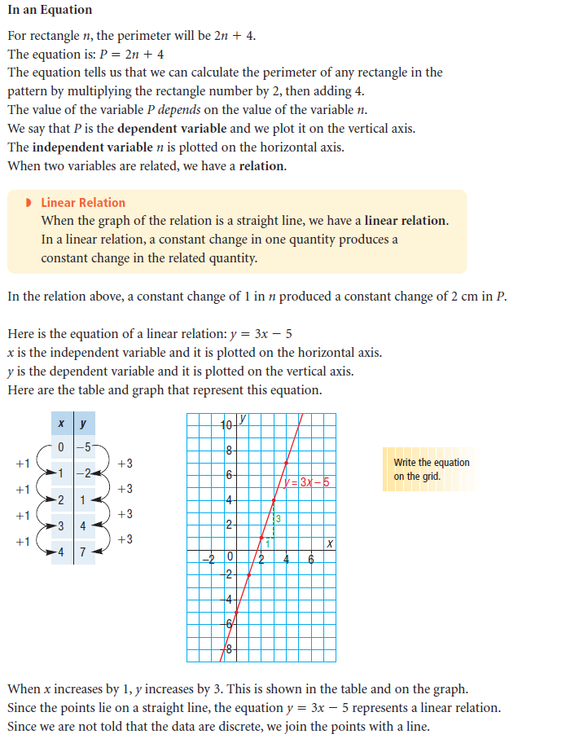
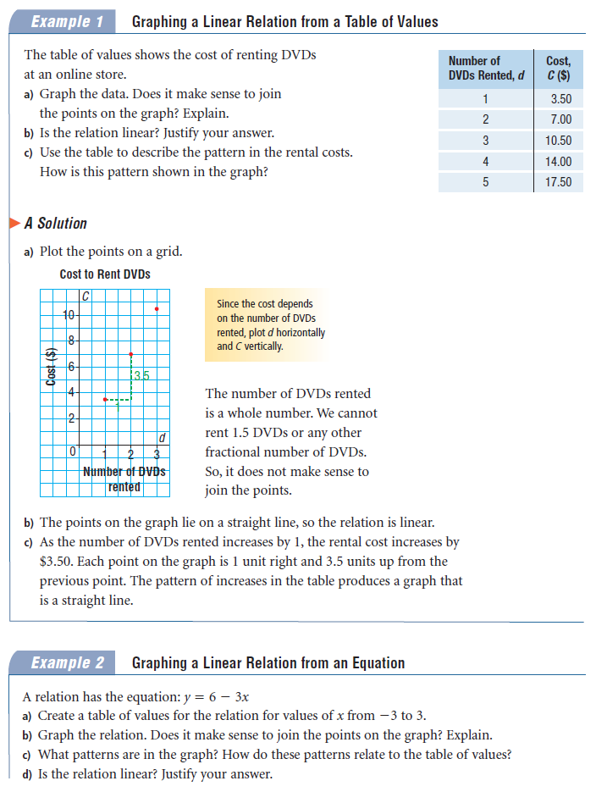

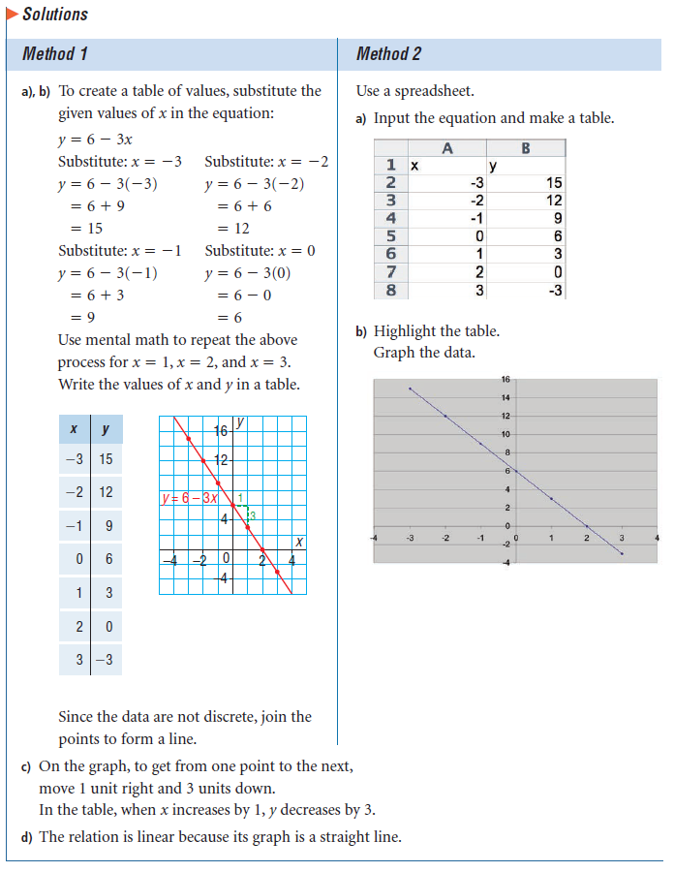
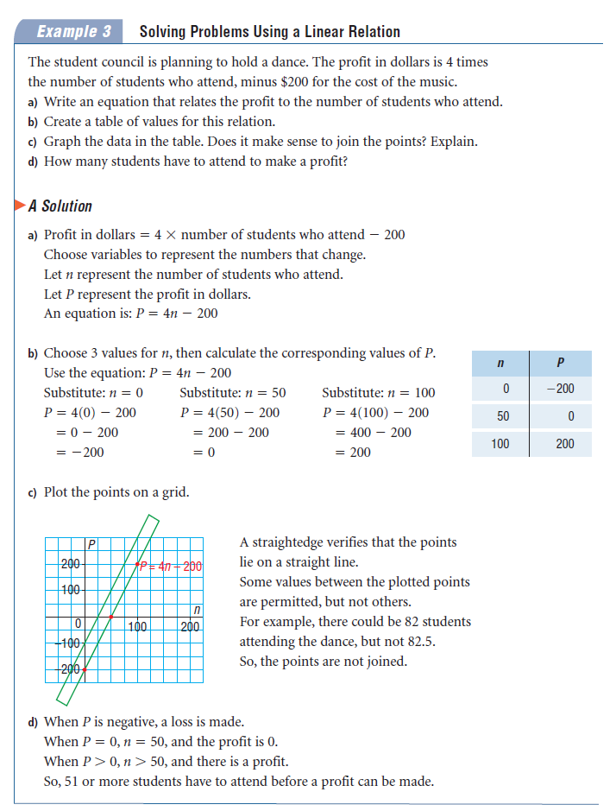

PRACTICE QUESTIONS
Grade 9 Math May 27 - June 2
Linear Relations Part 1b - Graphing Linear Relations

