Biology – Sexual Reproduction and Meiosis Student Worksheet

Welcome to week six where we continue our exploration of reproduction, with a focus now on sexual reproduction.

Part A: Review (Chemistry)

Please write the formula or name corresponding to the given name or formula for the following ionic compounds. You can use the “subscript” button in the “Home” bar to make small numbers.
Hints:
- For every question ask yourself, “Is this covalent or ionic?”.
- If the question is covalent, use prefixes and DO NOT BALANCE charges. If you need help, use the flow chart for covalent compounds found on the back of the chemistry reference package.
- If the question is ionic, you need to draw a t-chart to balance the charges. DO NOT use prefixes. If you need help, use the flow chart for ionic compounds found on the back of the chemistry reference package.
- If an element ends in something other than ‘ide’ it might be polyatomic. Treat these as ionic compounds. We have created these in bold below.
Carbon trisulphide | Cs₂SO₄
Chromium (III) bromide | Mn₃P₄

Part B: Review (Asexual Reproduction and Mitosis)

Before we start, using p.175, section 5.2 of the textbook, complete the following chart reviewing the advantages and disadvantages of asexual reproduction.

Advantages and Disadvantages of Asexual Reproduction
Advantages | Disadvantages
• | •
• | •
• | •
• | •

Review questions:
- Why are most multicellular organisms unable to reproduce by budding?

- To eat, sea stars attach their legs to oysters, pry open their shells, and eat the insides. Oyster farmers once tried to destroy sea stars by cutting them into pieces and throwing them back into the ocean. Predict what happened.

- If you drive to Shawnigan Lake, you will see a large sign asking all boaters to clean weeds off their motors and hulls before entering and after exiting the lake. Explain why this is asked of boaters (hint: it has to do with asexual reproduction).

- Mitosis can be remembered through the acronym PMAT. The letters stand for prophase, metaphase, anaphase, and telophase. How did the ‘Amobea Sisters’ explain a way of remembering what each term means?
P –
M –
A –
T –

- Name four different cells in our body that reproduce through asexual reproduction?

- What are the only two cells in our body that do not reproduce through asexual reproduction?

Part C: Sexual Reproduction

Look at the people around you in your family. How are they similar? How are they different? Each one of them has some differences in genetic information even though you are in the same family. This genetic information determines why members of your family share some similar characteristics but also have slightly different characteristics. This, of course, is the same for all living things that reproduce sexually, including plants and animals. In this assignment, you will explore the method of reproduction by which an organism receives genetic information from both its parents.

To begin, read pages 188 – 194 (Section 6.1 in your textbook) and answer the following questions:

- What does the term genetic diversity mean?

- Using the following diagrams of the outcomes of asexual and sexual reproduction, describe What is the function of meiosis is?

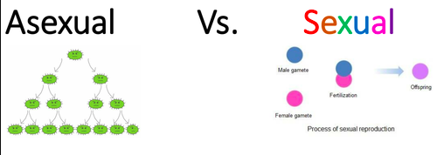

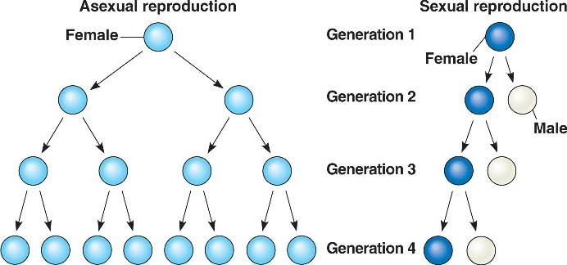
This image may be used for personal, non-commercial purposes only.
Full Text: COPYRIGHT 2016 Macmillan Reference USA, a part of Gale, Cengage Learning
Source Citation (MLA 8th Edition)

"Because organisms that reproduce asexually do not have to search for a mate, asexual reproduction is..." Biology, edited by Melissa Sue Hill, 2nd ed., vol. 4, Macmillan Reference USA, 2016. Gale In Context: Science, https://link-gale- com.bc.idm.oclc.org/apps/doc/PC3629887392/SCIC?u=bcdc&sid=SCIC&xid=f35a47ce. Accessed 8 May 2020.
Gale Document Number: GALE|PC3629887392

Because organisms that reproduce asexually do not have to search for a mate, asexual reproduction is very rapid and produces a large number of offspring. Sexual reproduction, though more time consuming, is far more common as it creates genetically different offspring and allows for a population to survive in a constantly changing environment.

- A) What is the haploid number of chromosomes in humans?
B) What is the diploid number of chromosomes in humans?

- Male sex cells are called _________________ or ________________.
- Female sex cells are called _________________ or ________________.

- What is another name for a fertilized egg?

Part D: Internal and External Fertilization

In sexual reproduction, a male gamete (sperm cell) must fertilize a female gamete (egg cell). As a result of meiosis and the union of sperm and egg cells, no two individuals will have the same DNA, except identical twins. Many aquatic animals reproduce through external fertilization. Most land animals reproduce through internal fertilization. Following fertilization, the zygote and embryo start to divide by mitosis, and cells will differentiate.

- You are about to watch a video titled, “Learn Biology: How to draw a Punnett Square.” Before watching the movie, take a guess as to what this will be about and write this guess below. (“IDK or I don’t know” is NOT an answer).

- Watch the following video by selecting the link below:
https://www.youtube.com/watch?v=prkHKjfUmMs

- Fill in the following Punnett square and answer the following questions:
(B = dominant allele; b = recessive allele)

 | B | b
b
b

If B = brown eyes and b = blue eyes, and using the above Punnett square, what are the probabilities for the following:
- Probability of brown eyes = % or Fraction /4
- Probability of blue eyes = % or Fraction /4

- Complete another Punnett square for runner beans with the following probabilities (presuming G = yellow colour allele; g = green coloured allele) You will need to add the parent alleles so they work out to the following probabilities.
  - 50 % yellow beans
  - 50% green beans

- Read the article titled: “Wizard of odds: wizard or muggle--could the chances of becoming one lie in a person's genes?” from the “Reference Materials”.

After reading the article, complete the following questions by selecting the correct multiple choice answer and writing its letter on the line provided or completing the question asked:

Genes are segments of (A) RNA. (B) DNA. (C) NBA.

Different versions of a gene are called (A) pedigrees. (B) alleles. (C) carriers.

The characteristics people inherit from their parents are called (A) genes. (B) traits. (C) ancestral lines.

Cystic fibrosis develops when a child inherits A) two recessive alleles. B) one dominant allele and one recessive allele. C) two dominant alleles.

About how many genes does a human have A) 2500, B)25000, C) 250000

Complete the Punnett square below with the following information and answer the question: If one human parent is a wizard (ww) and one is a muggle (MM), what are the odds their kids will be a wizard?

- Using p.220, section 6.2 of the textbook, complete the following chart reviewing the advantages and disadvantages of sexual reproduction.

Advantages and Disadvantages of Sexual Reproduction
Advantages | Disadvantages
• | •
• | •
• | •
• | •

Part E: Asexual and Sexual Research Project

Now that you know about asexual and sexual reproduction, complete the following project.

Create a portfolio demonstrating evidence of living things around your home and neighbourhood that reproduce sexually and asexually.

Criteria:
- Must include four examples of living things from your home or neighbourhood that reproduce asexually.

- Must include four examples of living things your home or neighbourhood that reproduce sexually (only one mammal may be included)

- Write the name of the two sources you used to confirm the reproductive method of each of your organisms. Use the following citation helper to help you properly credit the information you use: http://www.citationmachine.net (APA format)

- Presentation of evidence: photos (are easy to insert into the area provided) or drawings (take a picture of your drawing and upload it to your “My Work” section of the Teams Assignment).

- Each living thing must include its name.

- At the end of the assignment, include the differences and similarities between mitosis and meiosis.

Sexual and Asexual Reproduction Assignment

A
S
E
X
U
A
L

R
E
P
R
O
D
U
C
T
I
O
N
 | Name of organism: |  | Name of organism:
 | Name of organism: |  | Name of organism:

S
E
X
U
A
L

R
E
P
R
O
D
U
C
T
I
O
N
 | Name of organism: |  | Name of organism:
 | Name of organism: |  | Name of organism:

