Electricity - Introduction to Circuits Student Worksheet
Welcome to another week of virtual science at Quamichan. This week we are moving on to our physics unit. The ‘Big Idea’ in this unit is: Electric current is the flow of electric charge. Within the unit we will look at the components of circuits, different types of circuits (series, parallel, and short), and how the terms voltage, current, and resistance are linked.
To start, you will need to become familiar with the electricity simulation offered by PhET Interactive Simulations at the University of Colorado Boulder, under the CC-BY 4.0 license.
More specifically, this lab uses the Circuit Construction Kit DC simulation from PhET Interactive Simulations.
In addition, you will need to know how to take a screen shot of your work so you can include them in your assignment or you will need to be able to draw a circuit using the correct format and symbols (see textbook chapters and Electricity Datapages for assistance). If you are going to take screen shots of your work, you will need to determine how to do this with the device you are using. For example, with an iPad to take a screen shot you hold the home button and the power button at the same time (the iPad saves the image in you photos) or for a Mac computer, you can hold the command key, shift key and the number 4 key to get the screen shot icon to appear, you then highlight the area you want to save and it saves the screen shot on your desktop.
You will also require access to ‘Electricity Reference Package’ attached to this assignment to familiarize yourself with the different symbols and terms used in electricity.

Learning Goals
- Explore basic electricity relationships.
- Explain basic electricity relationships in series and parallel circuits.
- Use an ammeter and voltmeter to take readings in circuits.
- Provide reasoning to explain the measurements and relationships in circuits.

Part A: Initial Exploration
- Open the ‘Electricity Reference Package’ and take a look at the pictures and illustrations. This is HUGELY helpful for this unit. Please become familiar with the terms, symbols and illustrations found in this reference package.

- Please watch the following video on how to use the PhET simulation required in this assignment to show you how to use the simulation:
https://www.youtube.com/watch?v=DcKzoOb1Ofc

- Once you have watched the above video, please use the link below, open the Circuit Construction Kit DC simulation.
https://phet.colorado.edu/sims/html/circuit-construction-kit-dc/latest/circuit-construction-kit-dc_en.html

- Select ‘Intro,’ and play around with what you see. Read the challenges (a-d) below, try to make some circuits in the simulation and answer the questions below. Take two screen shots of any of the challenges below and add these in the space directly below the challenge you attempted.
  - Can you find the dollar bill? A dog
  - Are you able to build a circuit that bursts into flame?
  - Are you able to change the pictures in the left-hand menu into symbols for each picture?
  - Are you able to change the brightness of a bulb by changing the voltage on a battery?

Part B: Prediction Questions
Now that you have explored the simulation, consider the pictures of each of these circuits and answer the questions below.
Series Circuit Parallel Circuit Complex Circuit
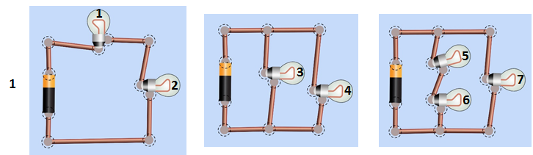
- From the circuits above, predict which bulb (or bulbs) will be the brightest (state the number of the bulb in your answer). Why do you think this?

- Describe what the difference is between a series circuit and a parallel circuit?

- Current is the flow of charge (the flow of electrons, measured in coulombs/sec = amps) in a circuit. Describe how you think current will flow in the different types of circuits above (series, parallel and complex).

Part C: Develop your Understanding:
- Explore the ‘Intro' screen of PhET Circuit Construction Kit DC
  - Build a circuit that shows how to make a light bulb light up.
  - Figure out how to measure current and voltage.
  - Insert an image below of your circuit with the current and voltage measured.

- Imagine you’re an engineer making a string of battery powered holiday lights. If a bulb burns out current cannot flow through that bulb any longer, as if the wire at the bulb has been cut. Figure out how to hook up 2 light bulbs and a battery so that when one bulb burns out or is disconnected the other one stays lit. Create this circuit in the PhET simulation and take a screen shot.
  - Insert images to illustrate that your circuit works as expected.

  - Explain why you think it works.

- Imagine that you want to make sure the battery for your string of lights will last as long as possible. A battery will last longer if it powers a circuit with low current. Using the PhET simulator, find a way to hook up a battery and 2 light bulbs so the least amount of current flows through the battery. Use the measurement tools in the simulation to check your design and take a screen shot to show your work.

  - Insert images to illustrate that your circuit works as expected.

  - Explain why you think it works.

Part D: Measuring Current and Voltage in Different Types of Circuits:
Instructions: Your goal is to write rules to describe how patterns of current and voltage in a circuit relate to the structure of the circuit. You will need to measure current and voltage in multiple places on several different circuits.
Examples:
Measuring Current | Measuring Voltage
“Current” is the flow of charge (flow of electrons), measured in Amps (Coulombs/s). An ammeter measures the current past a single point in the circuit. To measure current, you will need to “cut” the circuit and place the leads in between the cuts you have made.  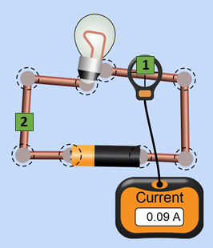  The current flowing through point 1 can be written as:  I₁ = 0.09. | “Voltage” is a measure of the difference in electric potential between two points (the amount of pressure). The voltmeter measures this difference by placing the two leads (pronounced “leeds”) at two different points in the circuit.  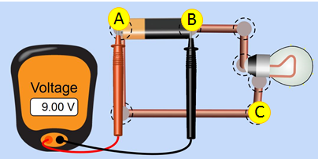  The voltage between points A and B can be written as V_{AB} = 9 V.

Use the table below to record your measurements and patterns you notice. Please take the measurements at the indicated places (Numbers = measure current/amps, Letters = measure voltage) . Please use a battery voltage of 9.0 Volts for each circuit in the table.
Circuit | Current Measurements (Amps) | Voltage Measurements (Volts) | What patterns do you notice?
11) Simple Circuit  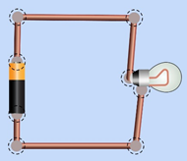  C  A  B  2  1 | I ₁ = ______ A  I ₂ = A | V_{AB} = ______ V  V_{AC} = ______ V  V_{BC} = ______ V | Where is the current the same?  Where is the current different?  Where does the voltage change?  Where doesn’t voltage change?
12) Series Circuit  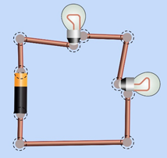  C  D  B  A  3  2  1 | I ₁ = ______ A  I ₂ = A  I ₃ = A | V_{AB} = ______ V  V_{AD} = ______ V  V_{DC} = ______ V  V_{BC} = V | Where is the current the same?  Where is the current different?  Where does the voltage change?  Where doesn’t voltage change?
13) Parallel Circuit  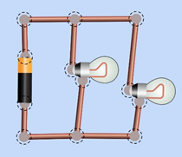  C  E  D  3  2  1  B  A | I ₁ = ______ A  I ₂ = A  I ₃ = A | V_{AB} = ______ V  V_{AD} = ______ V  V_{DE} = ______ V  V_{DC} = ______ V  V_{BC} = ______ V | Where is the current the same?  Where is the current different?  Where does the voltage change?  Where doesn’t voltage change?
14) Complex circuit  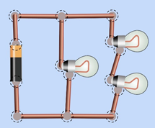  2  E  3  C  A  B  1  D | I ₁ = ______ A  I ₂ = A  I ₃ = A | V_{AB} = ______ V  V_{AD} = ______ V  V_{DE} = ______ V  V_{DC} = ______ V  V_{BC} = ______ V | Where is the current the same?  Where is the current different?  Where does the voltage change?  Where doesn’t voltage change?

Part E: Summarize your Understanding:
15. Compare the patterns you see in a series circuit to the ones you see in series and parallel circuits. Write rules about voltage and current for each type of circuit. Refer to your answers in the 4th column of the table above (“What Patterns do you Notice”) to help you. You must state rules about current, and voltage for each type of circuit.
For example, “In a series circuit, I see that the current ….., whereas in a parallel circuit I see the current… ”.

  - Rules for Current:

  - Rules for Voltage:

