Electricity – Circuits Review and Ohm’s Law Student Worksheet
Welcome to week eight (has it actually been 2 months since we had regular school....). This week we are continuing our exploration of electricity, with a focus now on Ohm’s Law.

Part A: Review (Chemistry)
Please write the formula or name corresponding to the given name or formula for the following ionic compounds. You can use the “subscript” button in the “Home” bar to make small numbers.
Hints:
- For every question ask yourself, “Is this covalent or ionic?”.
- If the question is covalent, use prefixes and DO NOT BALANCE charges. If you need help, use the flow chart for covalent compounds found on the back of the chemistry reference package.
- If the question is ionic, you need to draw a t-chart to balance the charges. DO NOT use prefixes. If you need help, use the flow chart for ionic compounds found on the back of the chemistry reference package.
- If an element ends in something other than ‘ide’ it might be polyatomic. Treat these as ionic compounds. We have created these in bold below.
Ammonium phosphide | B₃P₅
Manganese (II) sulfide | Cr₃(PO₄)₂

Part B: Review (Circuit Knowledge - Test your Understanding)

Please review your answers for Assignment # 7 to make your predictions below.
1. Predict from your rules above, the order of the light bulbs in these circuits from brightest to dimmest. Some bulbs might be the same brightness.
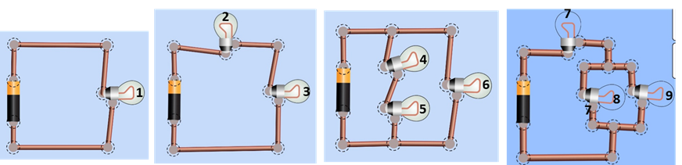
- Order the bulbs by increasing brightness (dimmest to brightness).

- After you make your rankings, build circuits to check your answers and list the correct ranking below. Insert images from the PhET simulation to support your sequence.

- Did your rules allow you to correctly rank the bulb brightness? If not, correct your rules in #15.

- Did you use any meters to help you make your list? If so, explain why.

2. In this question, you will need to make a flashlight that has two batteries and a lightbulb.
- Predict how you would hook them up to make the brightest flashlight and explain why.

- Build circuits in the PhET simulator to check your answer and insert images from the simulation for evidence.

Part C: Relationship between Current, Voltage and Resistance:
Voltage, current, and resistance are key terms in electricity. As you are watching the following video decide on a single word you could use to describe voltage, a single word to describe current and a single word to describe resistance.
Video: What are Volts, Ohms, and Amps? Daniel Sullivan
https://www.bing.com/videos/search?q=volts%2c+ohms+and+amps&docid=608027284167067004&mid=669E5EF83B99D710E2D3669E5EF83B99D710E2D3&view=detail&FORM=VIRE

3. In the following table, write a single word to describe each of the following electricity terms.
Electricity term | Definition | Single word to describe the electricity term.
voltage | The amount of pressure/tension in a circuit.
current | The flow of electrons in a circuit.
resistance | Slows the flow of electrons

Using the information you gathered in the simulations from last week’s assignment (Assignment #7), and the ‘Electricity Reference Package,’ build the following circuits. Note, you must use symbols for the parts of the circuits, not the actual images.
For example: Use the symbol for battery, 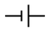 not a picture of a battery.

- Build a series circuit with one battery (set to 3V), 2 bulbs, and a switch that controls all the bulbs. Place a screen shot below.

- What happens to the brightness of the bulbs when you add another bulb in series?

- Build a parallel circuit with one battery (set to 3V), 2 bulbs, a switch that controls one of the bulbs, and a switch that controls all the bulbs. Place a screen shot below.

- What happens to the brightness of the bulbs as you add another bulb in parallel?

Voltage, current and resistance are related in electricity. This can be summed up in the phrase: voltage pushes current through resistance. Complete the following to discover this relationship.
4. For the following circuit, select the images (actual pictures) of the components.
(Example: Use the picture of a battery, not the symbol for a battery
- Build a series circuit using PHET with one battery (set to 9V), one bulb and one ammeter (this measures current).
- Click on the bulb so the ‘resistance’ sliding bar appears at the bottom of the screen.
- What happens when you lower the resistance of the bulb to zero?
- What happens in ‘c’ above is called a ‘short circuit’ and is the cause of many house fires. Why do you think this happens?
- Move the resistance sliding bar. Record what happens:
  - As you increase the resistance, what happens to the brightness of the bulb?
  - As you increase the resistance, what happens to the value on the ammeter?
  - Set the resistance to 20 ohms. What is the value on the ammeter (in other words, what is the current flowing through the circuit?)?
  - Multiply the value on the ammeter (current) by the resistance of the bulb. What value did you get?
  - The above value should equal the voltage of the battery. Is this true?

Part D: Ohm’s Law:

You just proved voltage pushes current through resistance. But you can also do this with a math equation using the formula V=IR, where V=voltage, I=current, and R=resistance. This is called Ohm’s Law.

5. Look at your ‘Electricity Datapages’ and read the ‘Ohm’s Law’ section. There are three examples, each one calculating either voltage (V), current (I), or resistance (R ). Use the examples to solve the following problems.
- If V= 10 V and R = 5Ω, what is the current (I)?
- If V = 3.5V and R = 10Ω, what is the current?
- If V = 10V and I = 2A, what is the resistance?
- If V = 3.5V and I = 0.5A, what is the resistance?
- If I = 11A and R = 3Ω, what is the voltage?
- If I = 7A and R = 4.5Ω, what is the voltage?
- A toaster has resistance of 8.6Ω and a current of 14A. What is the voltage?
- A coffee machine has a voltage of 120V and a resistance of 100Ω. What is the current?
- An iron has a voltage of 120V and a current of 4.6A. What is the resistance?

