Science – WEEK 1 – Both Grades

The following is a learning assignment that can be completed at home while a student is absent. Please submit your completed assignment to your teacher either electronically (through email) or by dropping it off at the office with your name, your teachers name and the class and block labelled.

Please do not do week 1 / 2 lessons before contacting your teacher. They may choose to assign something different to you.

Learning Intentions:

- Core Competencies of Communication, Thinking and Personal and Social Awareness and Curricular Competencies relating to making observations aimed at identifying students’ own questions, including increasingly complex ones, about the world around them.
- Big idea: The electron arrangement of atoms impacts their chemical nature.

Assignment Instructions:

- Please see attached Inquiry project titled “Going Retro. How do you make those groovy lava lamps.”

Criteria / Rubric:
- Assessment is based on a 4-point proficiency scale:
emerging | developing | proficient | extending
The student demonstrates an initial understanding of the concepts and competencies relevant to the expected learning. | The student demonstrates a partial understanding of the concepts and competencies relevant to the expected learning. | The student demonstrates a solid understanding of the concepts and competencies relevant to the expected learning. | The student demonstrates a sophisticated understanding of the concepts and competencies relevant to the expected learning.

Science 9 Inquiry Question
Going retro. How do you make those groovy lava lamps?

Name:

Date:

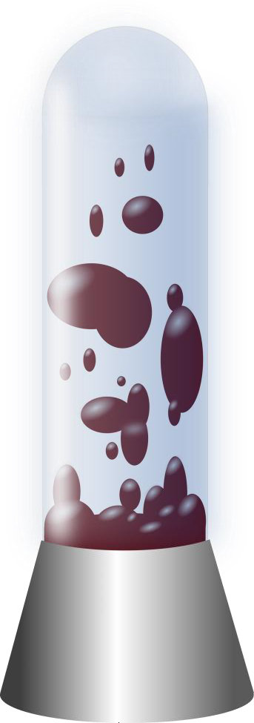

Lava lamps first came out in the 1960s. They rely on the varying densities of the different liquids and on the polarity of the different liquids.
Why are the densities of the liquids important in the lava lamp?
What is polarity and how does it play a role in the functioning of the lava lamp?
In this project you will be researching how to make a homemade lava lamp and the scientific principles involved in how they work. You will then be creating your own lava lamp and documenting the process by video or in photos.

General Instructions
The goal of this project is to gain a better understanding of density and polarity through the making of a lava lamp.
Materials you’ll need:

- the internet for research
- lava lamp supplies (container, oil, water, food colouring, alka-selzer)
- device for video recording or picture taking and presentation software
Ideas and Hints:

- Research the internet to discover how to make a homemade lava lamp.
- Create the lava lamp, record your process, either on video or through multiple pictures. You must appear in at least one photo or briefly in the video.
- The video or captions for photos need to describe the steps needed to create the lava lamp.
- There must be a write-up or explanation of how the lava lamp works from a chemistry point of view.

