Science – WEEK 2 – Both Grades

The following is a learning assignment that can be completed at home while a student is absent. Please submit your completed assignment to your teacher either electronically (through email) or by dropping it off at the office with your name, your teachers name and the class and block labelled.

Please do not do week 1 / 2 lessons before contacting your teacher. They may choose to assign something different to you.

Learning Intentions:

- Core Competencies of Communication, Thinking and Personal and Social Awareness and Curricular Competencies relating to making observations aimed at identifying students’ own questions, including increasingly complex ones, about the world around them.
- Big idea: The electron arrangement of atoms impacts their chemical nature.

Assignment Instructions:

- Please see attached Inquiry project titled “Matter is all around us but what do we know about matter and its changes?”

Criteria / Rubric:

- Assessment is based on a 4-point proficiency scale:

emerging | developing | proficient | extending
The student demonstrates an initial understanding of the concepts and competencies relevant to the expected learning. | The student demonstrates a partial understanding of the concepts and competencies relevant to the expected learning. | The student demonstrates a solid understanding of the concepts and competencies relevant to the expected learning. | The student demonstrates a sophisticated understanding of the concepts and competencies relevant to the expected learning.

Science nine Inquiry Question
Matter is all around us but what do we know about matter and its changes?

Name: Date:
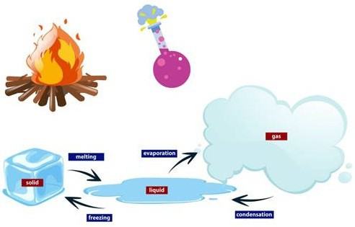

Everything around us is matter and it is classified in terms of what it is made up of. Is it made up of elements or compounds? Many things are mixtures such as the air we breathe. Is the mixture homogeneous or heterogeneous?
How do we describe this matter in terms of its properties? Physical properties are those properties that can be observed without changing what it is made up of. Examples of physical properties include: colour, state, density, etc. Chemical properties describe properties that are observed when the matter changes into something new. Is it reactive or non-reactive?
When matter changes in appearance, does it become something new or is it just in a different form but still made up of the same components? A physical change involves changes where the chemical composition doesn’t change. An example of this would be changes in state. On the other hand, chemical changes involve the creation of new species and the process is not easily reversible. An example of a chemical change is combustion of wood to produce carbon dioxide and water vapour.

General Instructions
The goal of this project is to understand all about matter and its changes.
Materials you’ll need:
- the internet
- Matter Homework Package worksheets
Ideas and Hints:

- Complete the following Matter Homework Package worksheets.

- Save your completed work.

Name: Date:

Physical and Chemical Changes and Properties of Matter Worksheet

Classify the following as chemical change (cc), chemical property (cp), physical change (pc), or physical property (pp).
- resistance to rusting 8. wood is chopped
- glass breaking 9. a knife blade rusting
- barbequing meat 10. flammable
- malleability 11. shininess
- water boiling 12. sun tanning
- fat turning rancid 13. mercury expanding
- melting temperature 14. neutralizes acids

Identify the following as being true or false to the left of the sentence.
15. The formation of carbon dioxide causing dough to rise is a physical change.
16. When a liquid turns blue due to a new substance formed, this is a chemical change.
17. Steam condensing to water is a physical change.
18. When acid is poured on a metal and it fizzes, this is a physical change.
19. Fruit rotting is a chemical change because colour and odor change.
20. When water evaporates, there is cooling. Therefore, this is a chemical change.

Identify each of the following as a physical or chemical change.
- A sheet of plywood is nailed to a wall.
- Plastic is heated, turns black, and produces toxic fumes.
- Iced tea powder dissolves in water.
- Cells in a green plant produce oxygen.
- Over-exposure to sun causes sunburn.

Classifying Matter
Classify each of the following materials as an element, a compound, a solution (homogenous mixture), or a heterogeneous mixture.

1. chlorinated tap water | 2. | pepper | 3. | unfiltered orange juice
4. copper | 5. | bronze | 6. | silver
7. granola | 8. | white sugar | 9. | iced cappuccino
10. clean air | 11. sulphur |  | 12. muddy water
13. titanium | 14. bleach |  | 15. salt water
16. nitrogen dioxide | 17. plywood |  | 18. Greek salad
19. barium iodide | 20. mercury |  | 21. carbon dioxide
22. helium | 23. sodium nitrate |  | 24. wood smoke
25. pizza | 26. aluminum alloy |  | 27. pure diamond
28. energy drink  31. pure water | 29. gravel  32. hydrogen sulphide gas |  | 30. clear vinegar

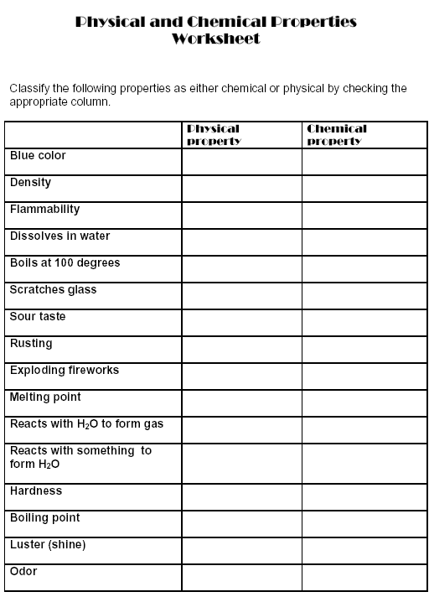

Page 5 of 6

Identify each of the following as an example of a physical property or a chemical property.
  - Tin can be used in solder because it can be melted with a torch.

  - When warm moist air rises, water vapour condenses to form clouds.

  - Sodium metal oxidizes to form sodium peroxide when exposed to air.

  - Propane burned in a barbeque produces carbon dioxide and water vapour.

  - Water is a gas at 104°C.

  - Neon does not form compounds with other elements.

  - Fluorine reacts with most other elements.

  - Liquid nitrogen poured out of a thermal flask, bubbles rapidly and turns into nitrogen gas.

  - Copper develops a greenish coating called a patina when exposed to oxygen and sulphur compounds in the air.

  - Mercury is the only metal that is liquid at 25°C.

  - Magnesium metal is easily attacked by acids.

  - Diamond particles are hard enough to be used in saws that cut through ceramic tiles.

  - Wine left open to the air for a long time turns to vinegar.

  - Carbon fiber, used in high-end bicycles is very strong and light.

