Science – WEEK 3 – Both Grades

- The following is a learning assignment that can be completed at home while a student is absent. Please submit your completed assignment to your teacher either electronically (through email) or by dropping it off at the office with your name, your teachers name and the class and block labelled.

Learning Intentions:

- Core Competencies of Communication, Thinking and Personal and Social Awareness and Curricular Competencies relating to making observations aimed at identifying students’ own questions, including increasingly complex ones, about the world around them.
- Big idea: Cells are derived from cells.

Assignment Instructions:

- Please see attached Inquiry project titled “When two organisms unite, what offspring can be created?”

Criteria / Rubric:

- Assessment is based on a 4-point proficiency scale:

emerging | developing | proficient | extending
The student demonstrates an initial understanding of the concepts and competencies relevant to the expected learning. | The student demonstrates a partial understanding of the concepts and competencies relevant to the expected learning. | The student demonstrates a solid understanding of the concepts and competencies relevant to the expected learning. | The student demonstrates a sophisticated understanding of the concepts and competencies relevant to the expected learning.

Science Nine Inquiry Question
When two organisms unite, what offspring can be created?

Name: Date:

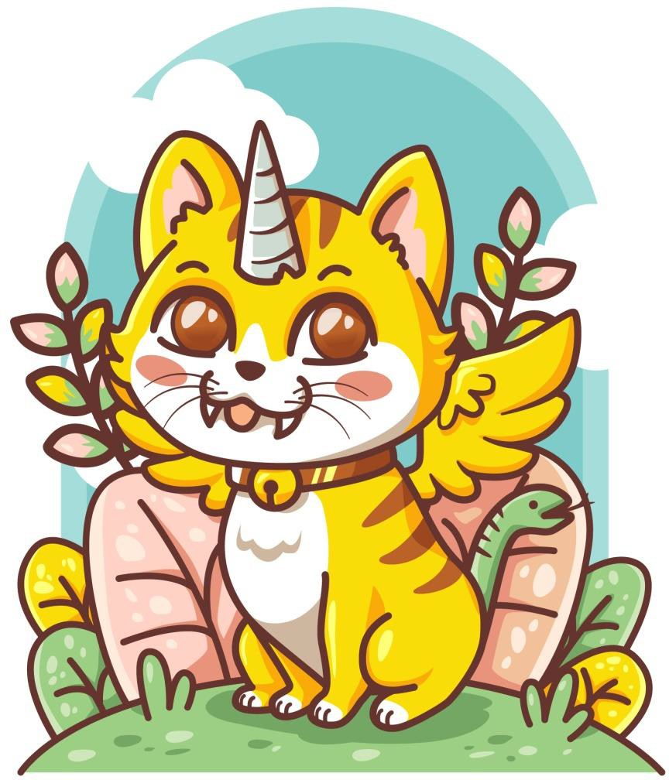

When two organisms unite to reproduce the resulting offspring have a combination of characteristics from both parents. There are many traits to consider and these result from a combination of genes provided by both the male and female parent. These genes can have either dominant or recessive forms, giving a variety of possibilities for the offspring.

In this activity you will first watch a video which will help in predicting the different possibilities for offspring. Then you will "create" and draw the predicted offspring from two parent organisms.

The choice of parent organism is yours. You can either pick a known organism that uses sexual reproduction to create offspring or you can use your imagination and create offspring from fictional parent organisms. If you choose to let your creative juices flow then be sure to still follow the science of the real world.

General Instructions
The goal of this project is to learn how to predict the traits of offspring given the characteristics of the parent organisms.
Materials you’ll need:

- Internet
- paper
- pencils
- coloured pencils
Ideas and Hints:

- Watch the following video from the Khan academy, Introduction to Heredity.

- Choose two organisms as parents to your organism and describe their genetics. You will then allow for sexual reproduction between the two parents.

- Draw the resulting offspring taking into account dominant and recessive traits. Include a Punnett square, as described in the video, to help explain the possible results.

- Answer the following questions:
  - Where does the organism live?
  - What does it eat?
  - Does it have any predators?
  - Give any other interesting facts.
  - Make sure to include the description for at least 4 adaptations in the offspring and why they are beneficial.

